NACL BAKERY

Web programming class project, acadimec year 2023 /2024

|  |  |  |  |  |
| --- | --- | --- | --- | --- |
| Student Name in English | Student Name in Arabic | Student ID | Section time as shown in zajel | Work percentage |
| Bayan Futyan | **بيان علام فتيان** | 12112220 | 9:30-11:00 | 50% |
| Raghad  Eid | **رغد صالح عيد** | 12112270 | 8:00-9:30 | 50% |

Date/time

---------------------------------------------This section is intended for the Instructor---------------------------------------

|  |  |
| --- | --- |
| **Topic** | **Mark** |
| Project Idea |  |
| Project Complexity |  |
| Project Tools |  |
| Project Requirements and Modeling |  |
| Project Discussion |  |
| Project Completeness |  |
| Project Output Results or reporting |  |
| Project Administration and Management |  |
| Project Report |  |
| Team work |  |
|  |  |
|  |  |
|  |  |
|  |  |
|  |  |

**Abstract : >**

Throughout the web development course, our primary objective was to enhance our comprehension of HTML, CSS, PHP, and JavaScript through hands-on experience. This report delves into our project analysis. Initially, we selected the concept of a bakery store specializing in cakes, pastries, bread, and croissants. We collected essential project information and images, and will include details on the tools employed, a UML diagram, explanations of user interfaces and the admin interface, and conclude with a list of references utilized in our project .

**Table of Contents:**

Introduction **2**

Project Requirements **3**

Project UML **4**

Project GUI **5**

Project Responsive**48**

Conclusion **49**

Our future **49**

Tools andreferences **50**

**Introduction : “**

Our goal in this project is to consolidate the skills we learned in the web programming course in a practical way. We designed an easy-to-use electronic bakery store that contains many different and new types of goods using HTML, CSS, PHP, and JavaScript. The website will showcase all the products and services we offer, enabling customers to easily place orders without having to leave their homes. Our goal is for the customer to have an easy and enjoyable shopping experience.

In the future, we will strive to ensure compatibility with all different devices such as smartphones and small tablets, providing a consistent and smooth user experience. We will also work to ensure that the site is secure and fully protects customer data.

**Requirement: ?**

We decided to design an electronic bakery store, and we succeeded in doing so, thanks to God, and we showed it with beautiful interfaces and quick access. I hope you like it. the requirement of this project is :

There is two kind of user can login in this website , customer or admin , to log in you need to have an account , this account contains an unique email , password , location , phone , and user name .

Our project has three basic pages ( home , shop , contant ) .

**- Home page :** contane our section and our sale and a special products ( oue feture , best saller , and new item ) , It enables us to quickly access each of them via buttons.

**- shop page** : in this page we show our products ( each product has a picture , name , price , and if it has sale ) , we can move between types of products by using filter by type , or sort by ( name A-Z or Z-A or price high to low or low to hight ) , each customer has a special cart and favorite page , each products can exist in many cart , and if the user is the Admin , he can dalete , edit , add a products and receiving orders and so on .

**- contant us :** in this page customer can send comment or any question and the admin handle them .

**UML : ?**

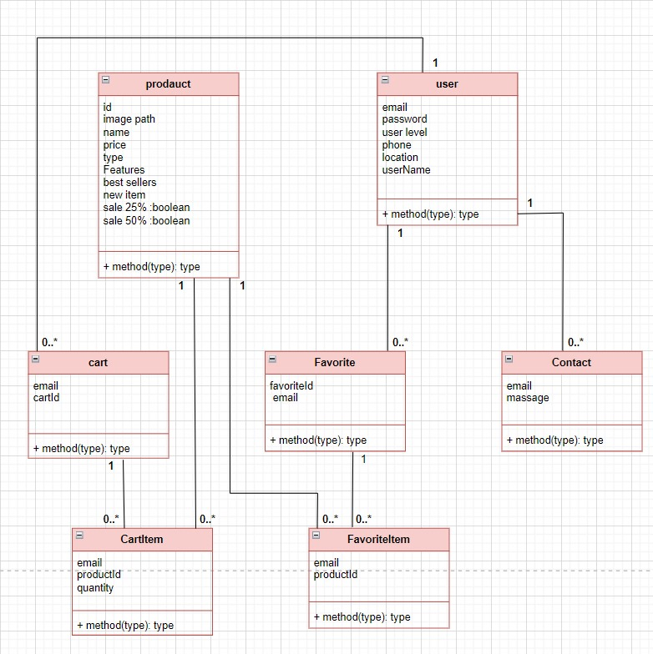

**GUL: ?**

1. **Login page:**

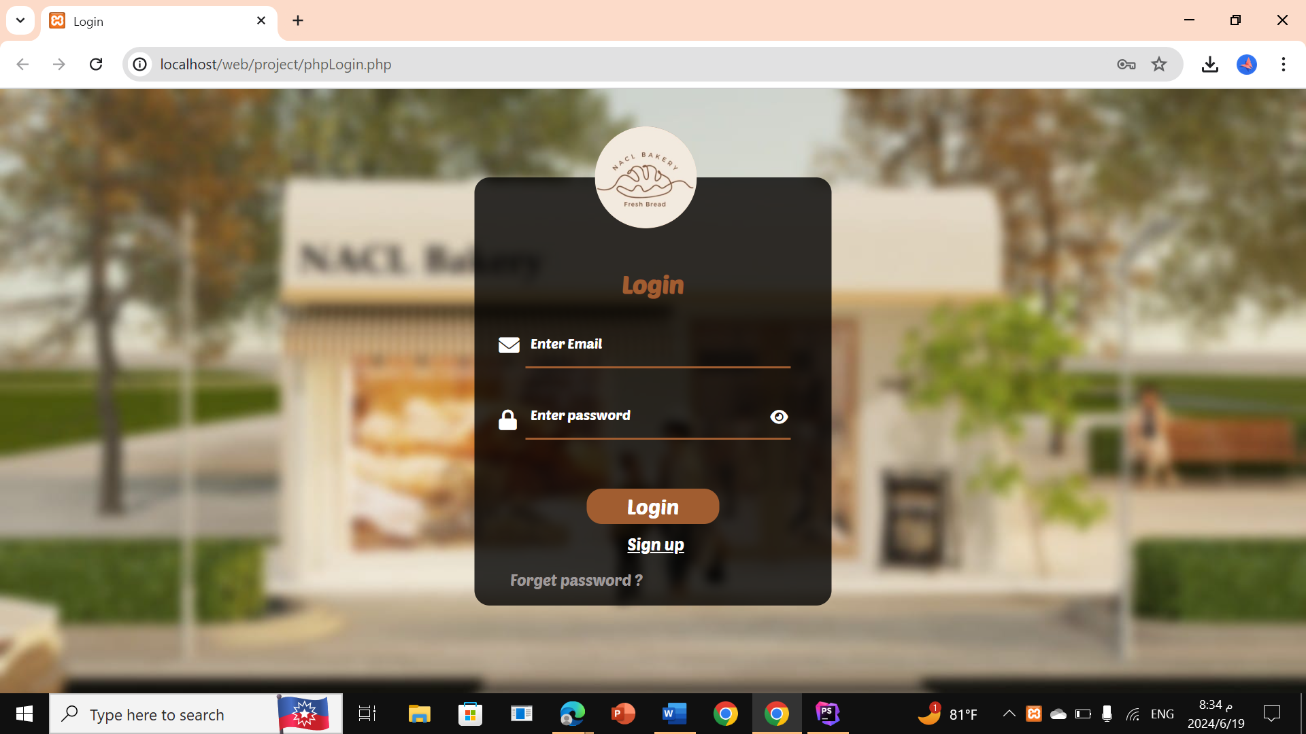

Here the user will enter his account , each user has a different account , because each user will has a special page of cart and favourate , and It can show and hide the password:

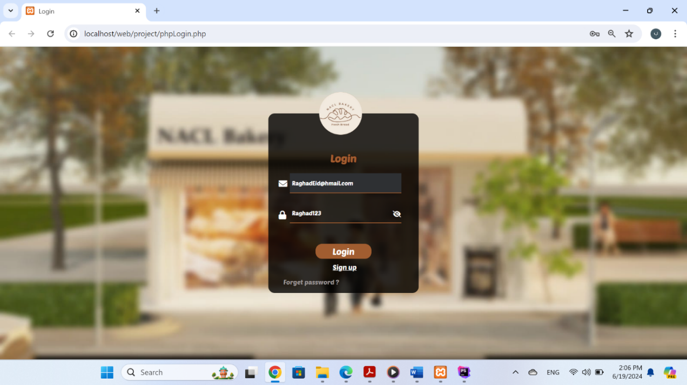

**show the password**

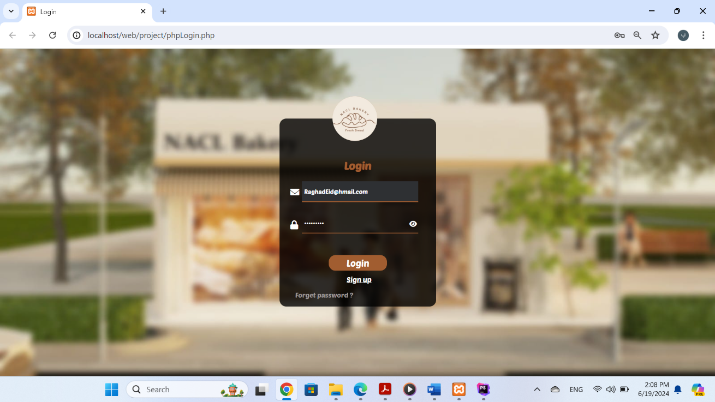

**hide the password**

Then he clicks on login and has three options:

**a.** If the user doesn’t have an account or there is an error in the information, an error message appears. In this case, the user can try enter an email and password again , and if is hasn’t account he can create an account by clicking on sgin up.

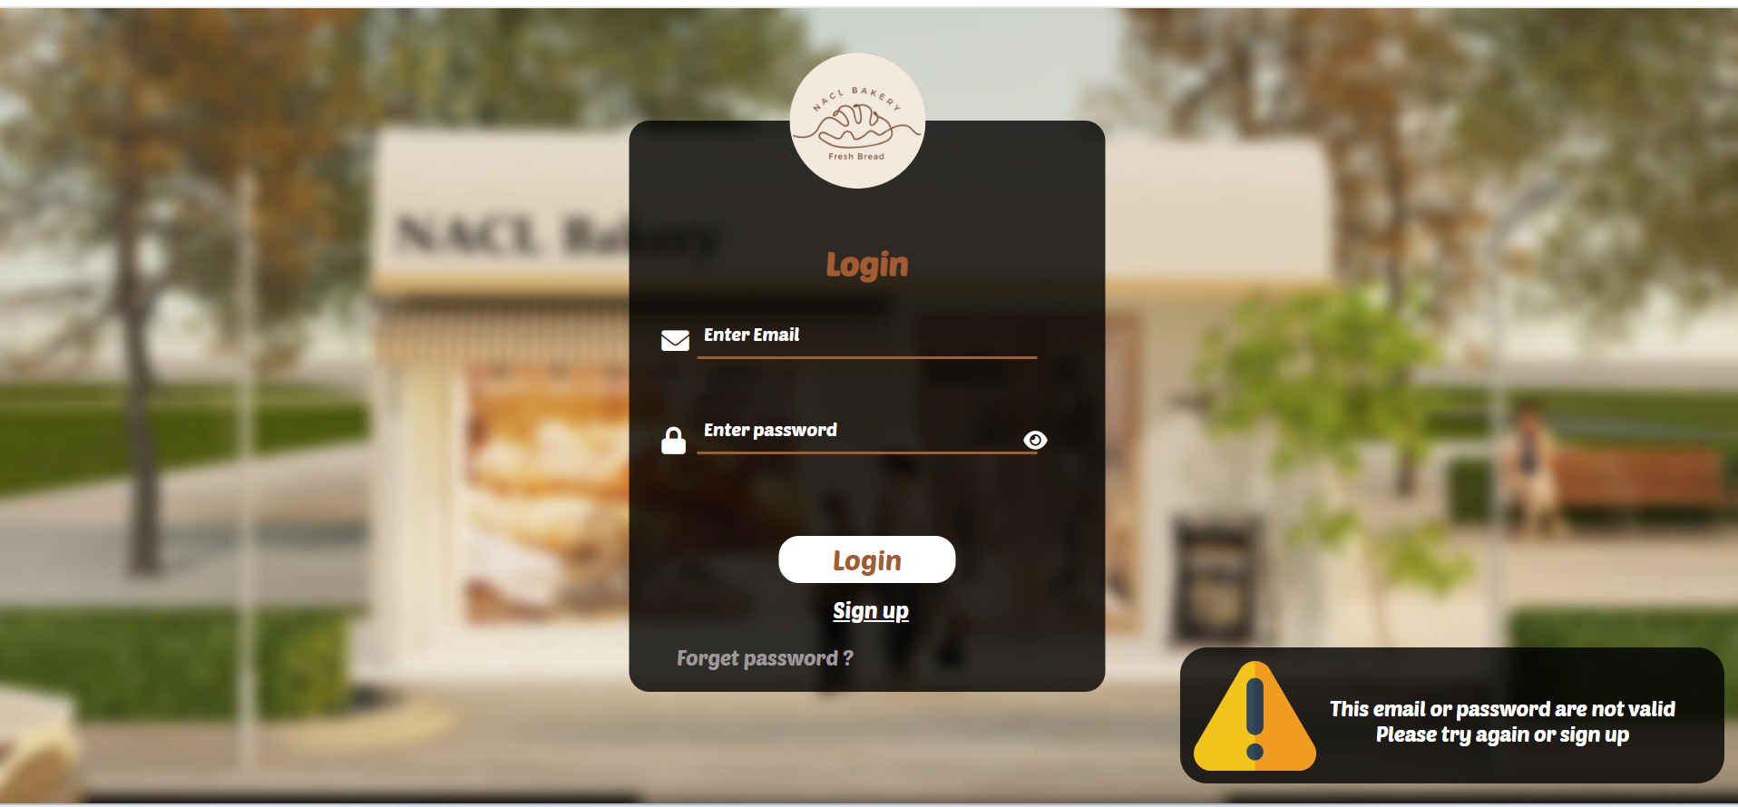

**b.** If everything is correct and the user level in the database is 0 (user ) , the user will be taken to the home page, We'll talk about it later

**c**. If everything is correct and the user level in the database is 1( Admin ) , the admin will be taken to the admin home page, We'll talk about it later

1. **sgin up page:**

This page appears by click on sgin up in the Login page.

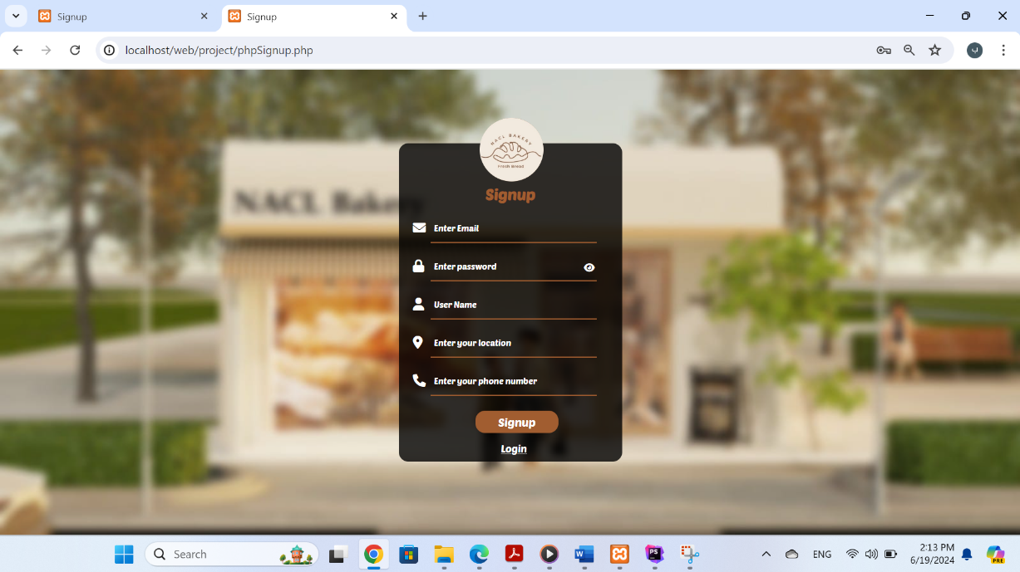

We will enter the information, taking into account the types, then click on sgin up

If everything is correct it will move user to Login page page to make log in:

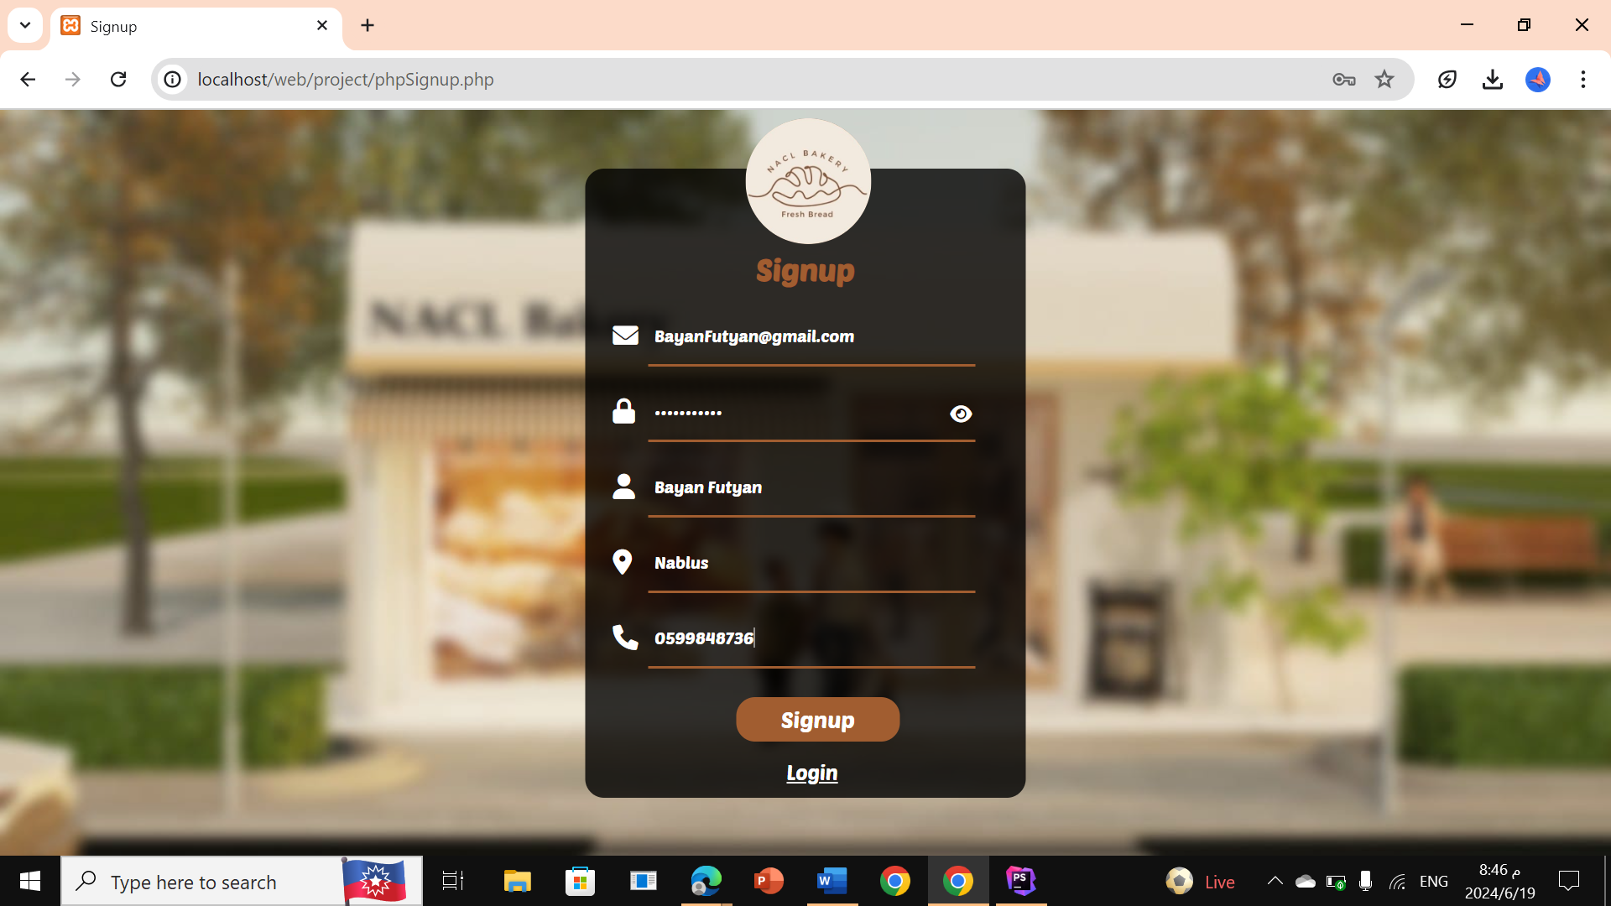

The password may also appear:

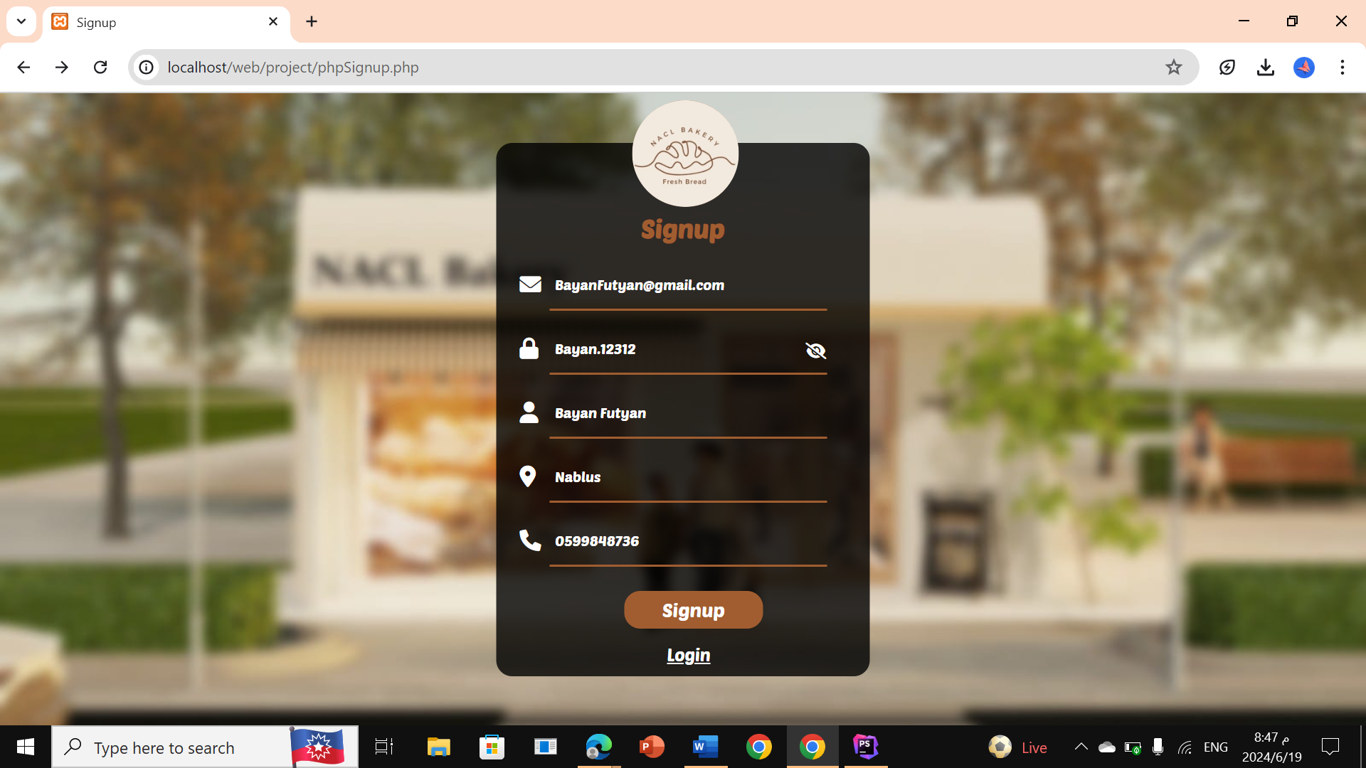

**show the password**

**User pages**

1. **Home page:**

- This page appears when user make log in.

- When the page starts loading, a text animation will appear.

- We include a picture from our bakery store .

- when click on go to shoping it will move user to shop page.

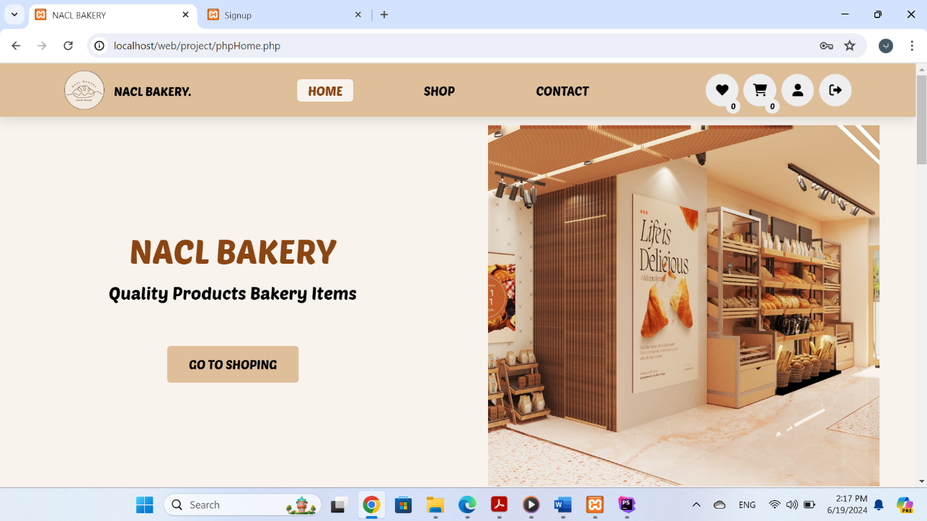

Four icons appear in the header:

Note: When the mouse is brought closer, it rotates 360 degrees:

1. Log out icon: When you click on it, you log out the current user and will go to login page .
2. Personal account icon: It displays the profile information of the current user, and there is an edit button .
3. Shopping cart icon: When you click on it, the products that the user has placed in his shopping cart appear and As shown in the picture, the number of products added to the cart is 0 .
4. Favorite products icon: When you click on it, the products that the user has placed in his favorite products section appear . the number of favorite products added to the cart is 0 .

**I will talk about them more extensively later.**

Our store offers four basic sections of baked goods. When you click on a specific sections , you will be taken to the shop page to view the products of the type you have selected.

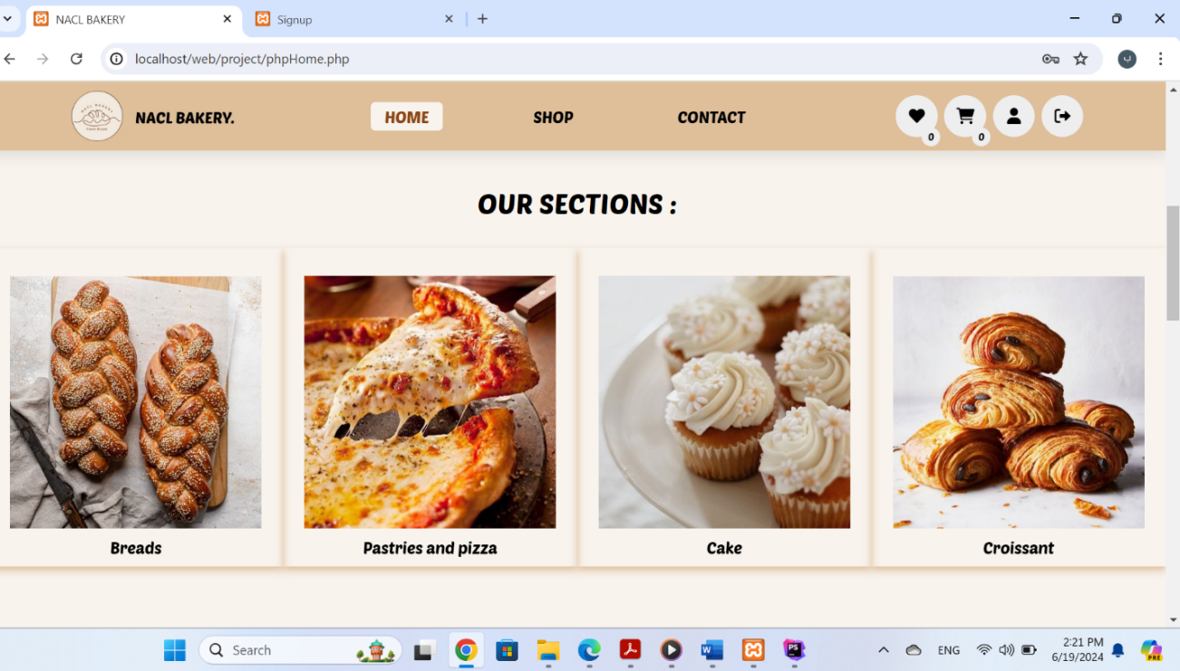

- For example if choose the first type ‘Bread’ :

We will talk about shop page in more detail later.

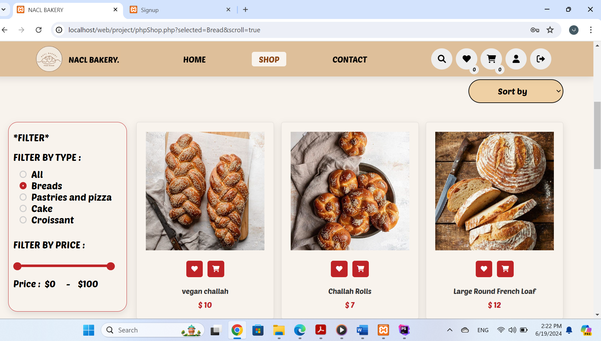

**Well, we will return to Home, here is the offers section :**

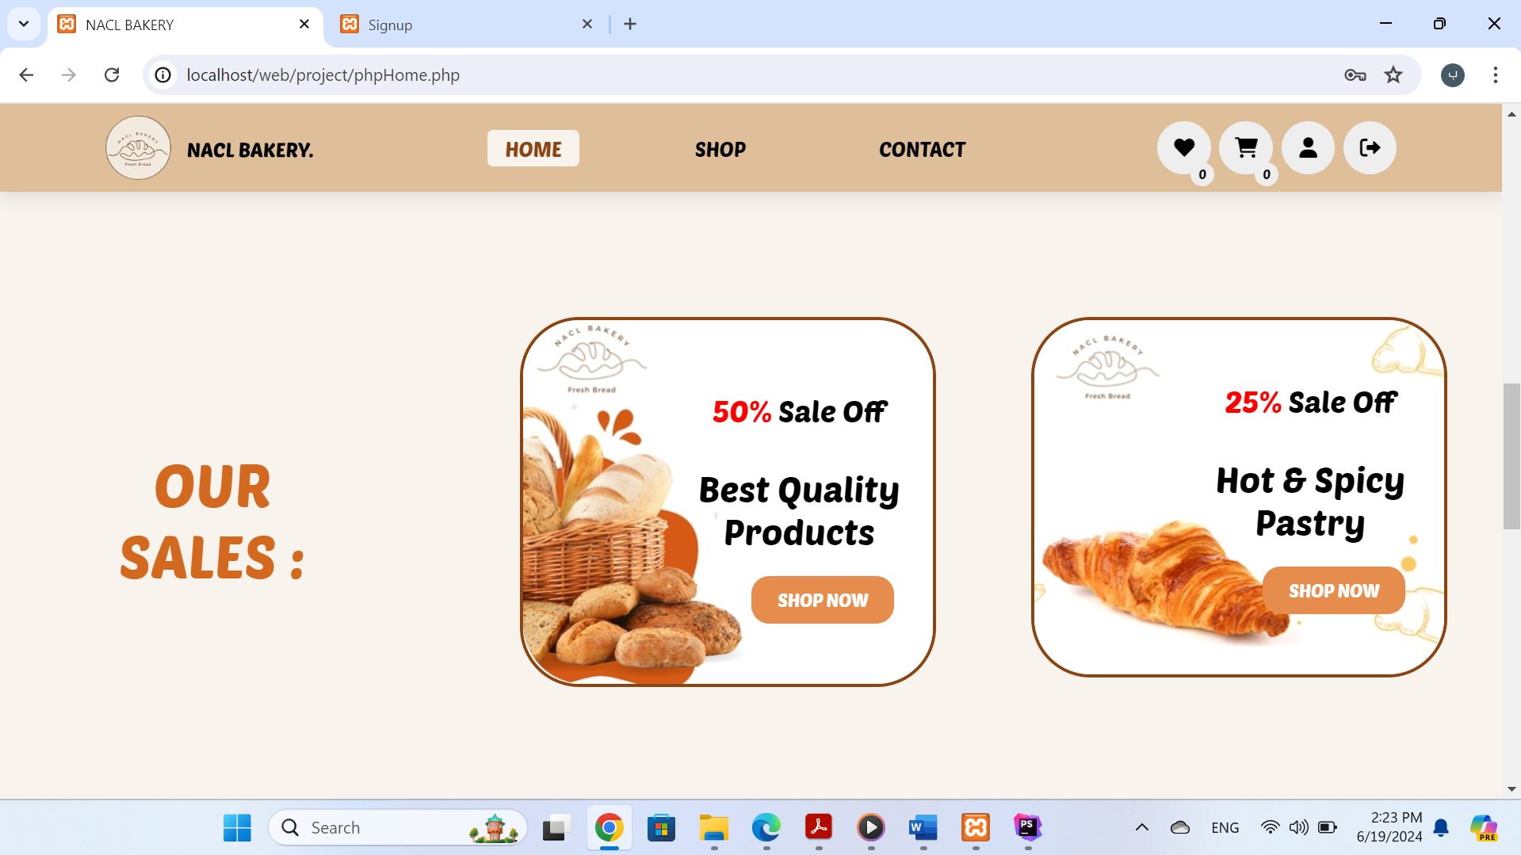

In the first image, when you click on Shop Now, you will be taken to the shopping page and display the products that have a 50% discount.

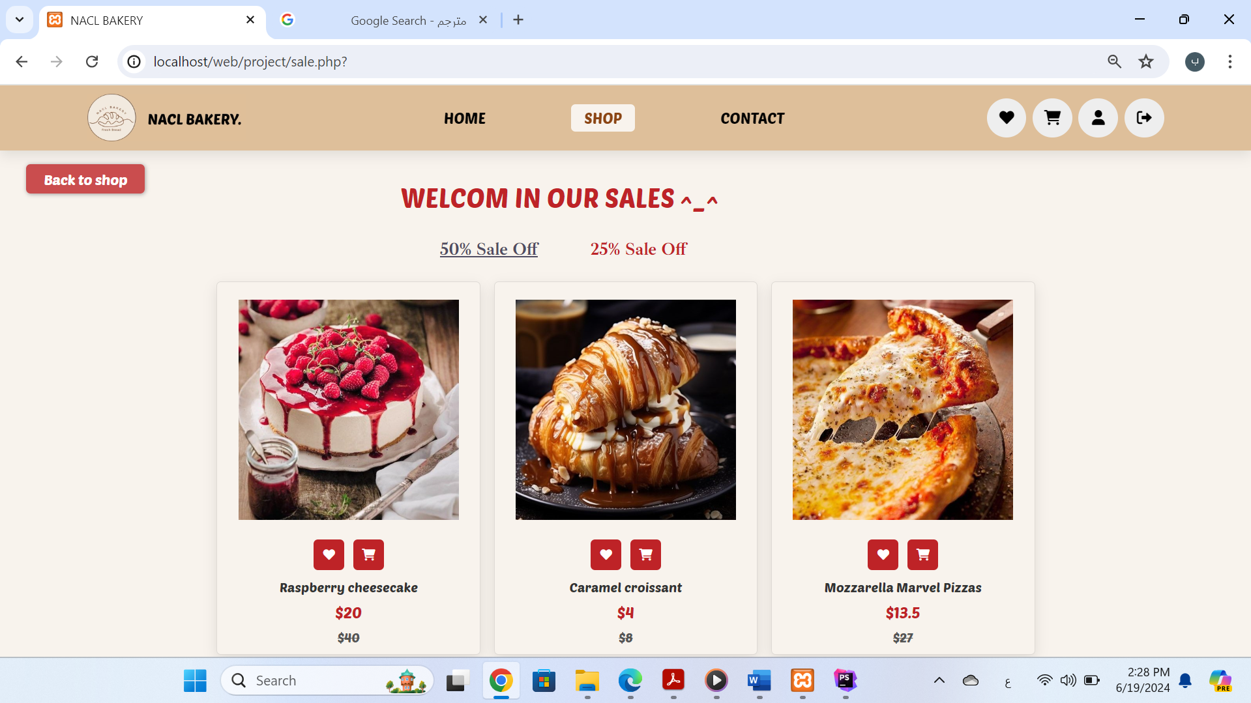

In the second image, when you click on Shop Now, you will be taken to the shopping page and display the products that have a 25% discount.

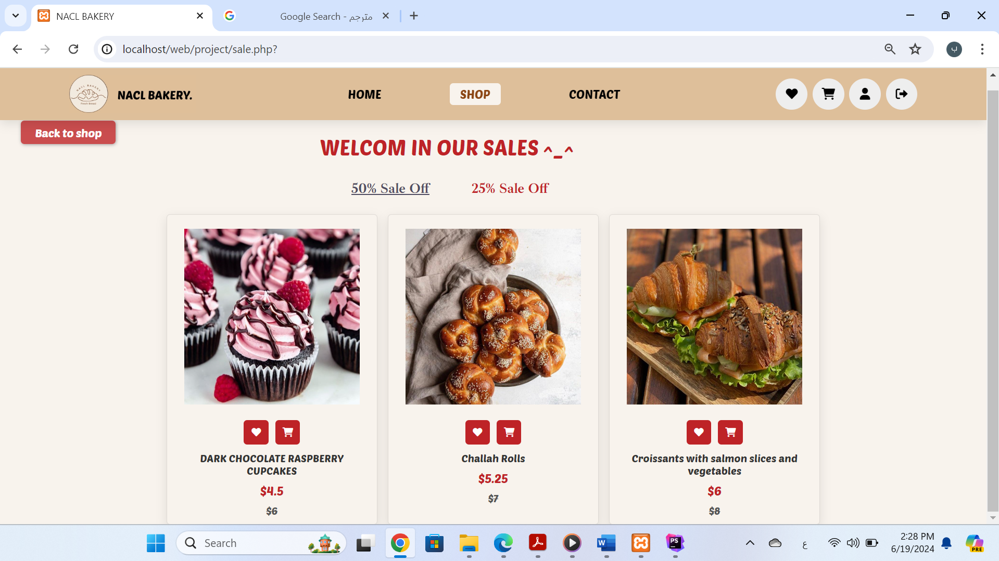

And next we will show our special products as shown in the pictures, the products will be displayed according to the tab that the user chooses(our features or best sellers or new items).

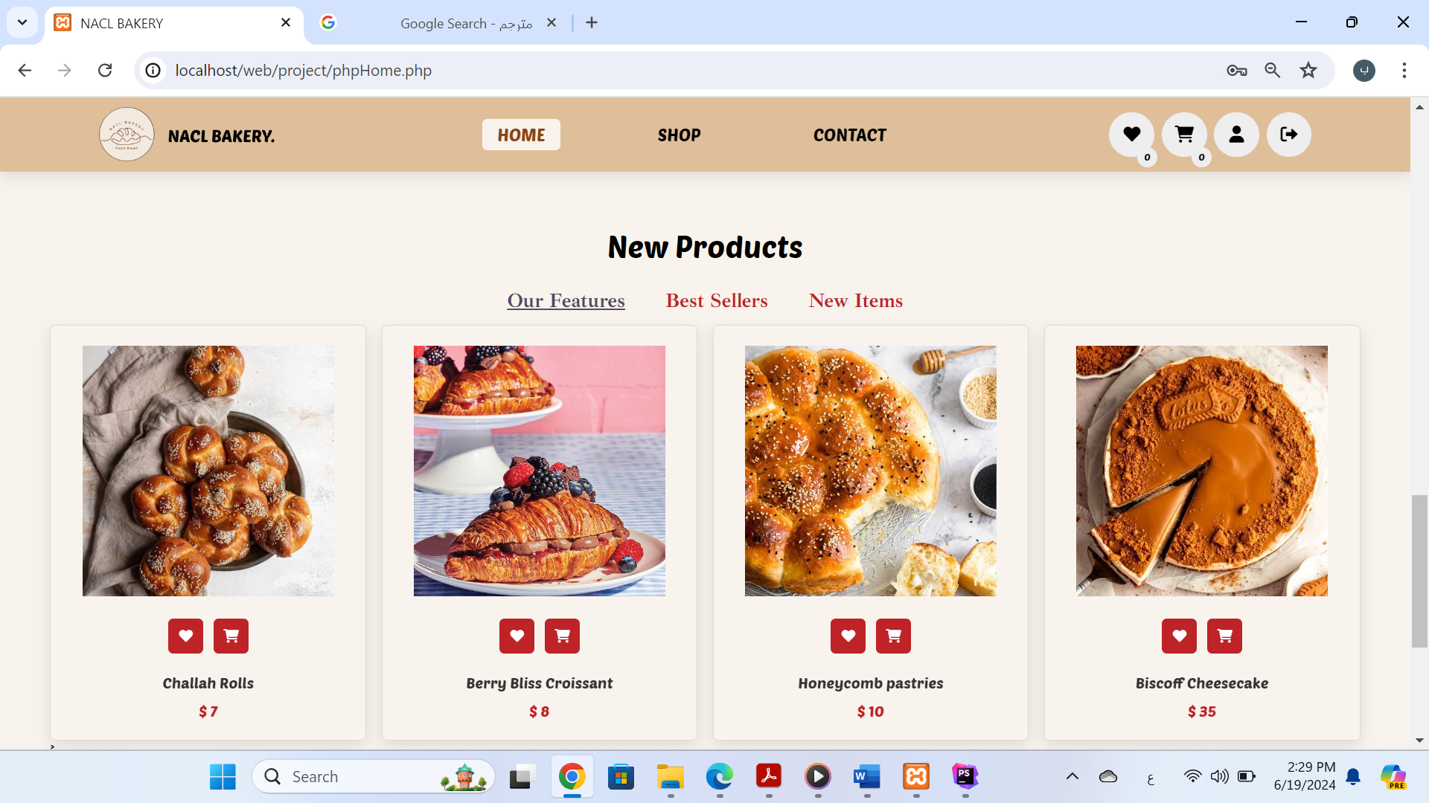

(1)

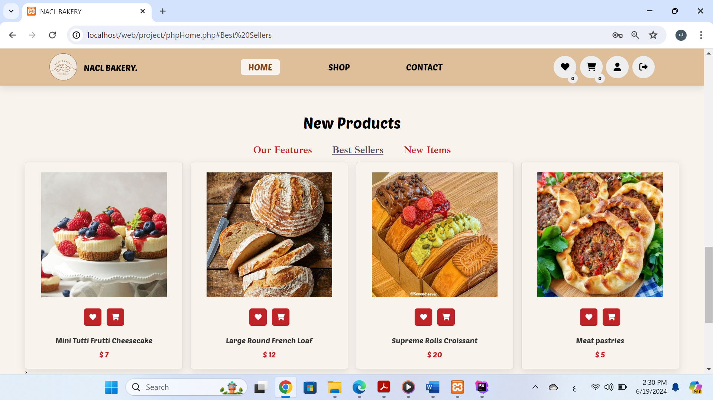

(2)

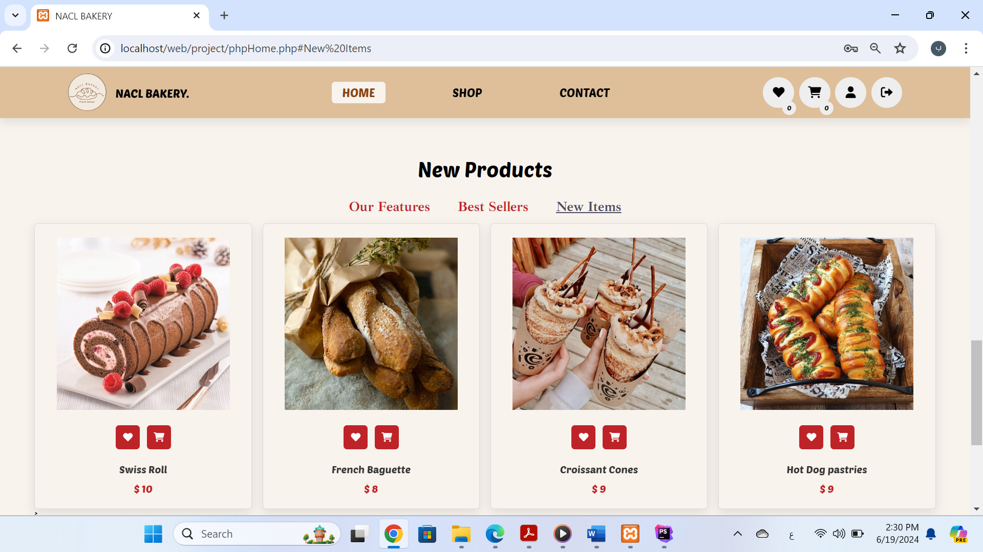

(3)

-footer

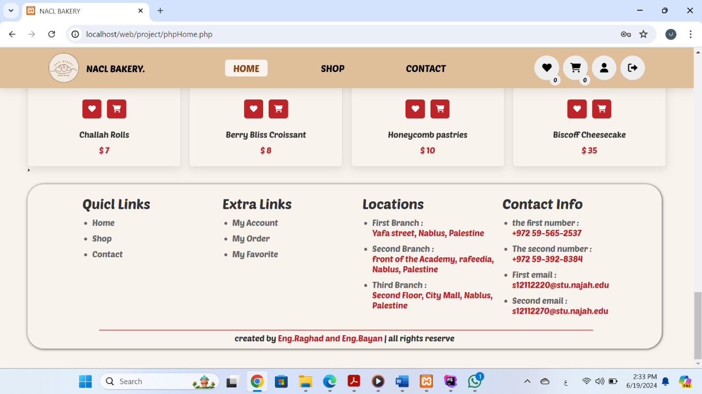

2. **Shop page:**

- When the page starts loading, a text animation will appear ,and behainde the text there is a picture from our bakery store .

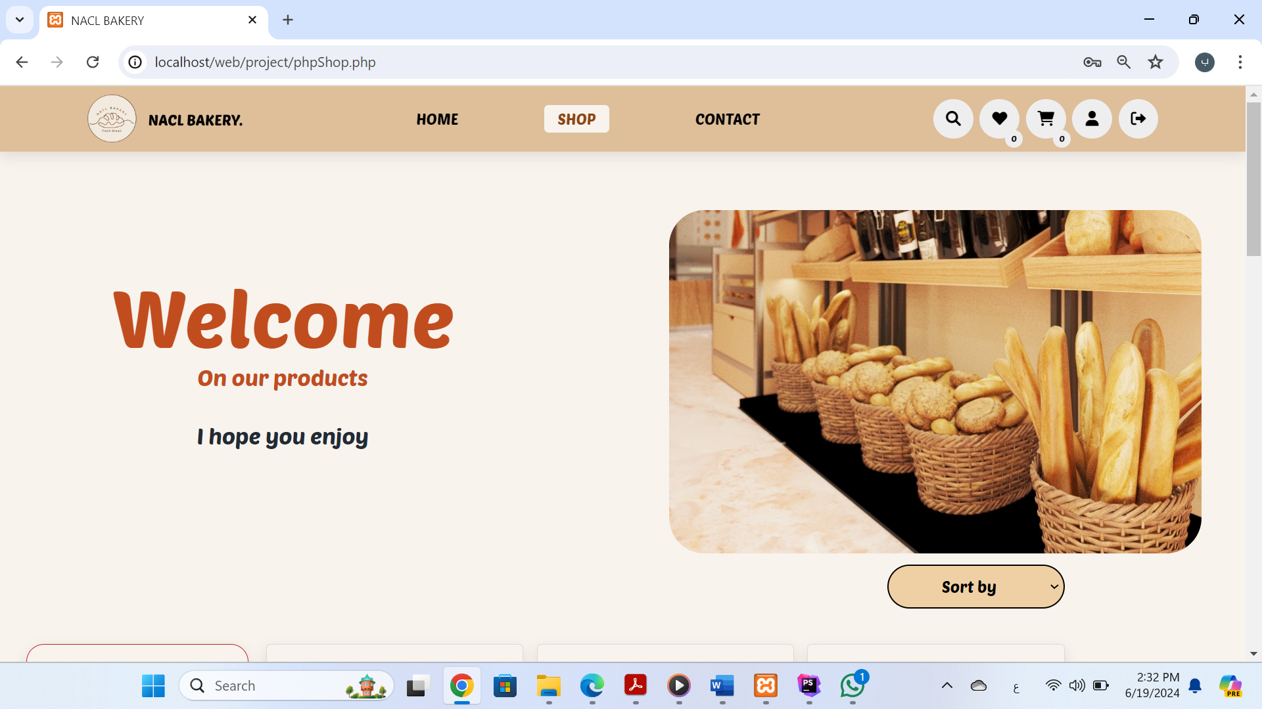

- We include 39 products ( 12 cake , 9 bread , 9 pastries , 9 croissant ) you can move between sections using the filter in left of products, The filter appears when we access the products , and still fixed until end the products ,These pictures show some of the products that are displayed when you choose all.

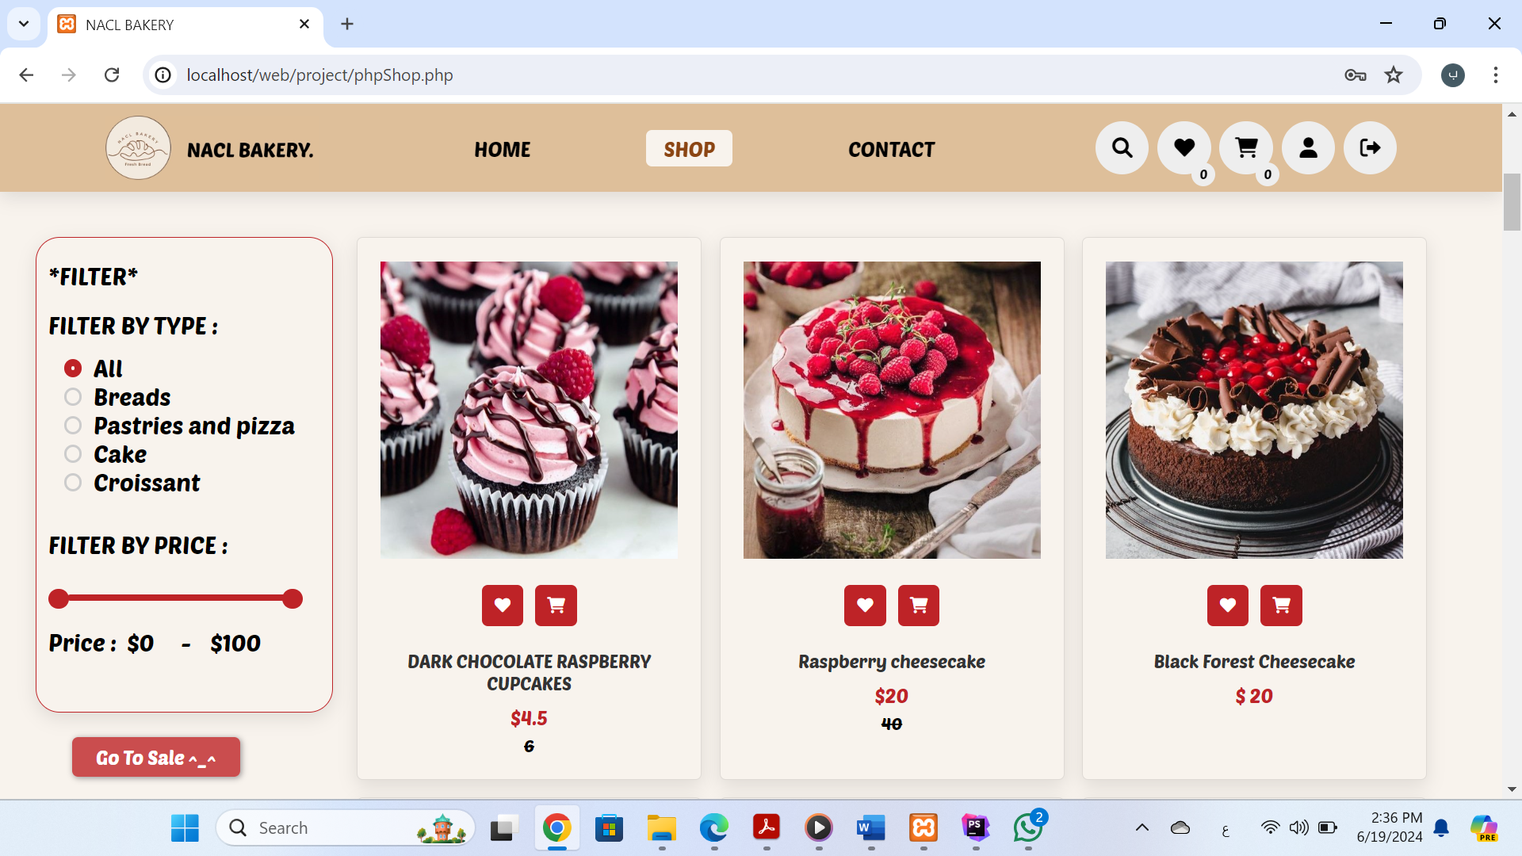

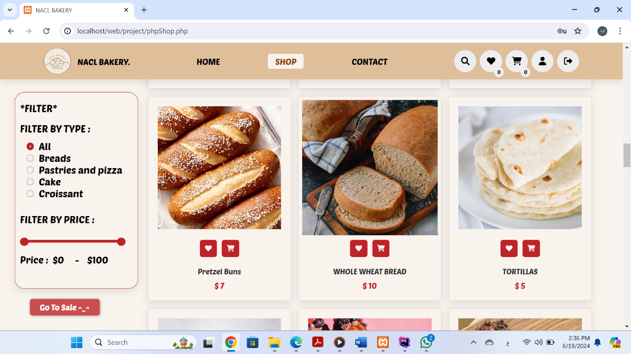

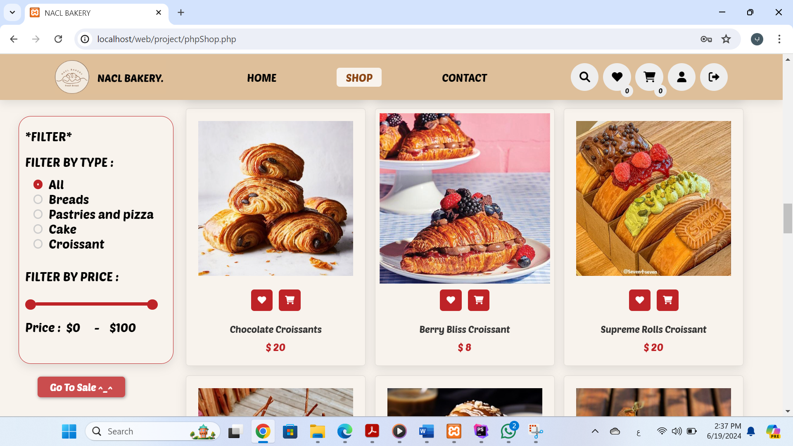

-This image shows some of the products that are displayed when you select Breads.

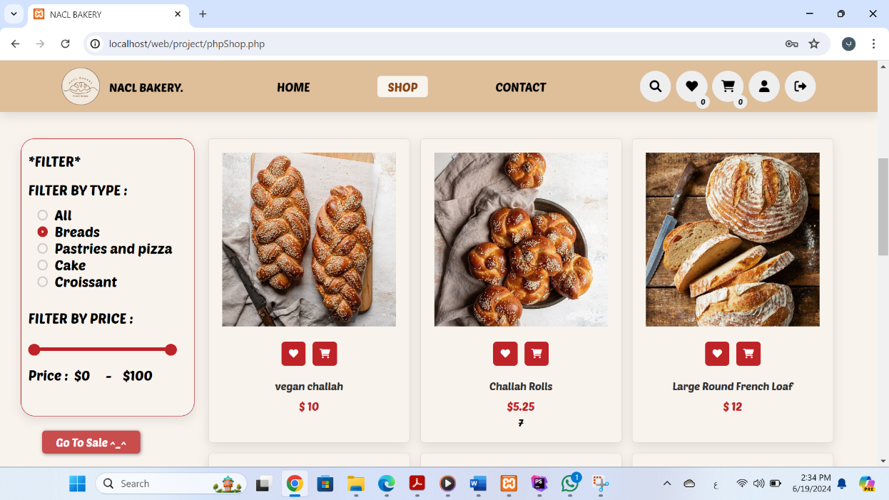

-This image shows some of the products that are displayed when you select Pastries and pizza.

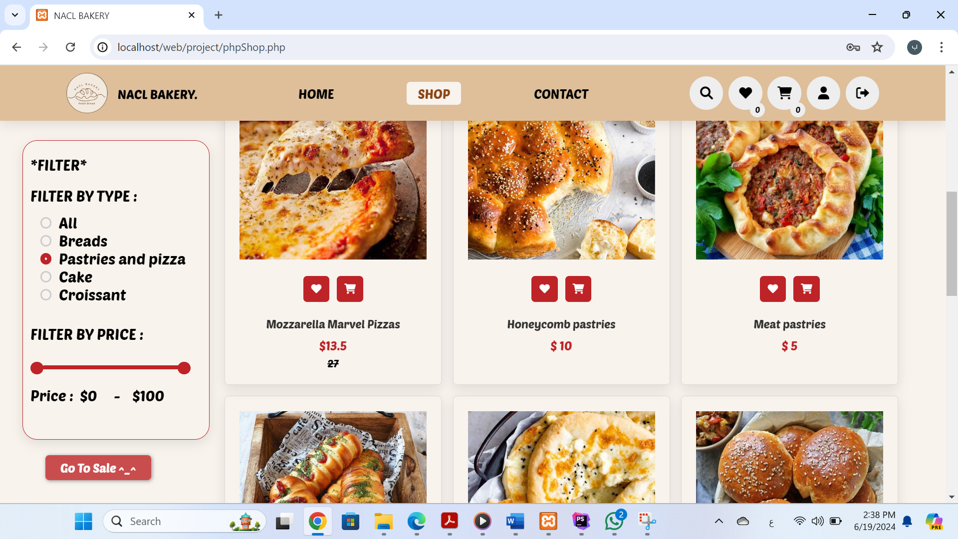

-This image shows some of the products that are displayed when you select Cack.

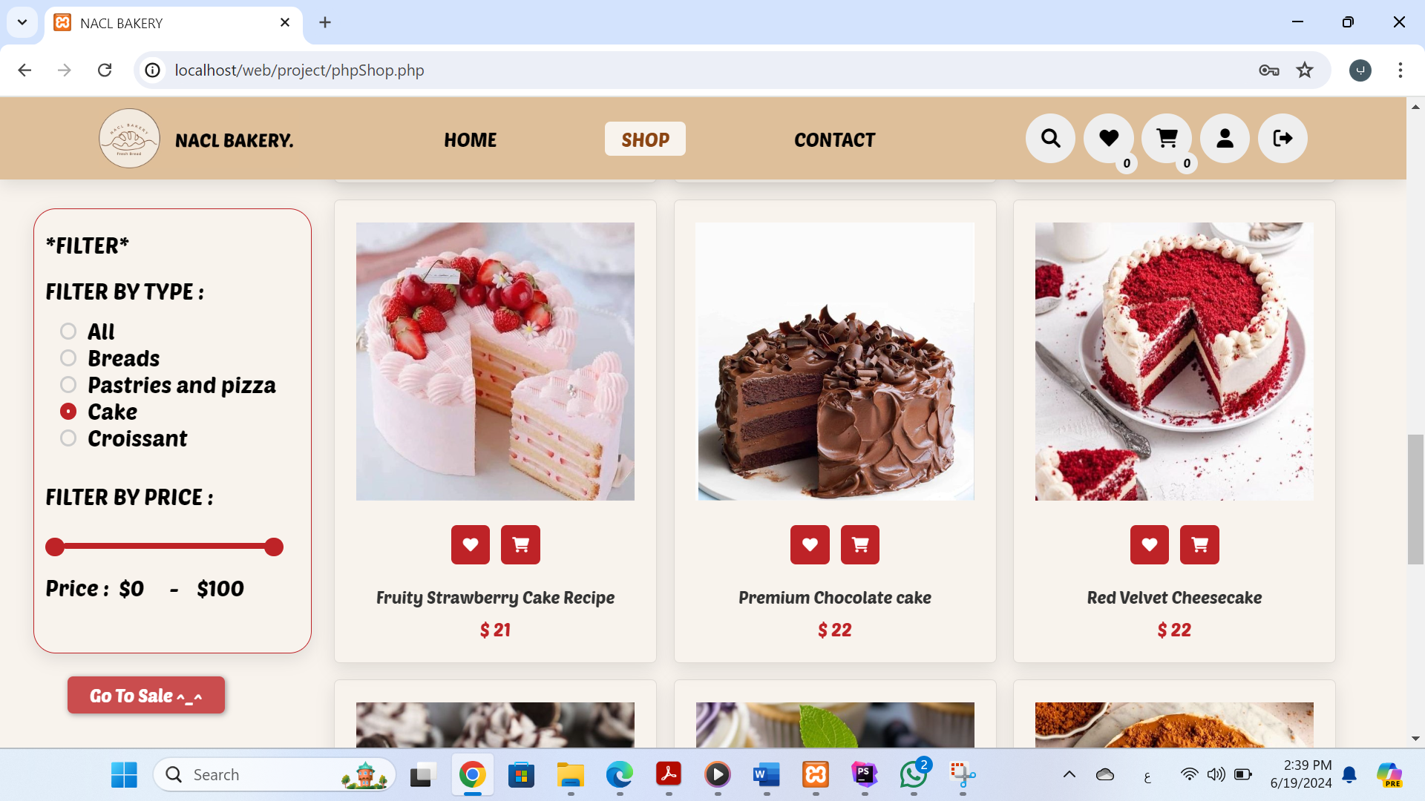

-This image shows some of the products that are displayed when you select Croissant.

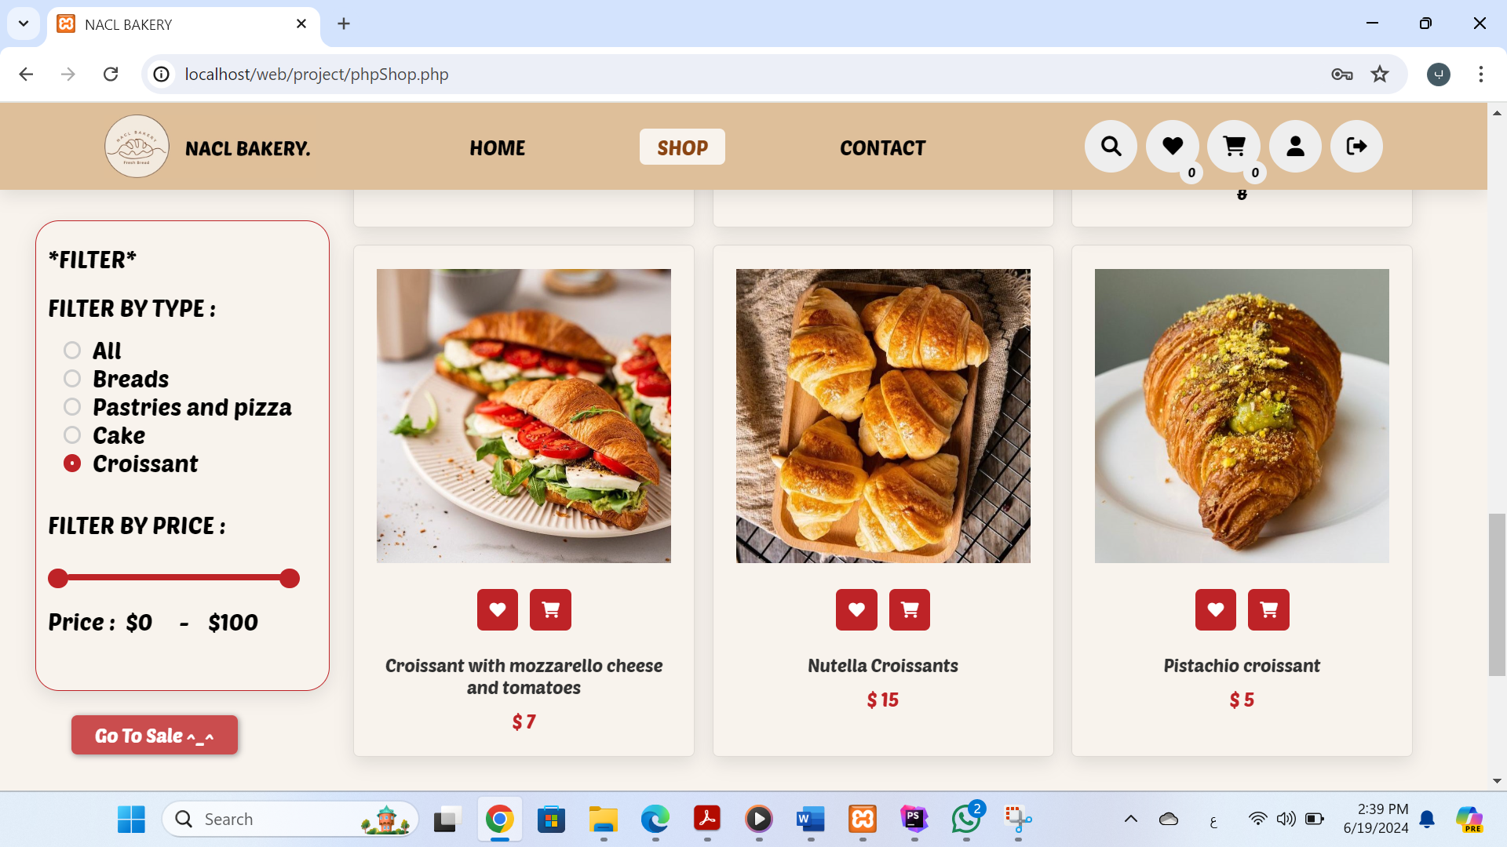

-Now when you click on Sort By, a drop-down list will appear As in the picture

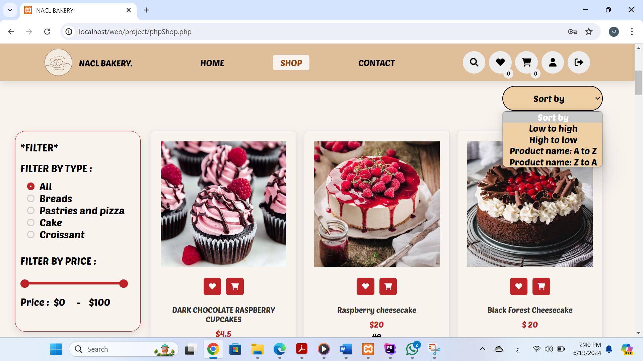

- I will attach some pictures that show how the sort by

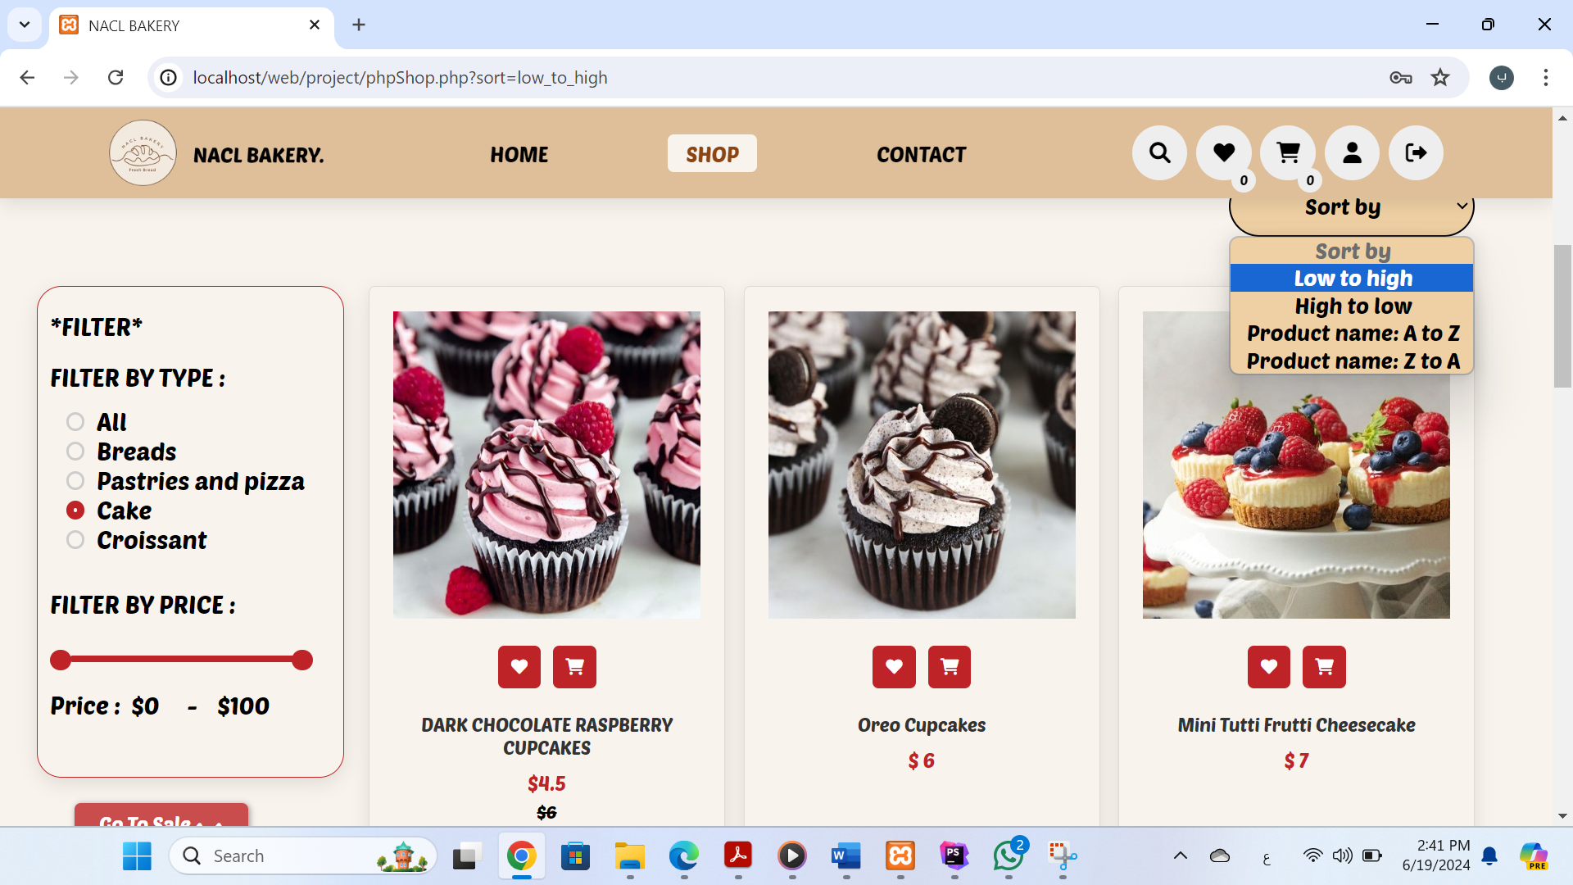

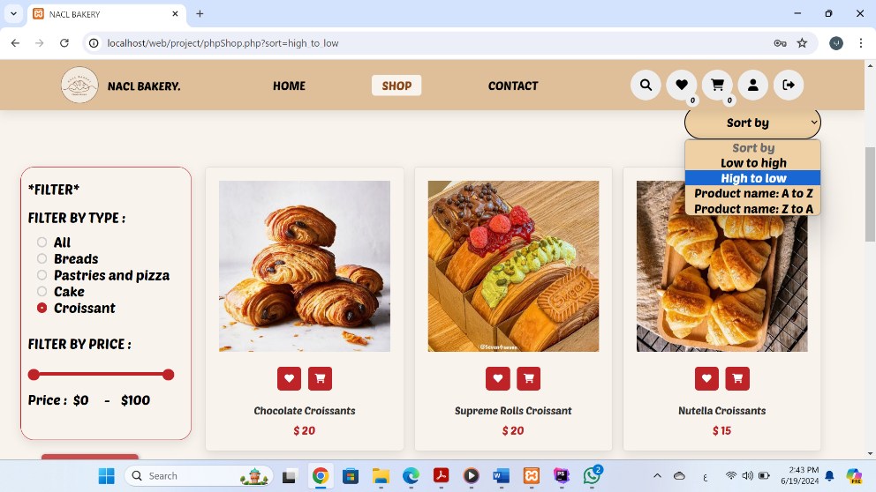

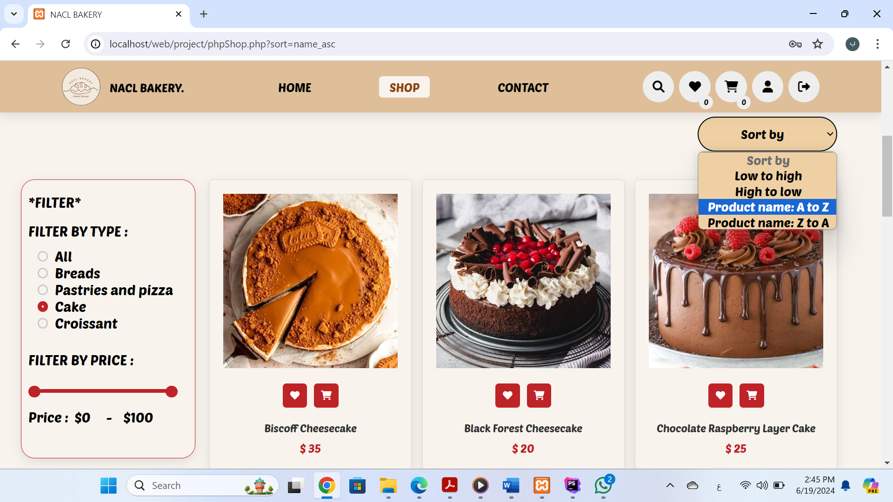

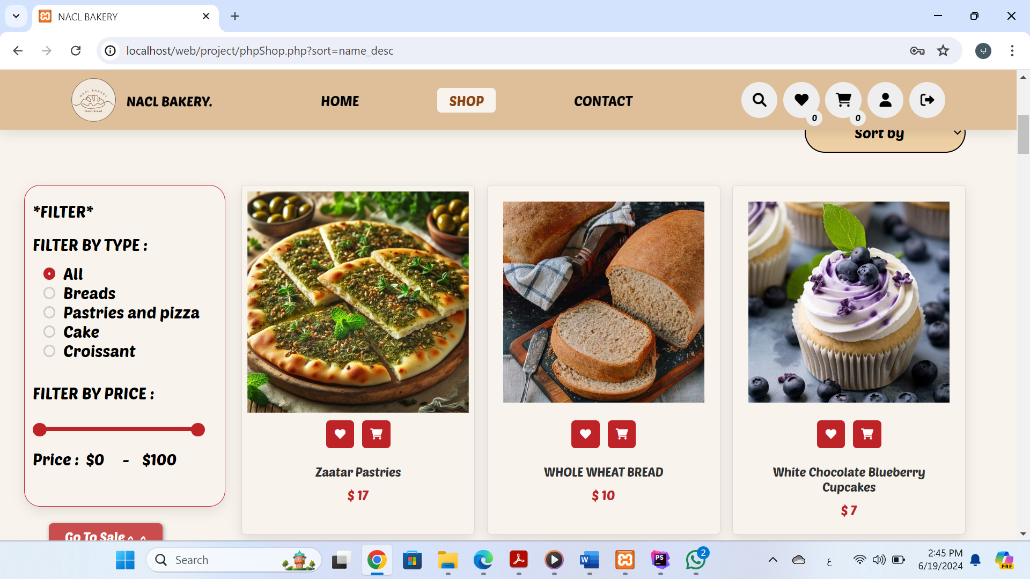

- Here you can select the price range of products using filtering by price:

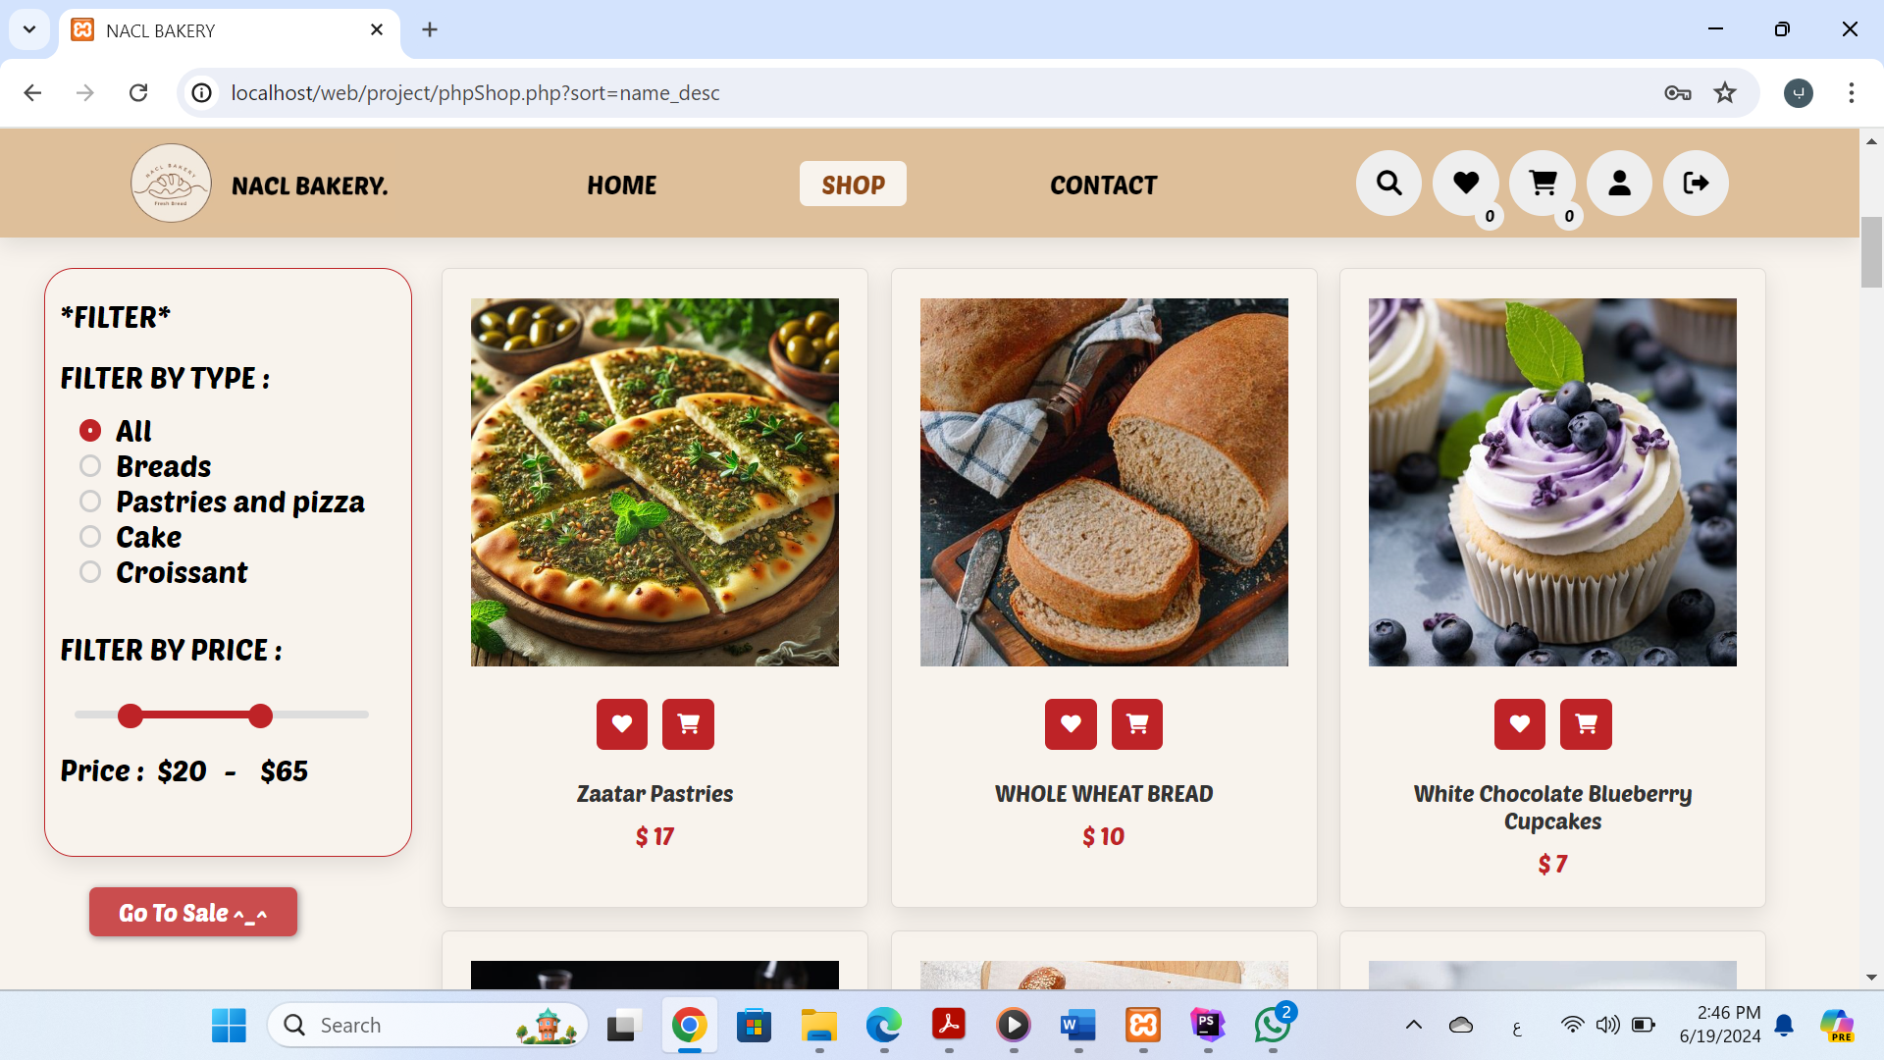

Now when click on:

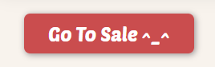

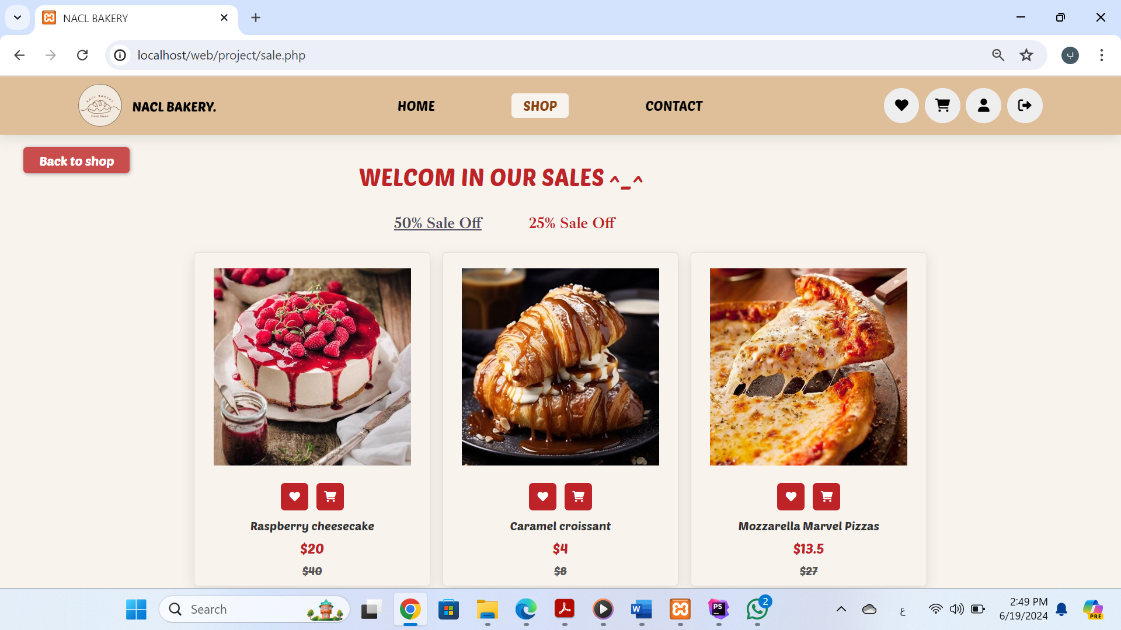

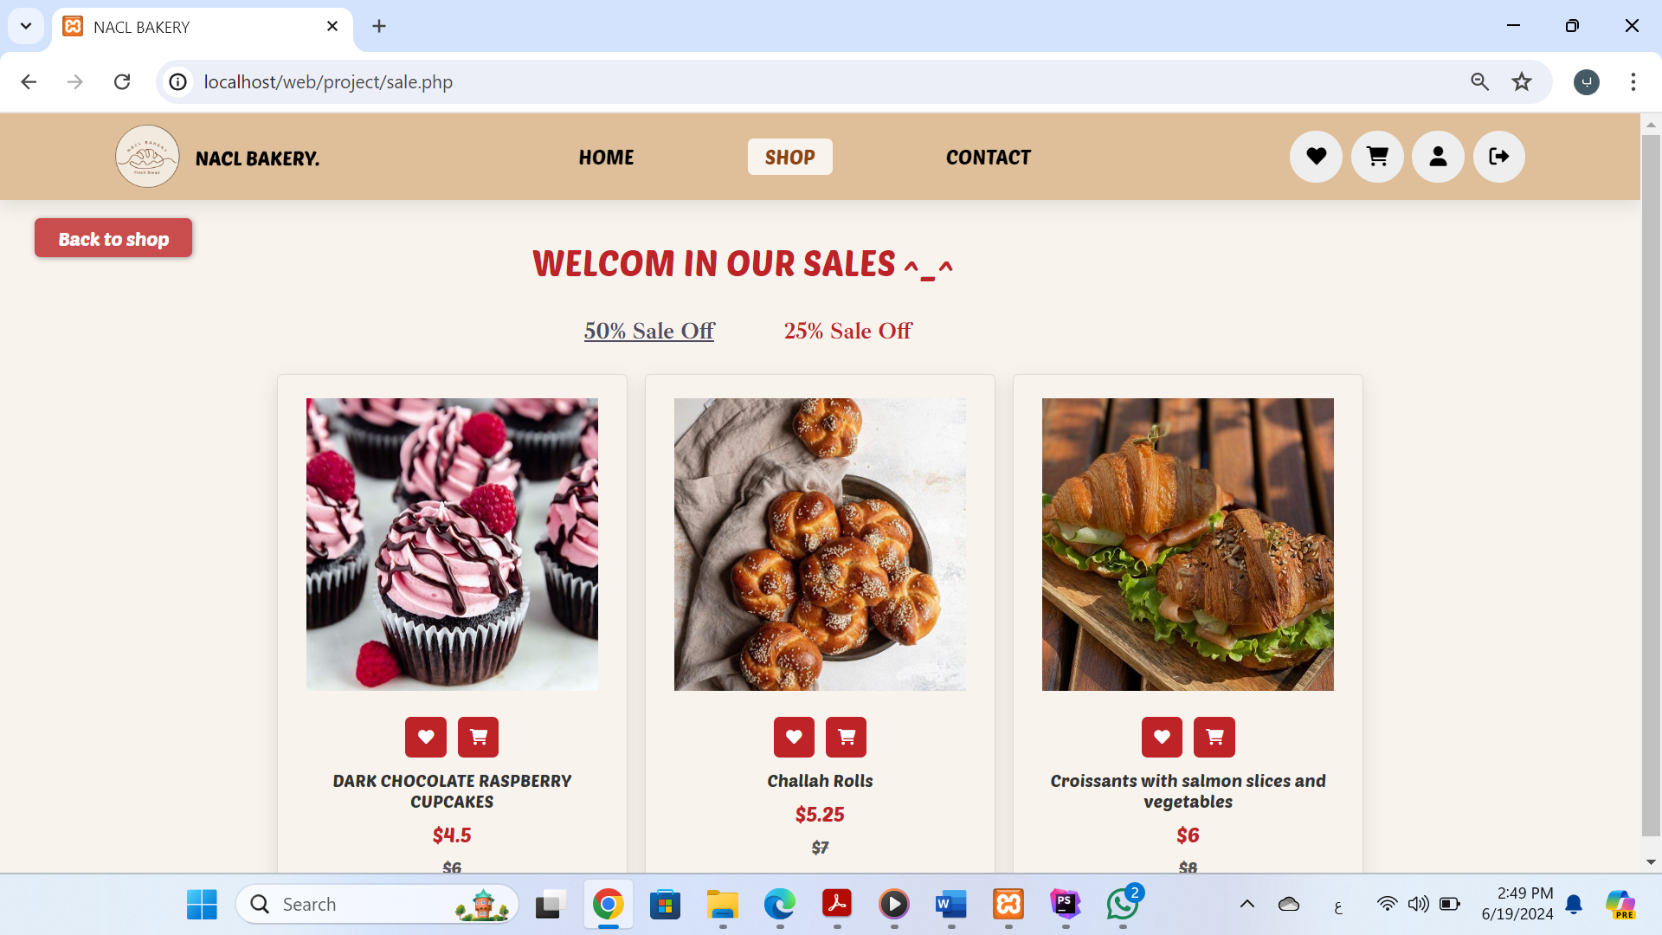

-Now in this part I will explain the icons

Five icons appear in the header:

Note: When the mouse is brought closer, it rotates 360 degrees:

a .Log out icon: When you click on it, you log out the current user and a login page appears .

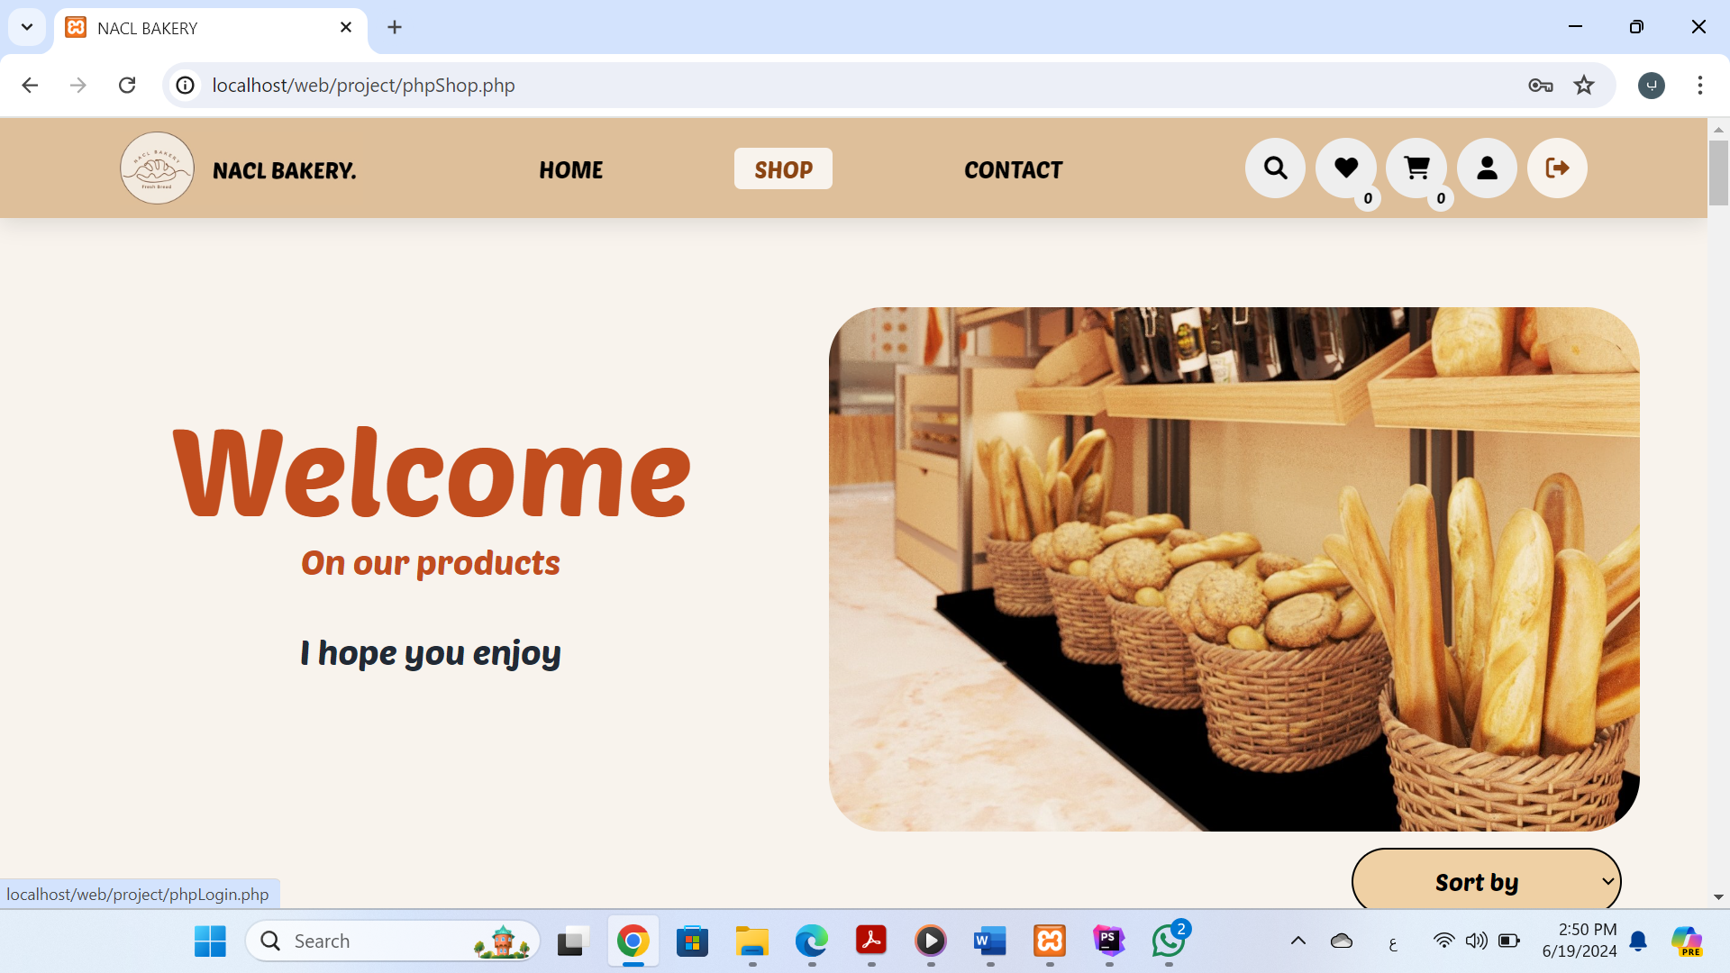

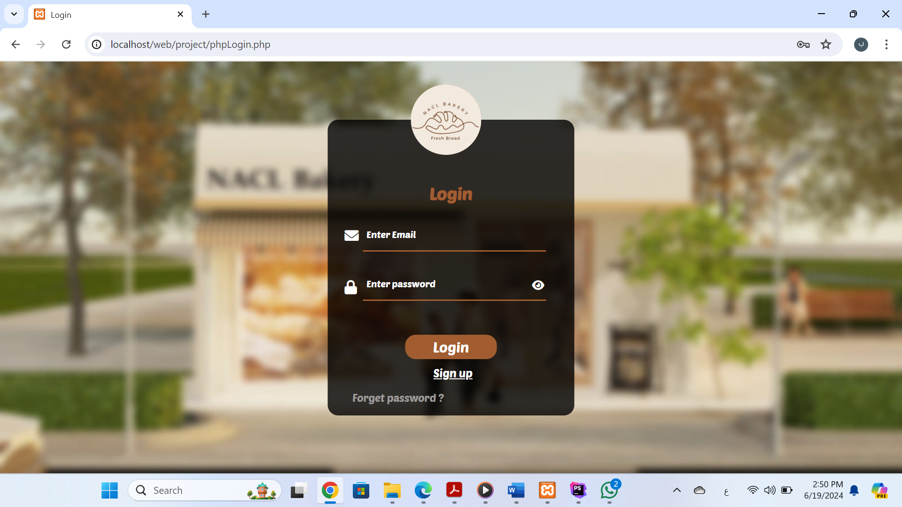

b .Personal account icon: It displays the profile information of the current user, and there is an edit button .

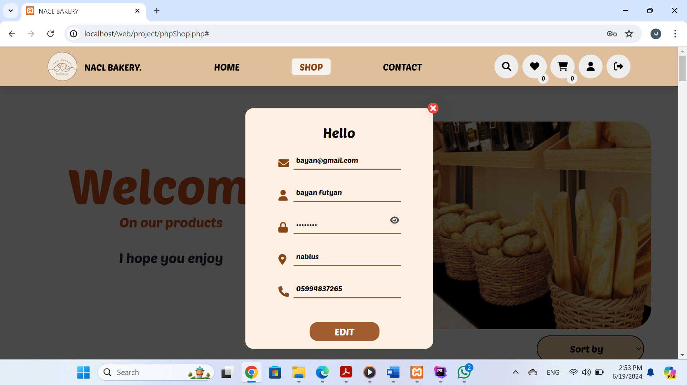

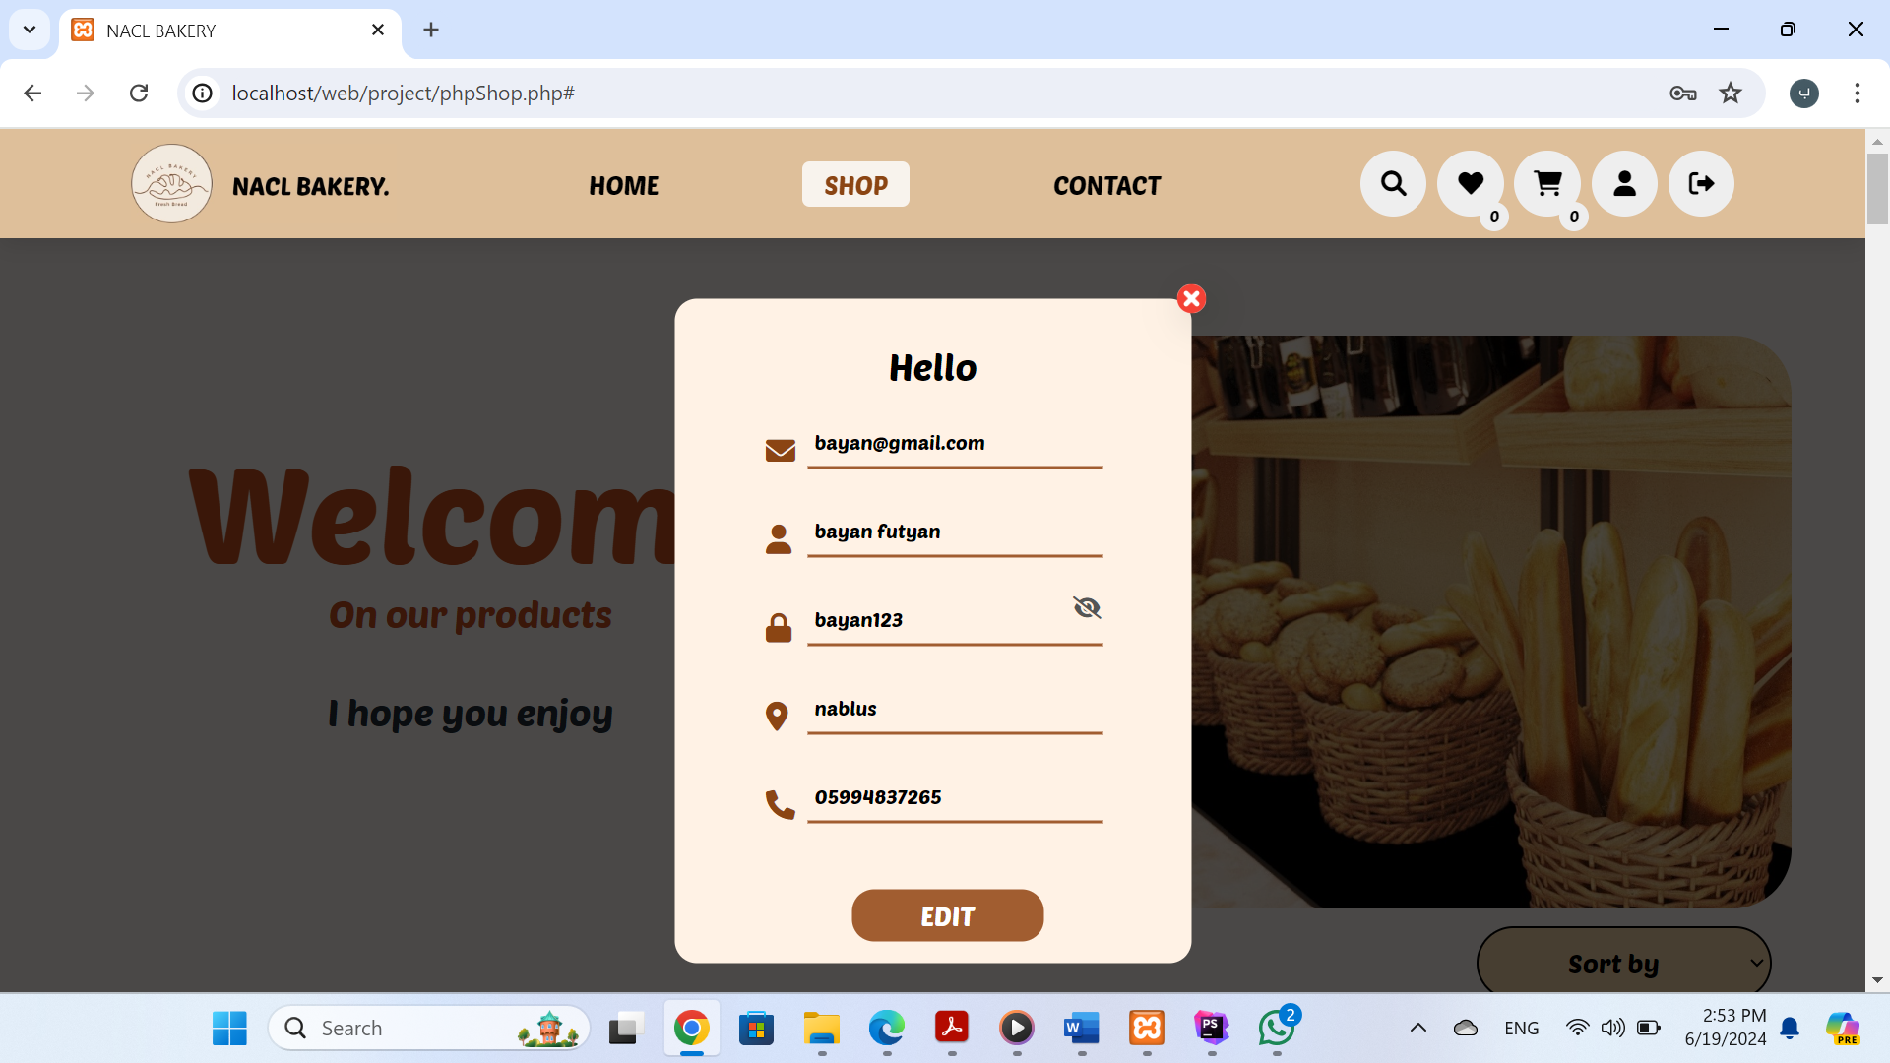

show the password

-A user can modify any information, then click on modify, and the modification will move to the data base

c .Shopping cart icon: When you click on it, the products that the user has placed in his shopping cart appear and As shown in the picture, the number of products added to the cart is 0 .

-Now I will add some products to the shopping cart by clicking on the cart icon located below the product, When you move the mouse closer, the cart icon will turn blue as shown in the picture

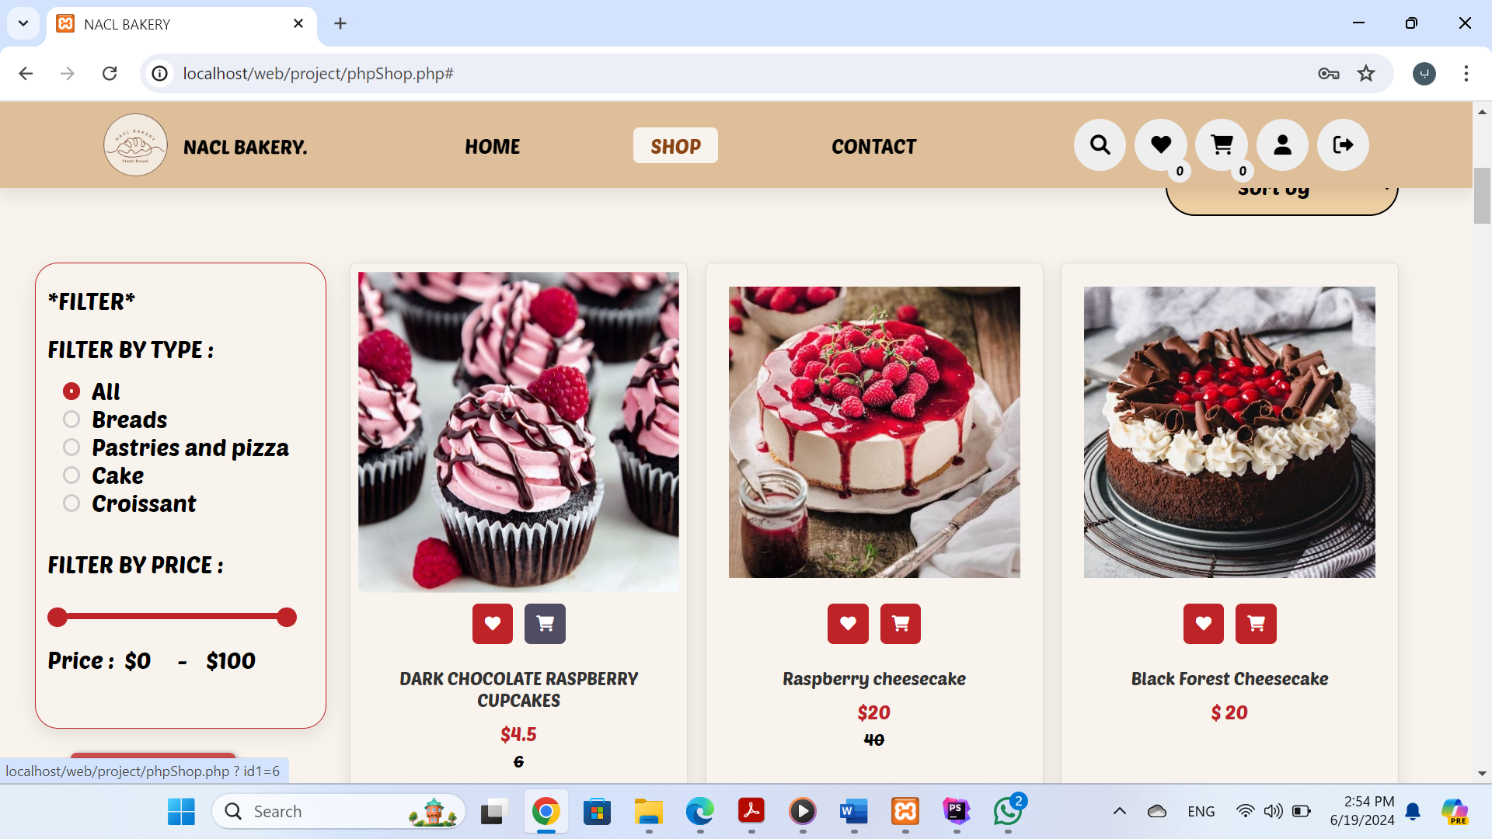

-As shown in the picture, the number of products added to the cart equals 1 and the product appears in the shopping cart, Naturally, if another user is logged in, the logged in user's shopping cart products will appear

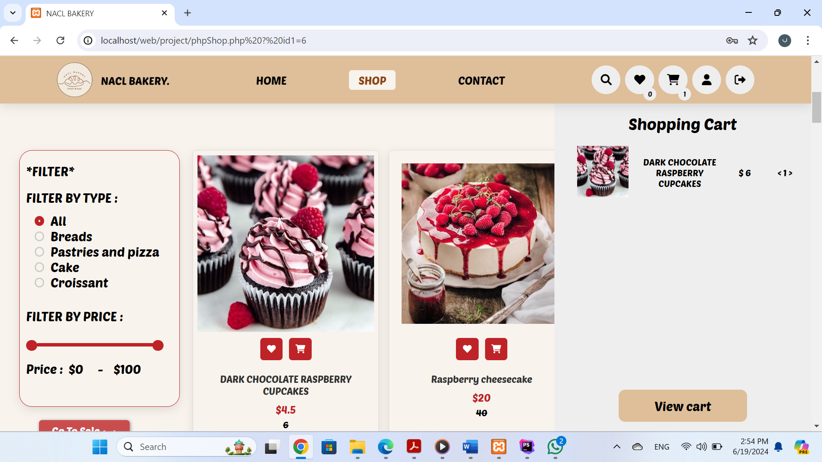

-A scroll will appear when the number of products in the shopping cart increases

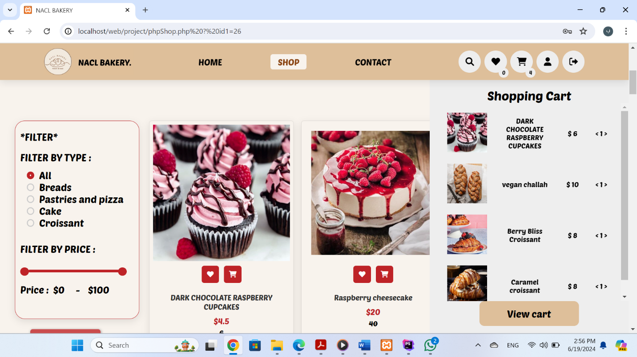

-When you click on View Shopping Cart, the Shopping Cart page will appear

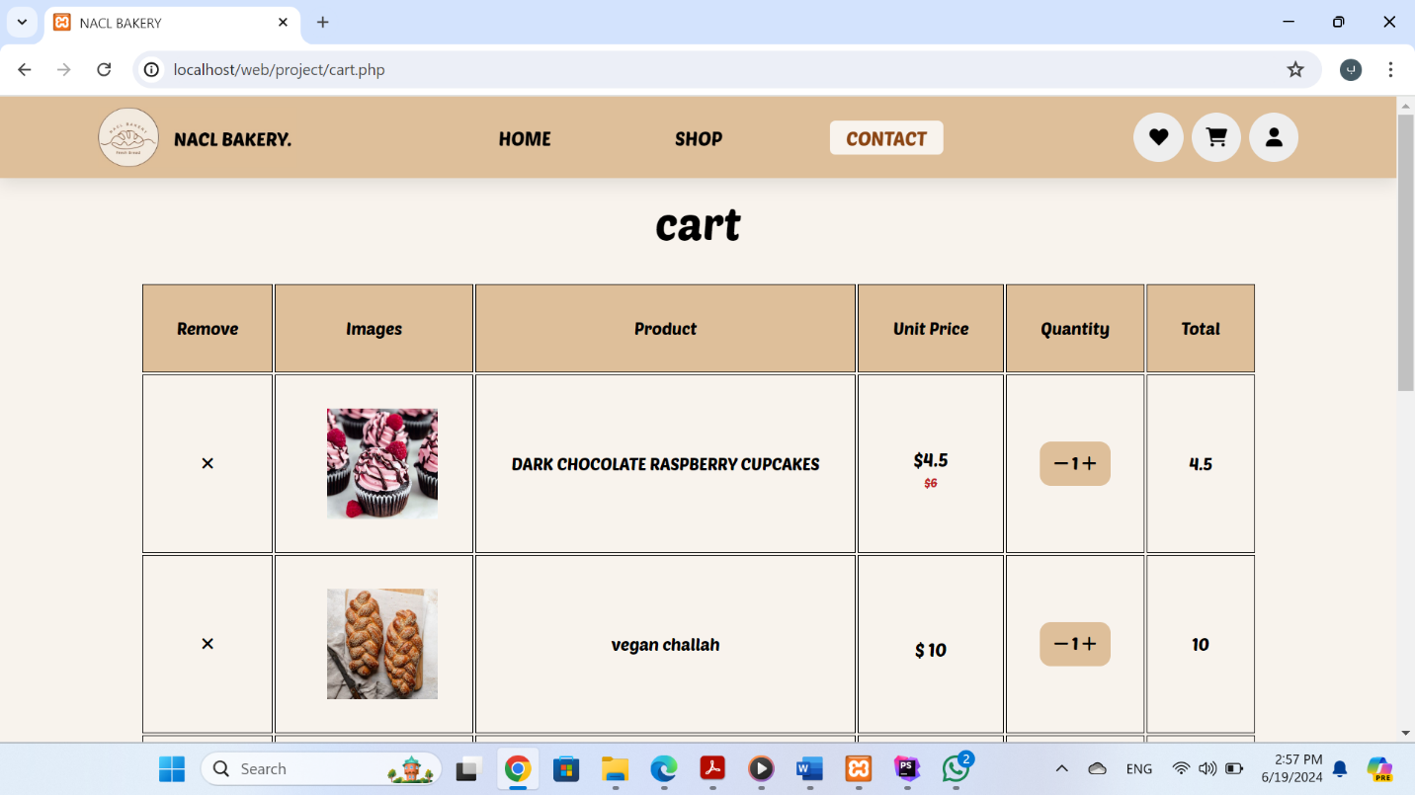

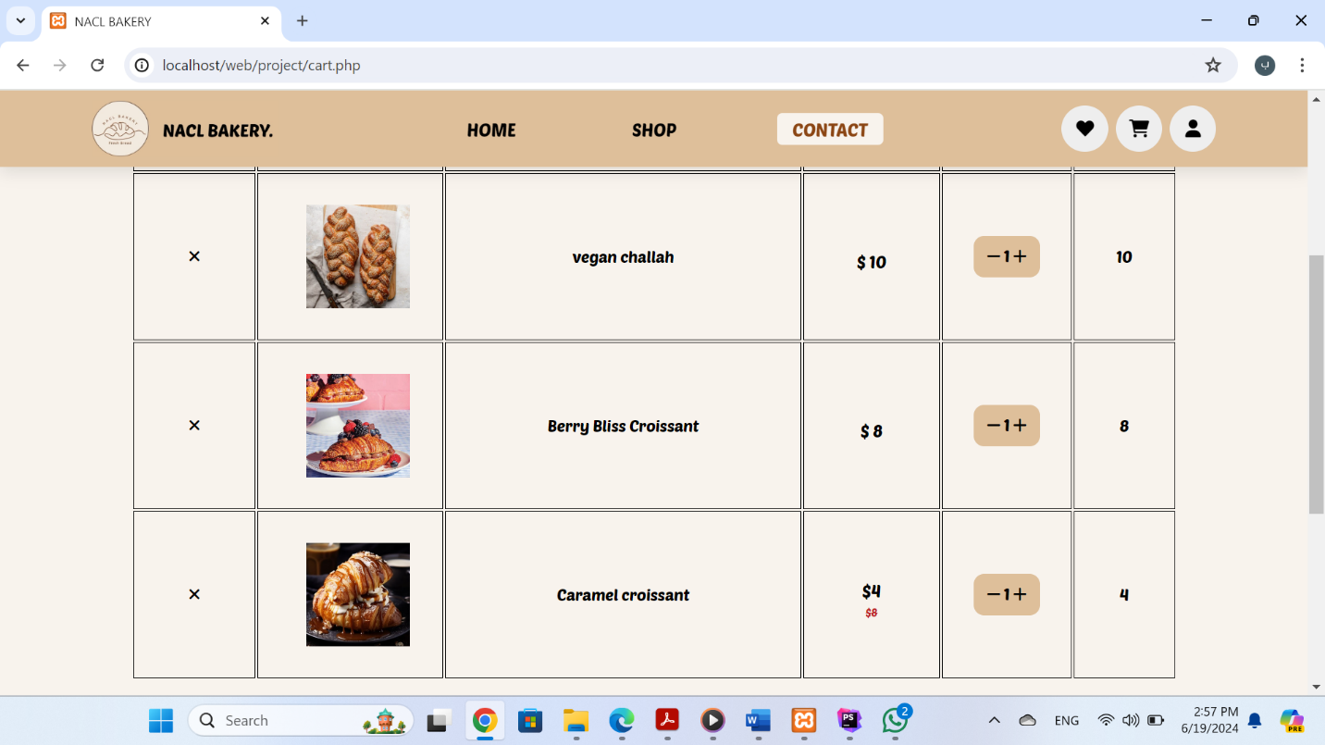

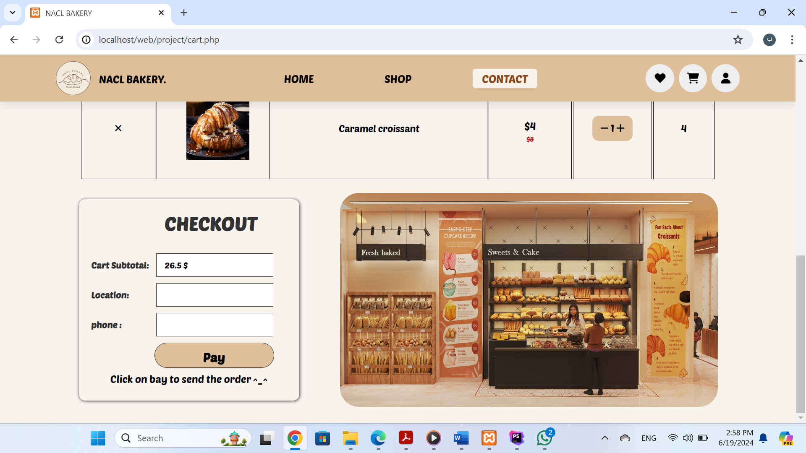

- When you press plus, the number of the product will increase and the price will be calculated, and There is an x ​​button that, when pressed, removes the product from the basket

- When filling out the data and click on pay :

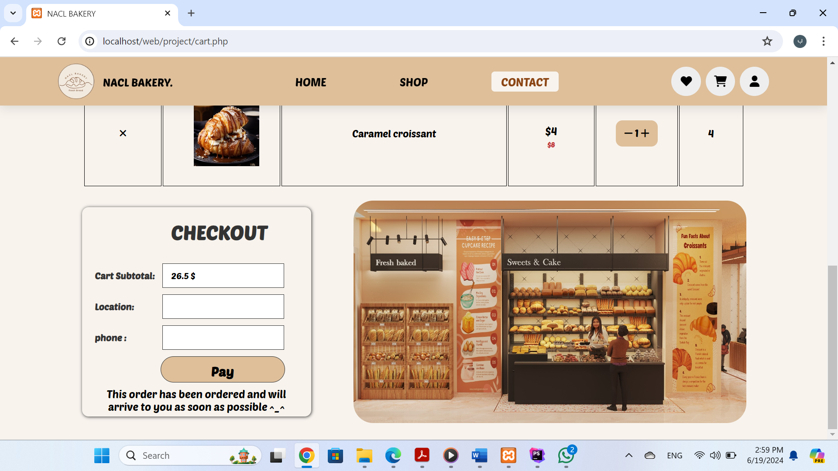

- When you receive the order through the admin (I will explain this later, the cart will be empty, and the total price will be empty.

1. Favorite products icon: When you click on it, the products that the user has placed in his favorite products section appear . the number of favorite products added to the cart is 0 .

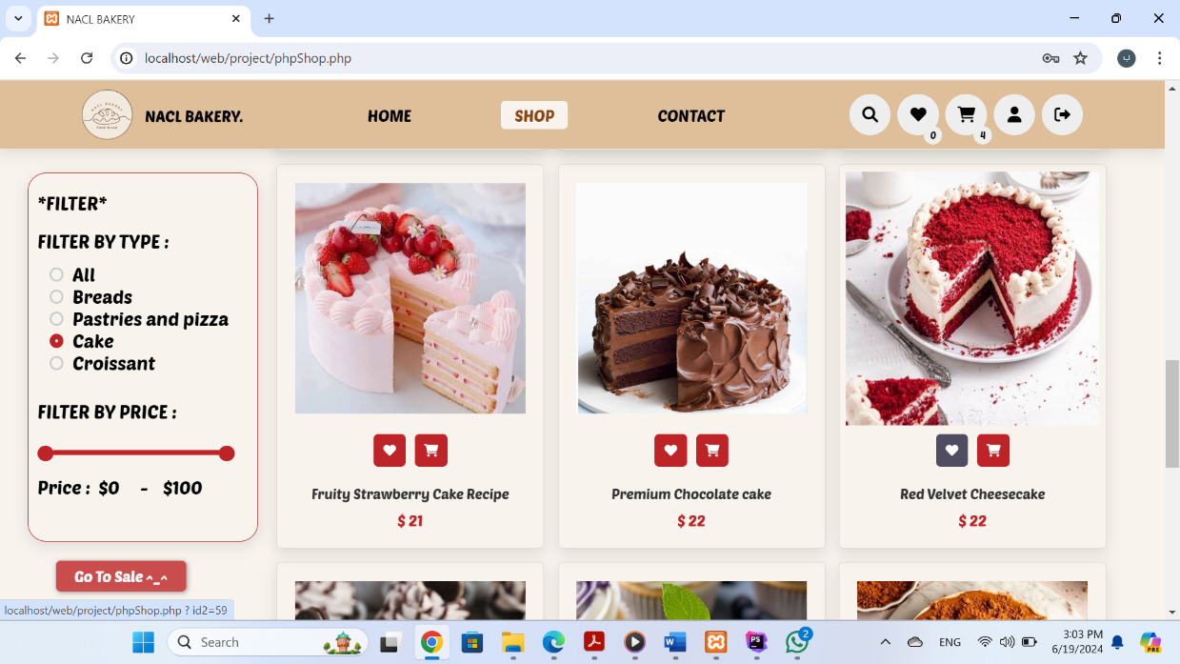

-I have added 3 products to my favorites, as the number appears above

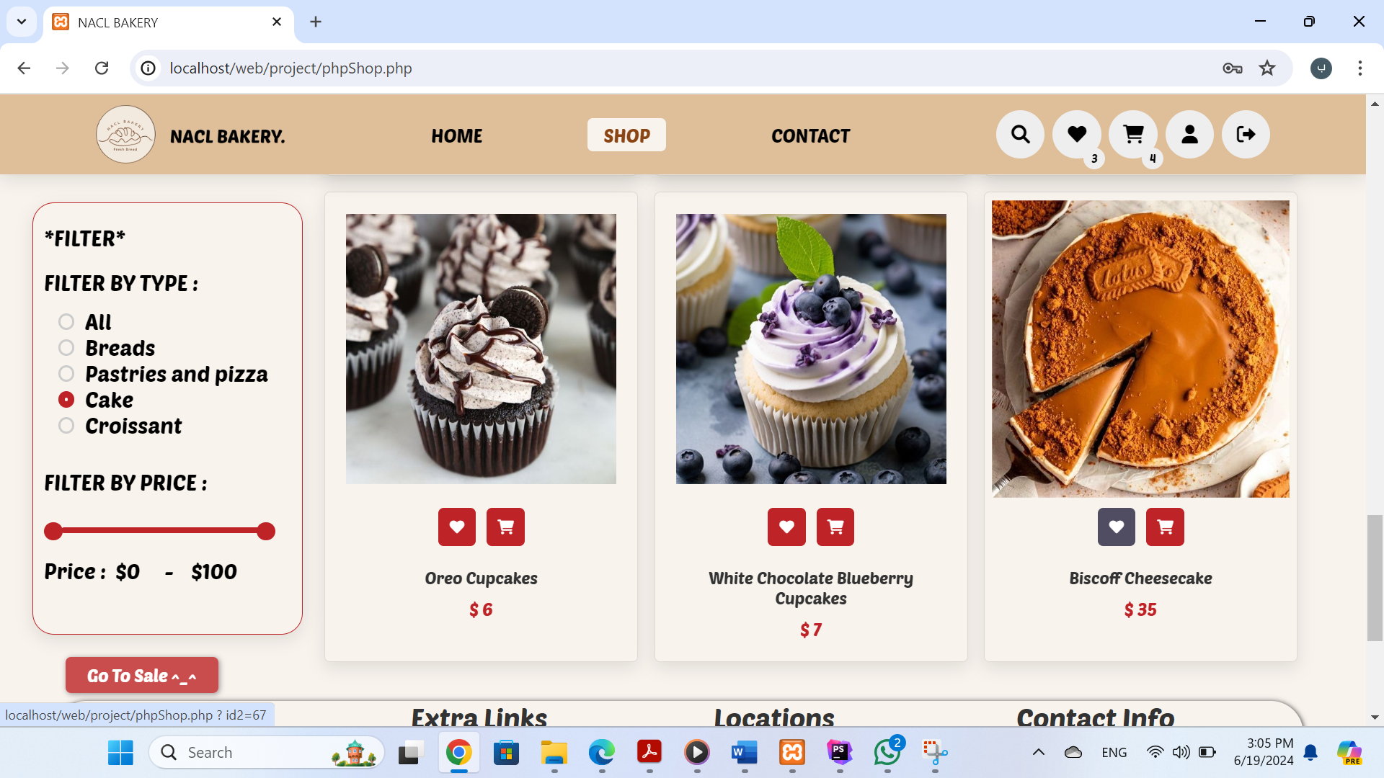

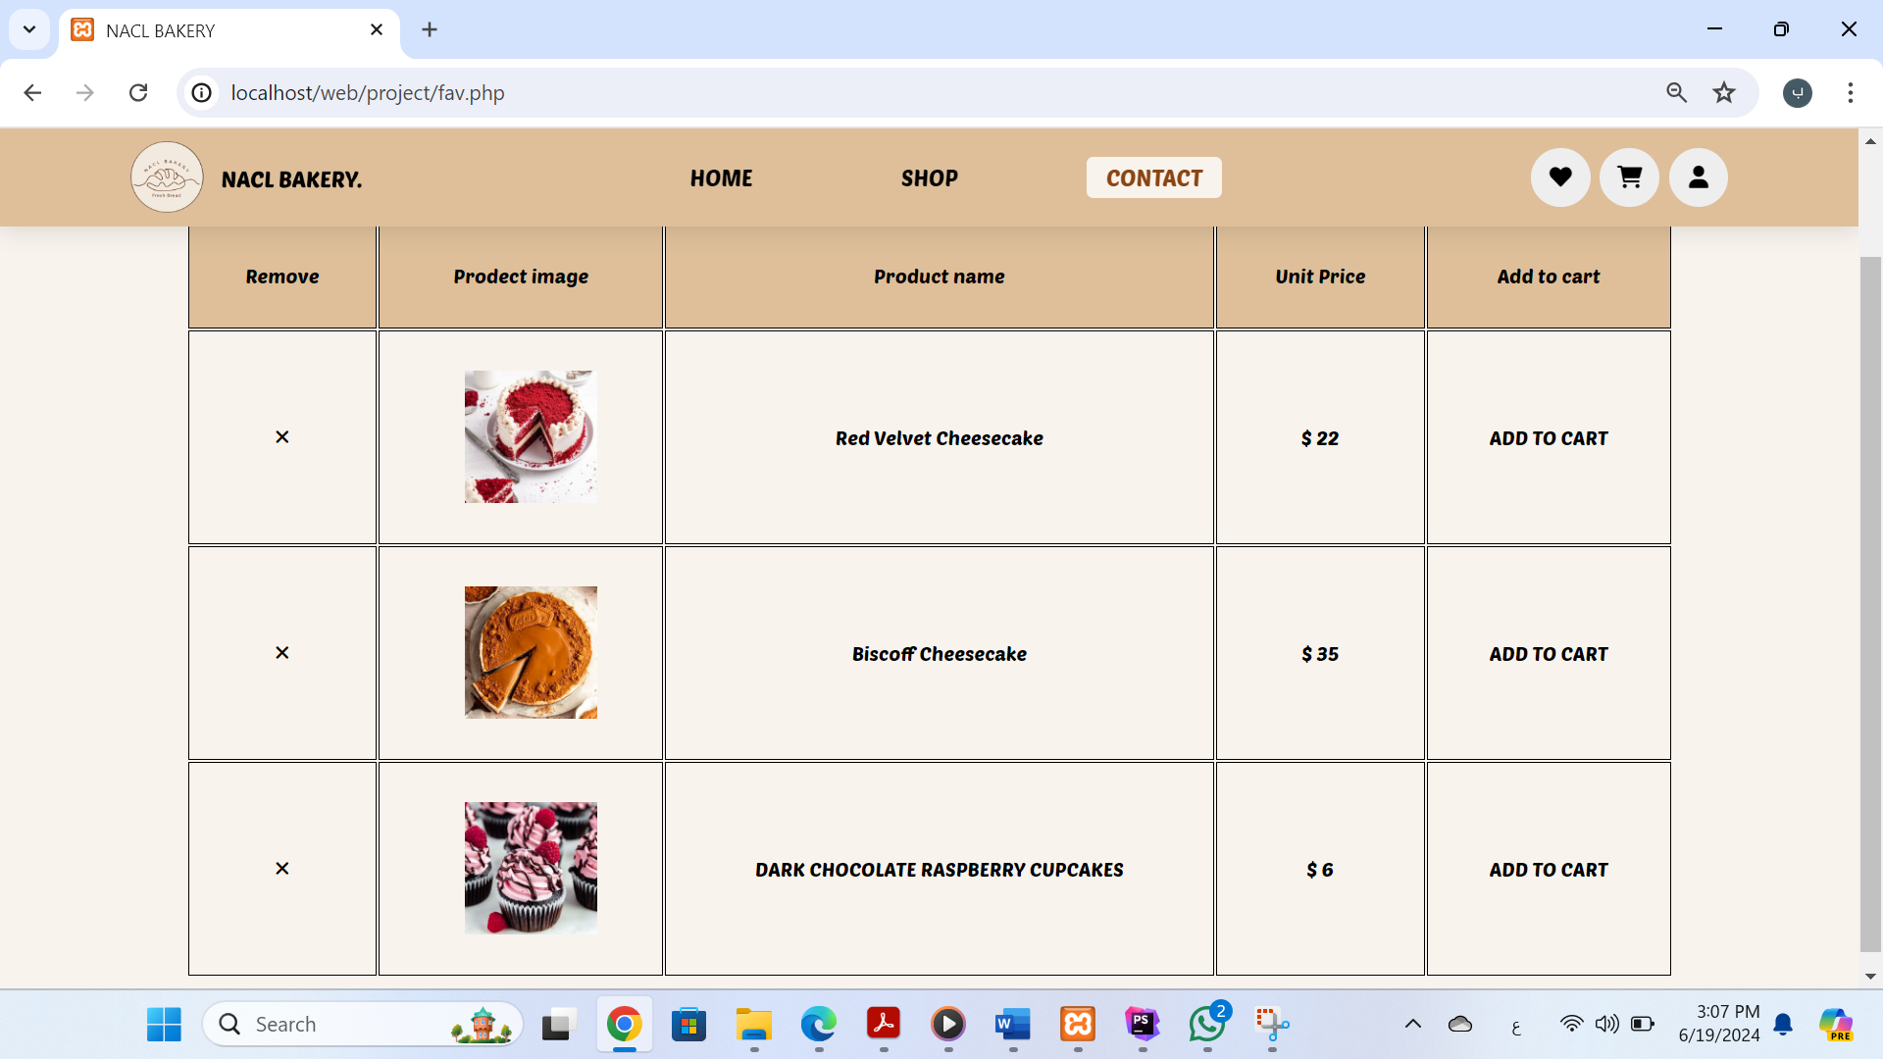

- When you press x, it will remove the product from your favorites

-When click on add to cart The product will go to the shopping cart

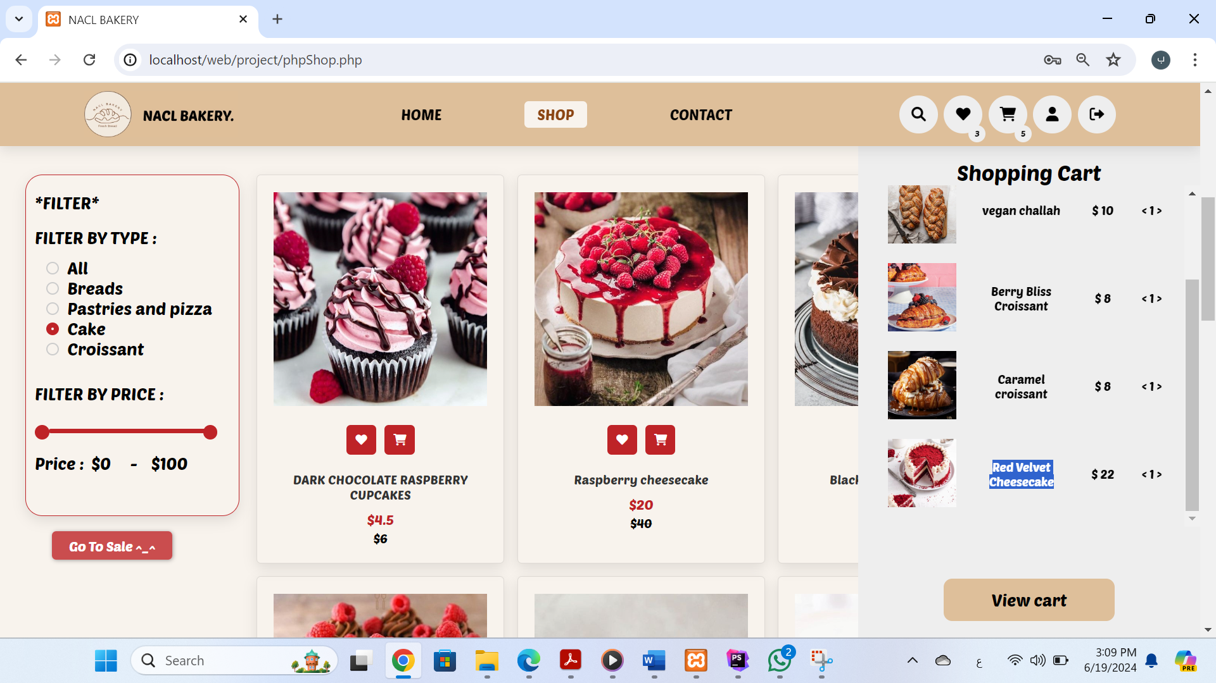

1. Search icon:

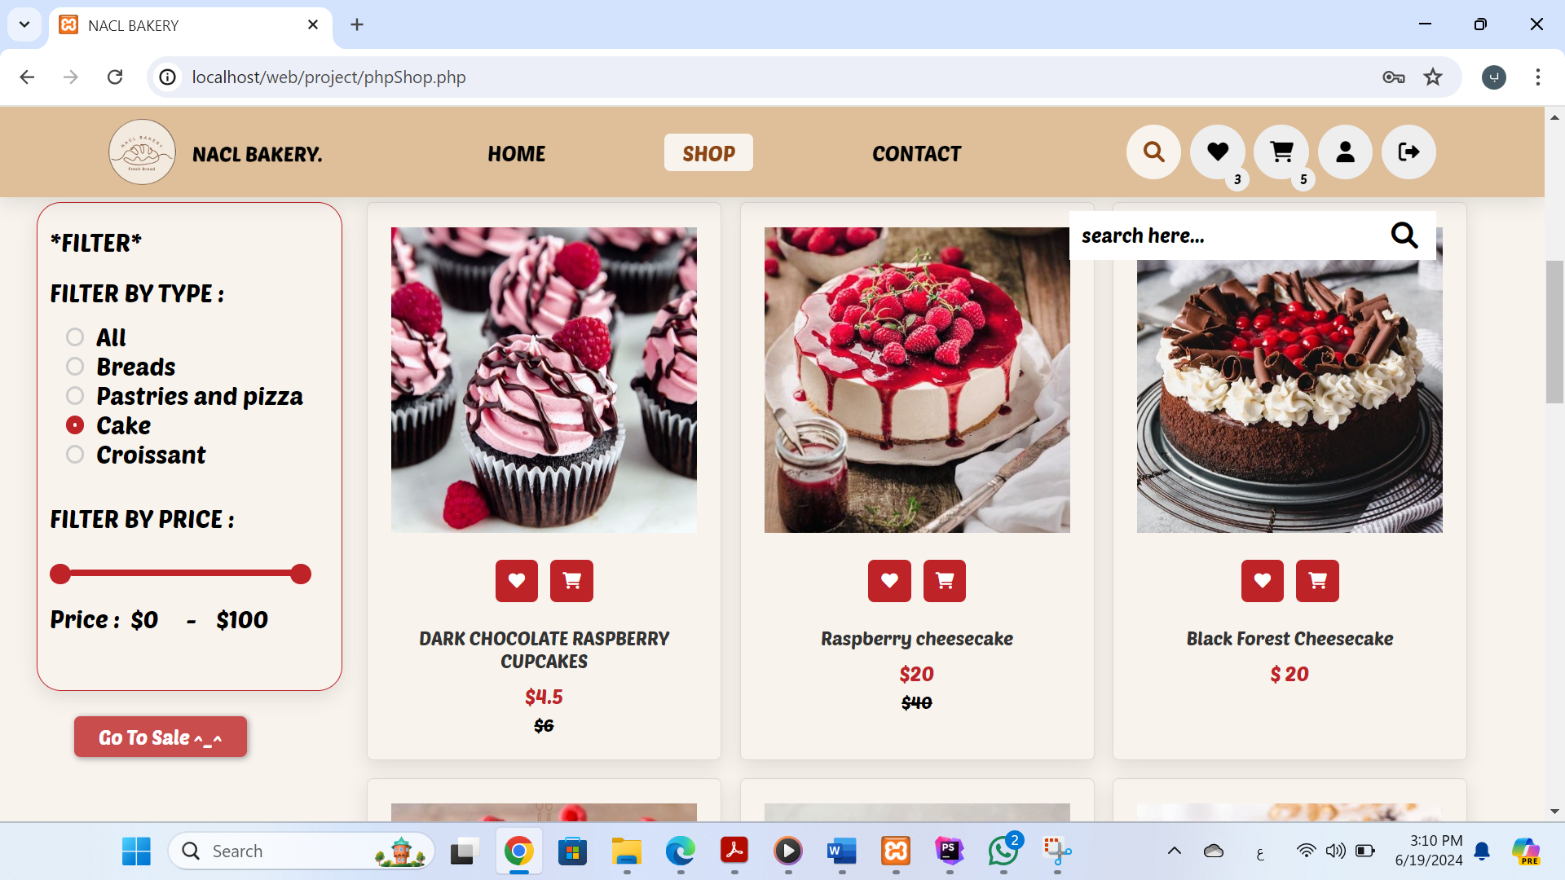

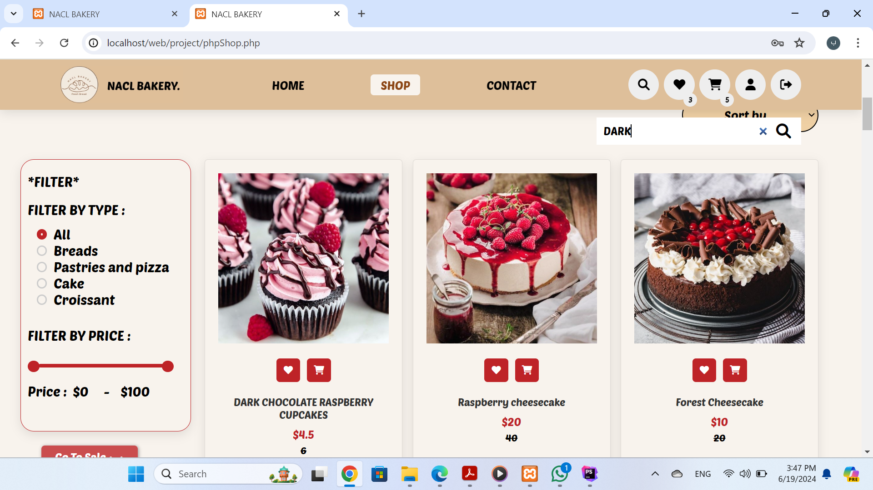

-footer

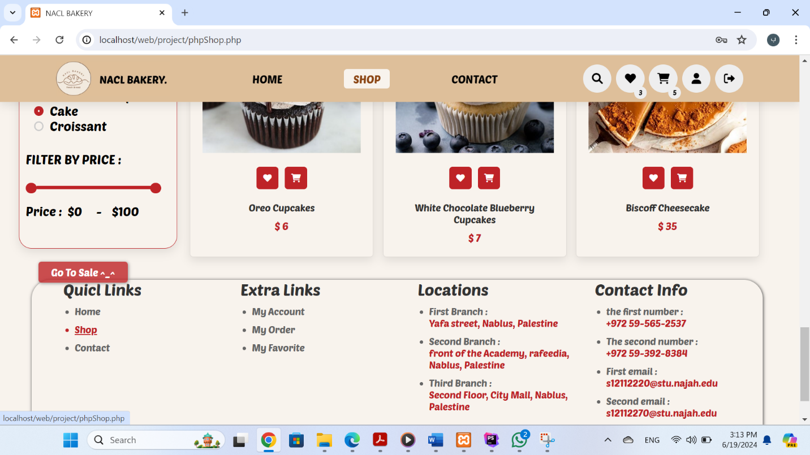

3. **Contact page:**

-Here the customer will send any question or comment and click on send message and all messages will appear to the admin on a page I will talk about later.

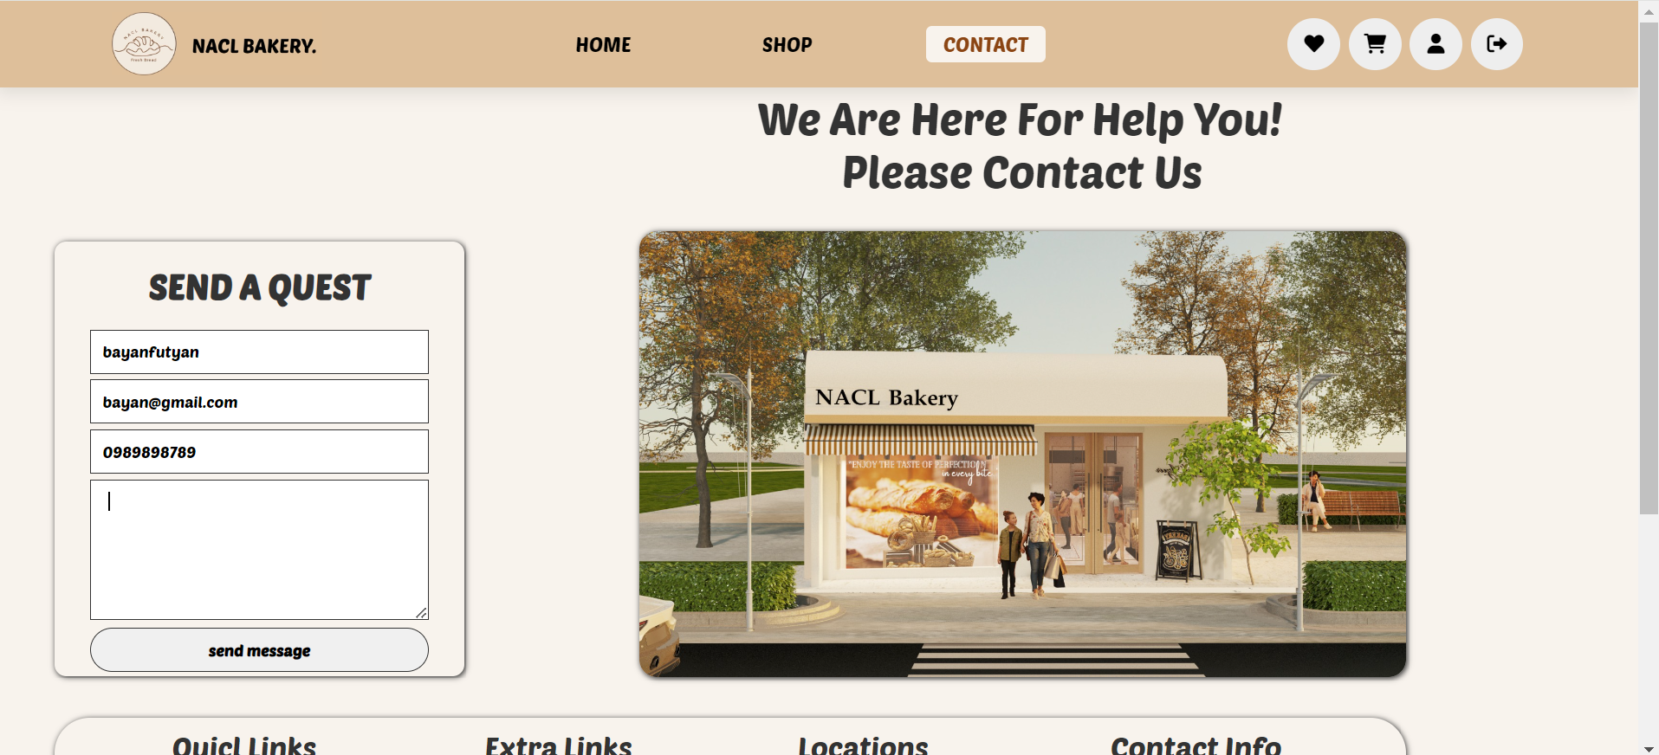

-footer

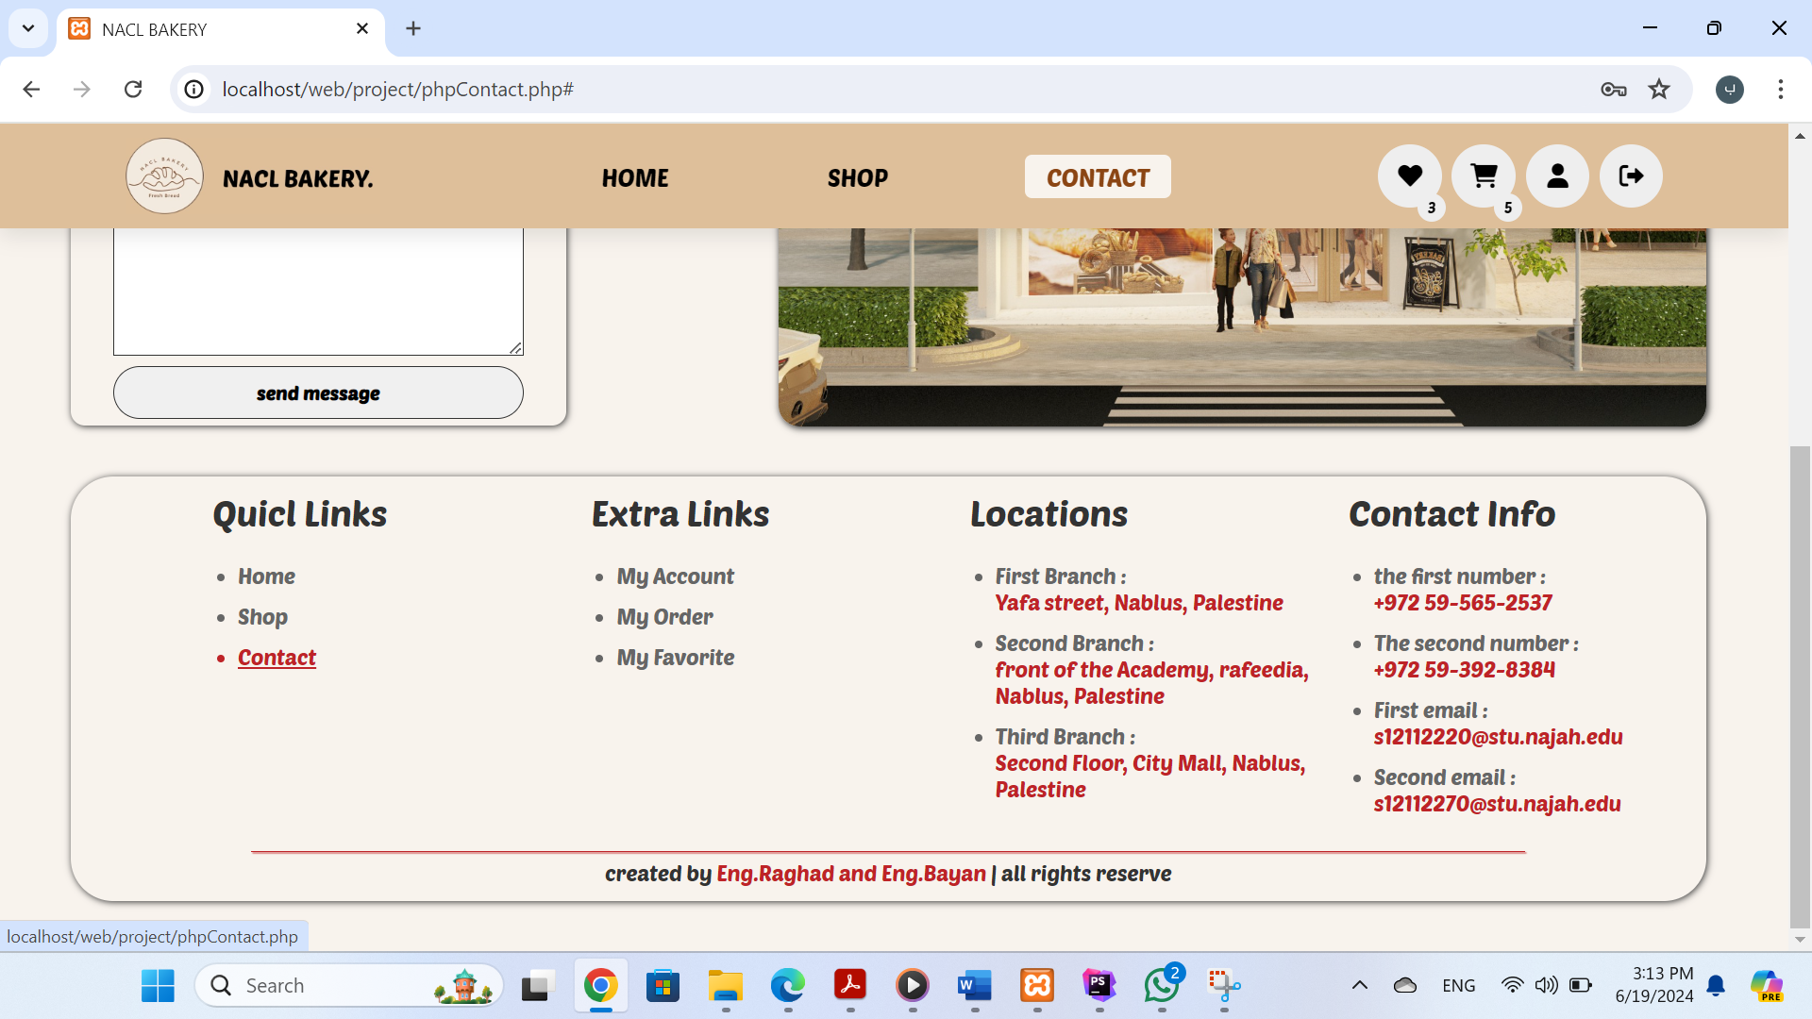

**admin pages**

- There is one admin ,the user level value in the login table is equal to 1

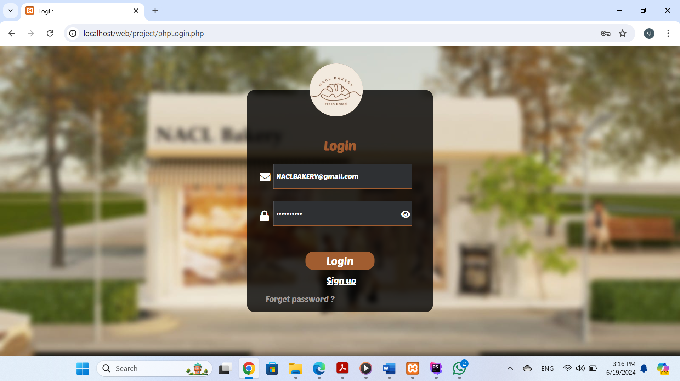

1.**Home admin page:**

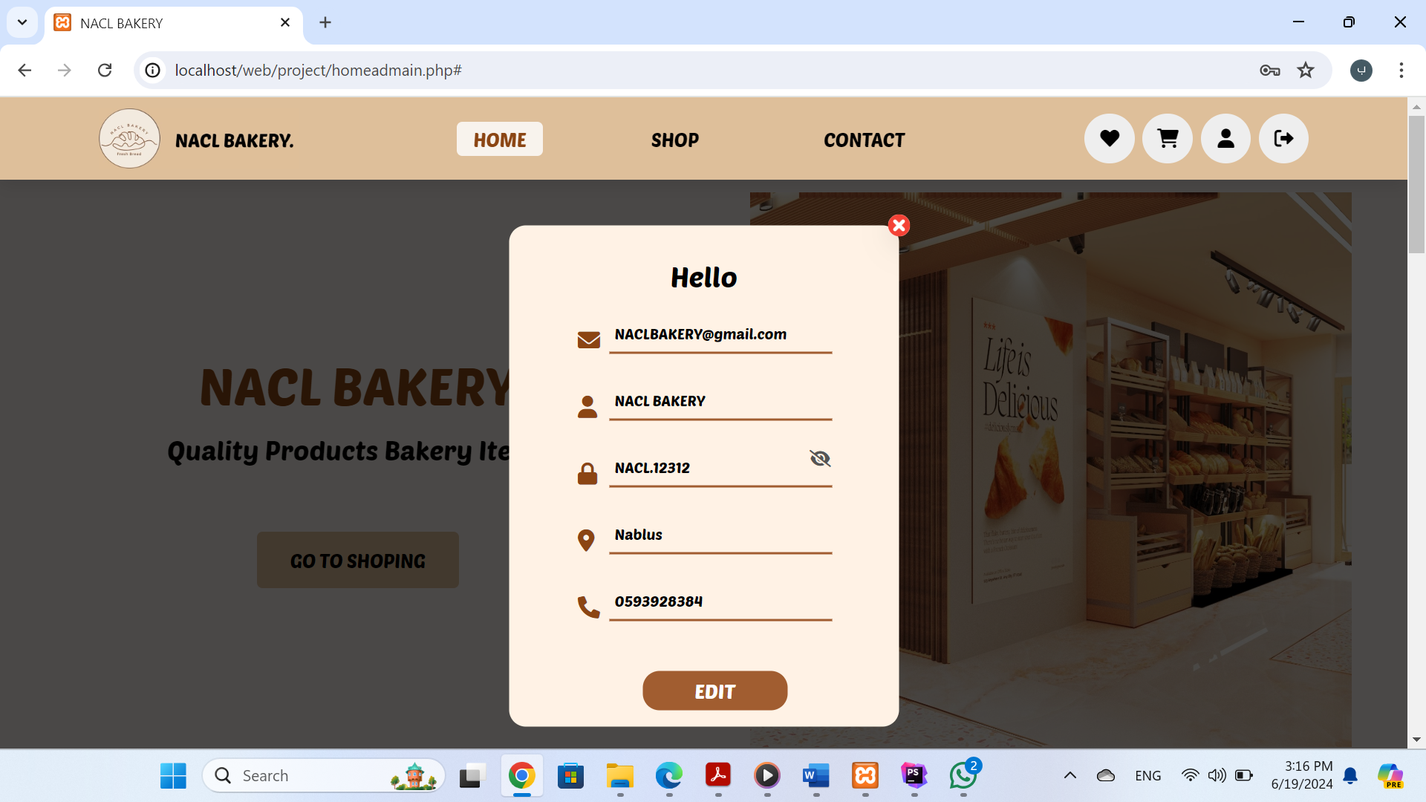

-The home page will appear as I explained previously, the only difference is in this part , the admin can modify and delete a product using the delete and modify icon

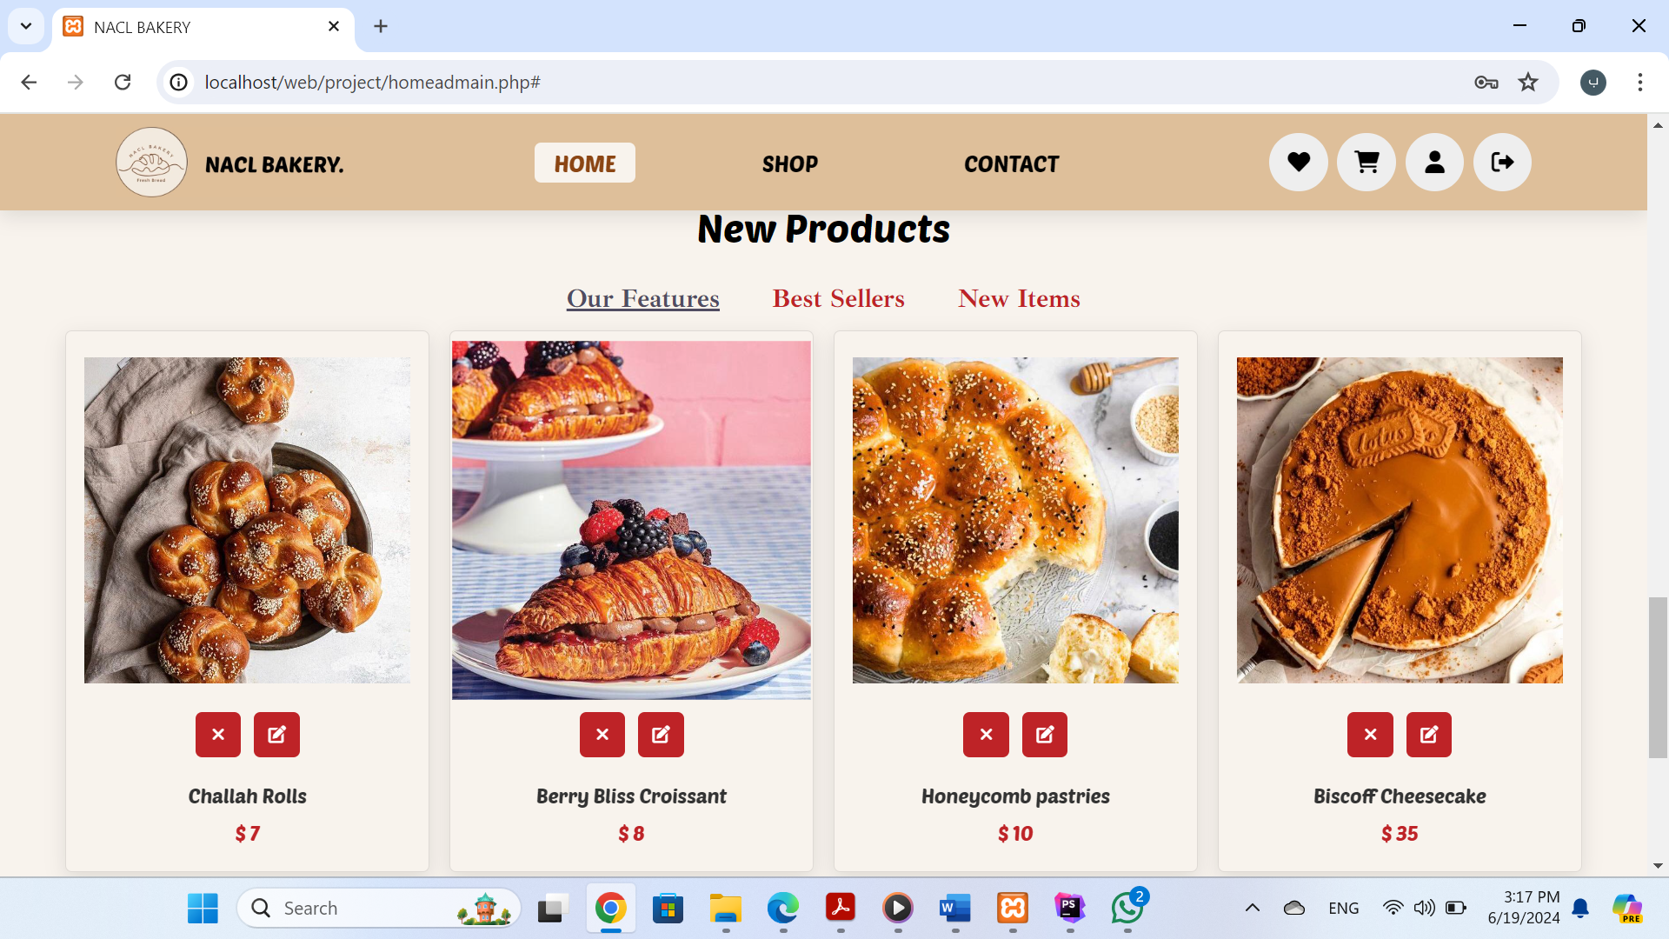

delete icon

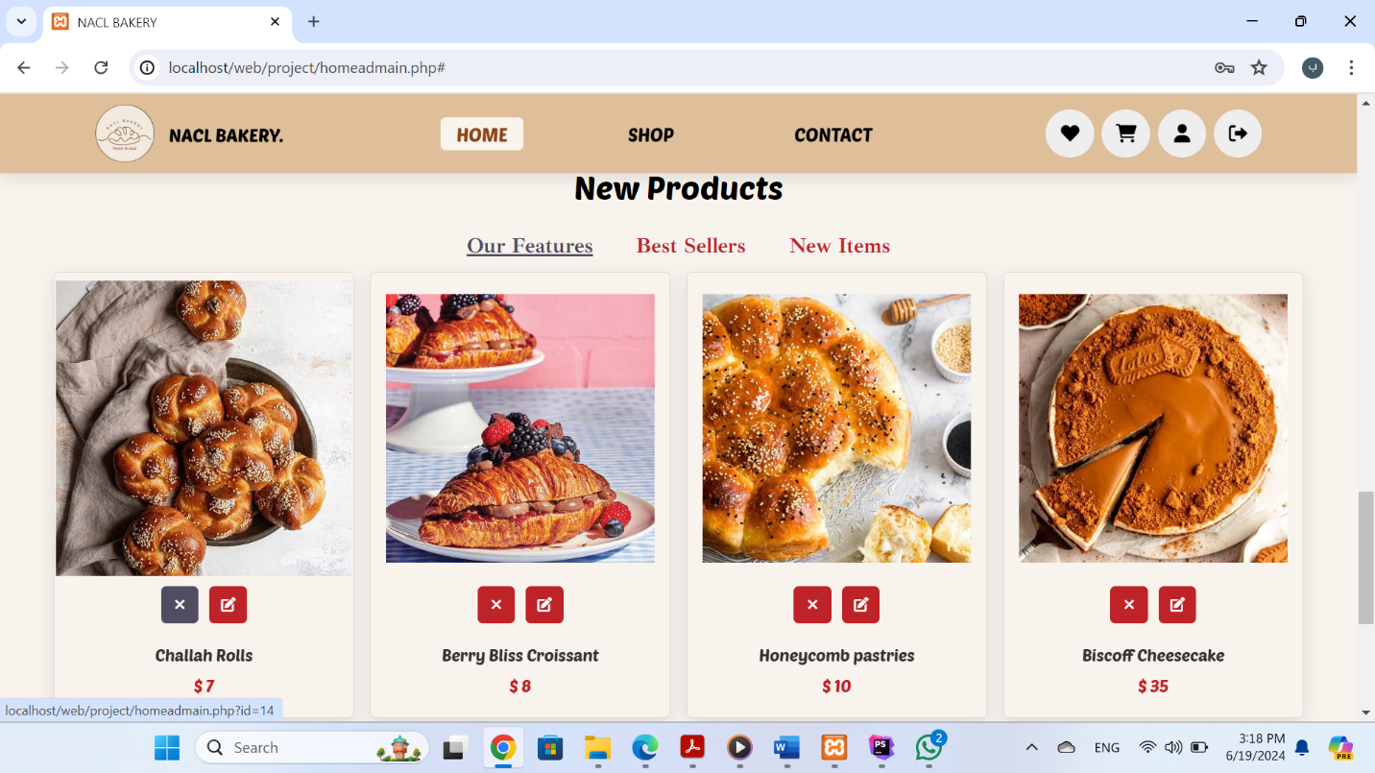

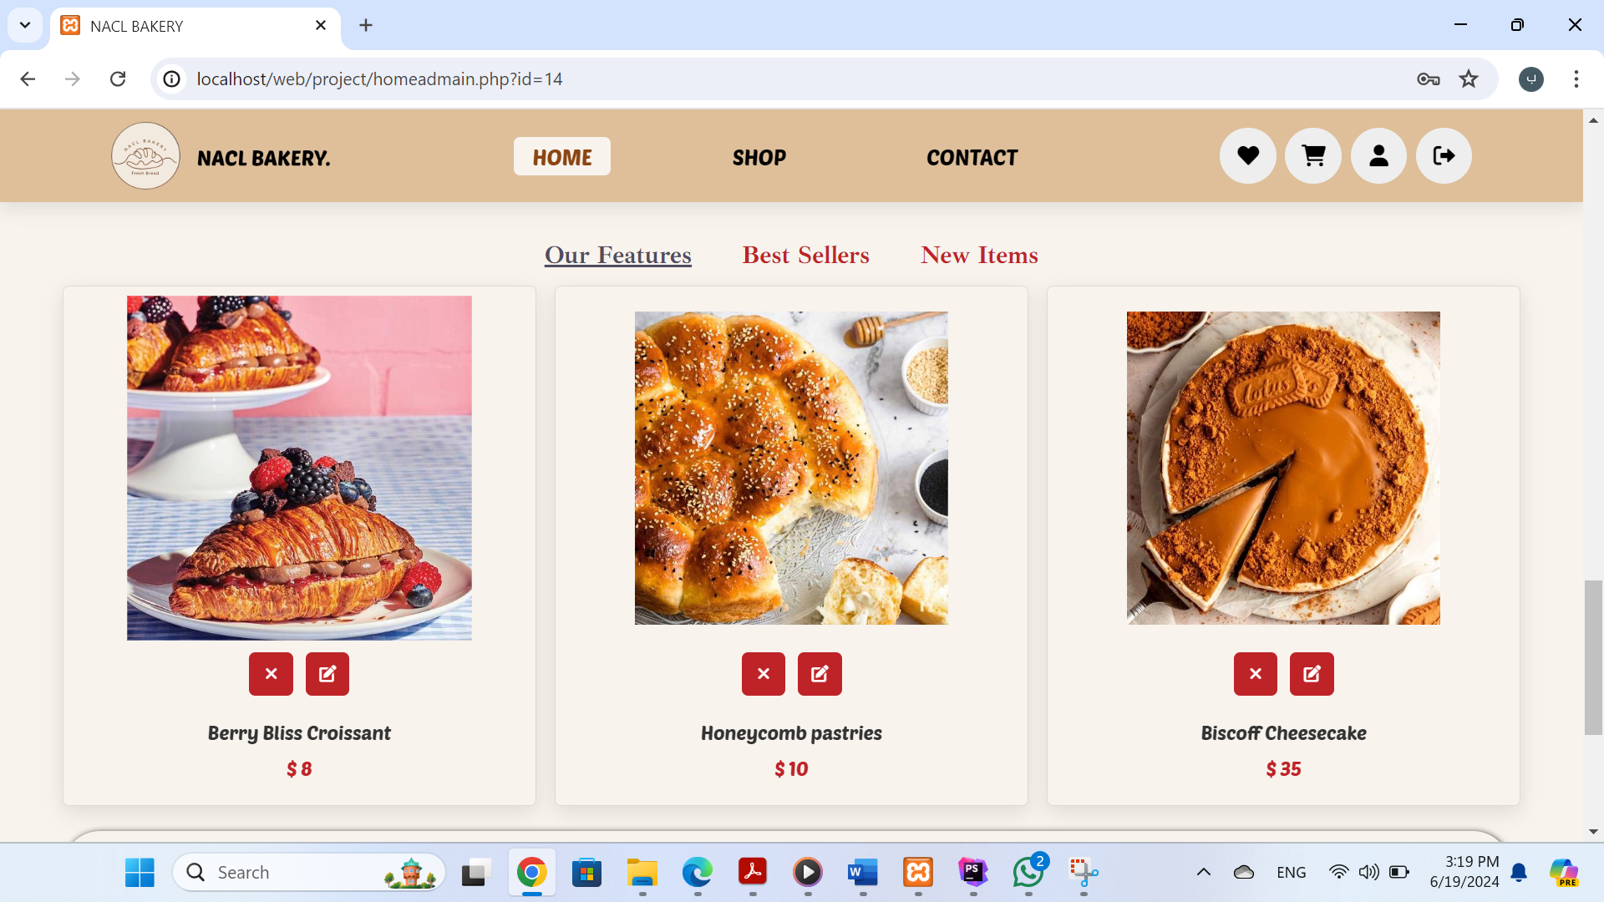

modify icon

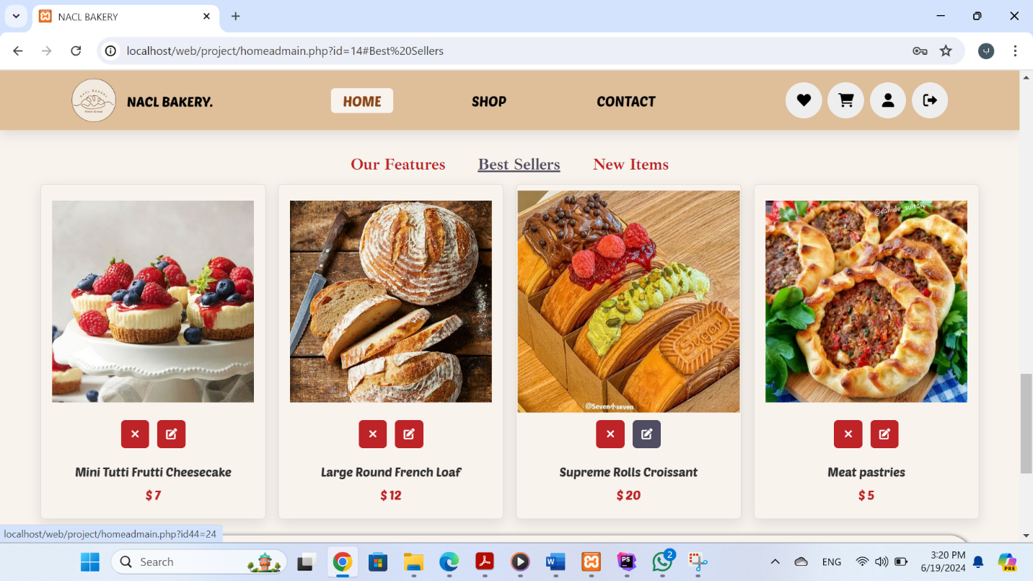

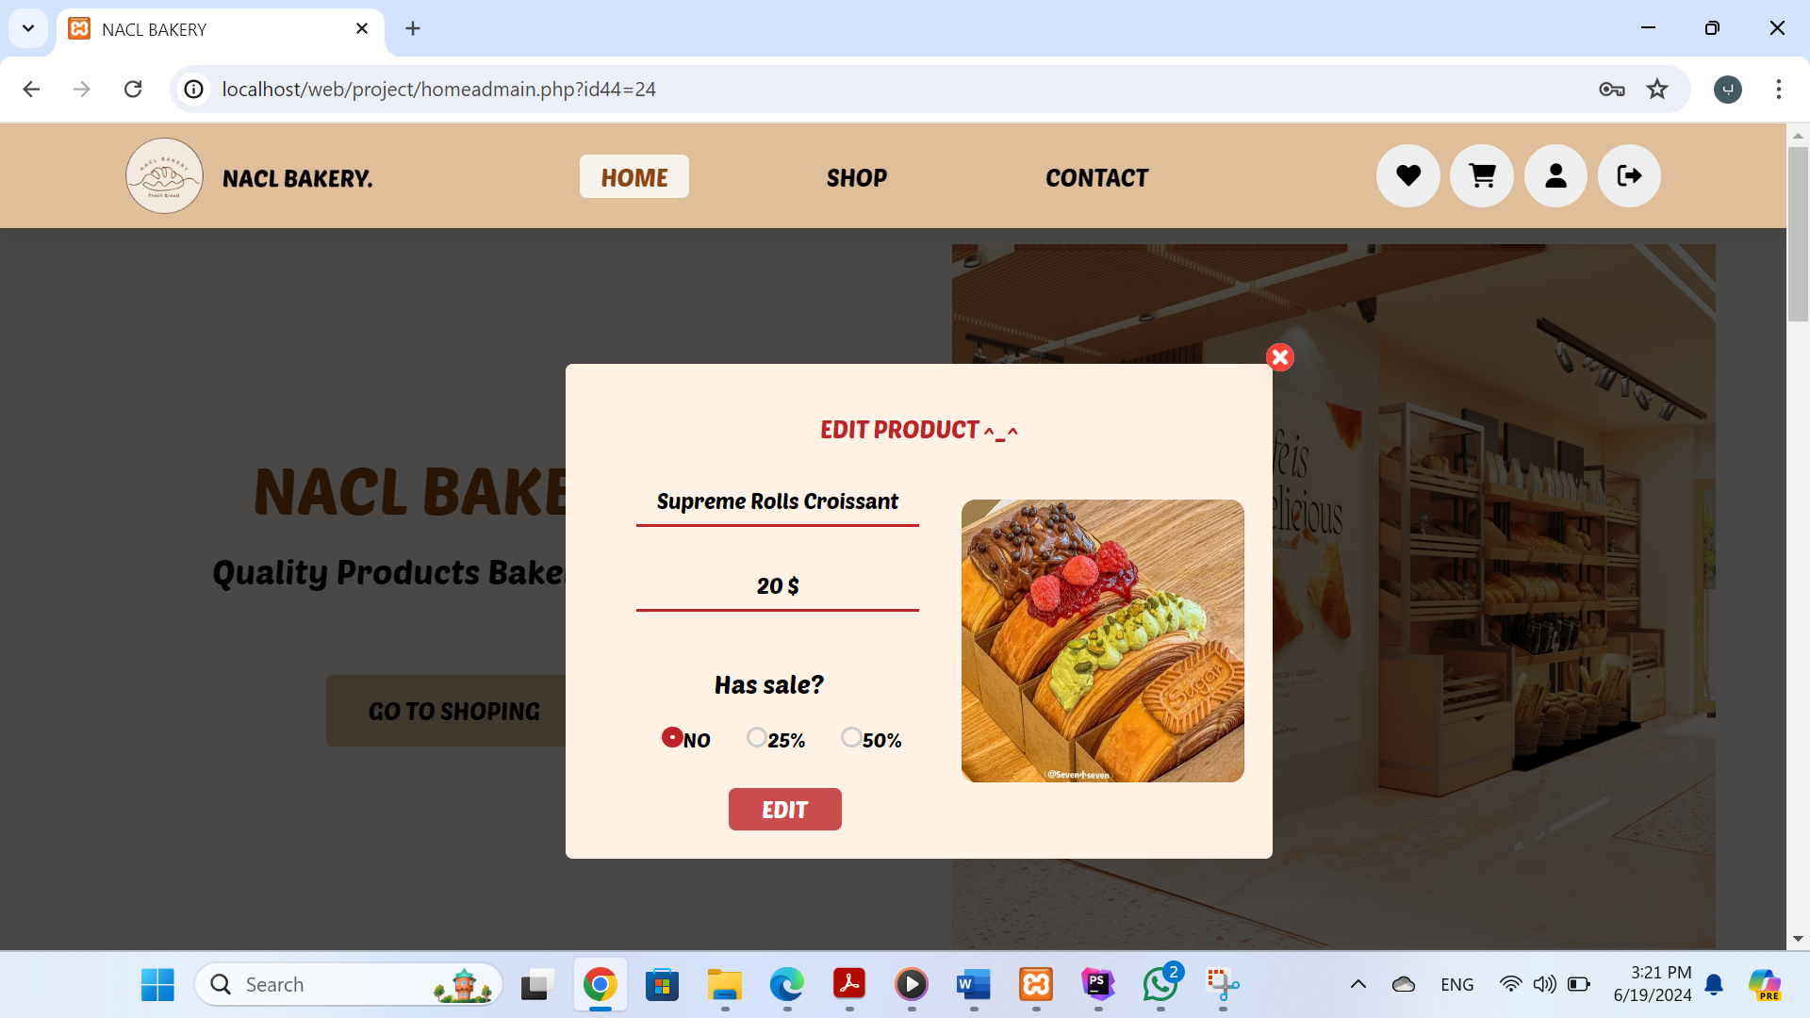

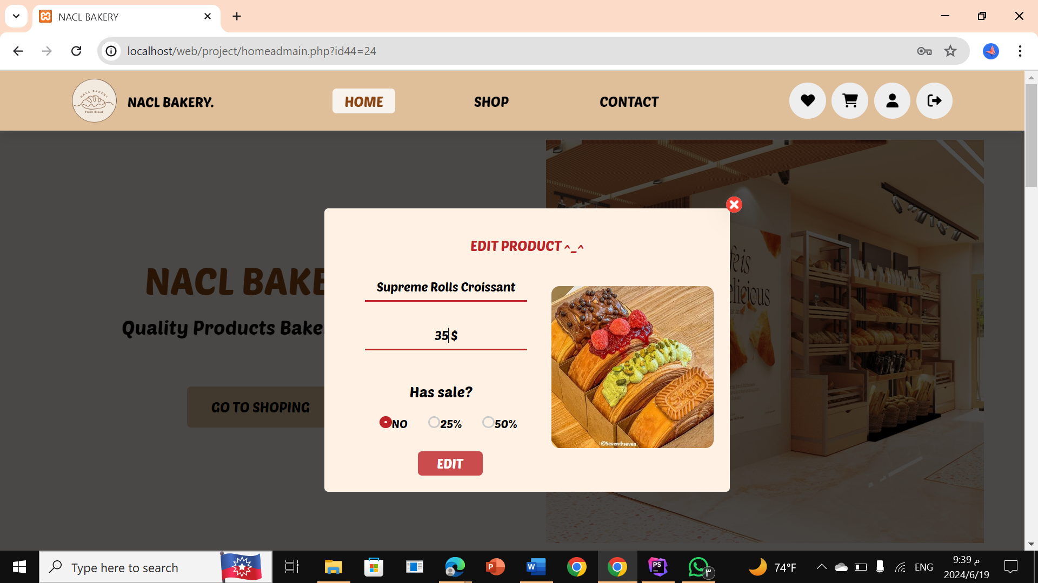

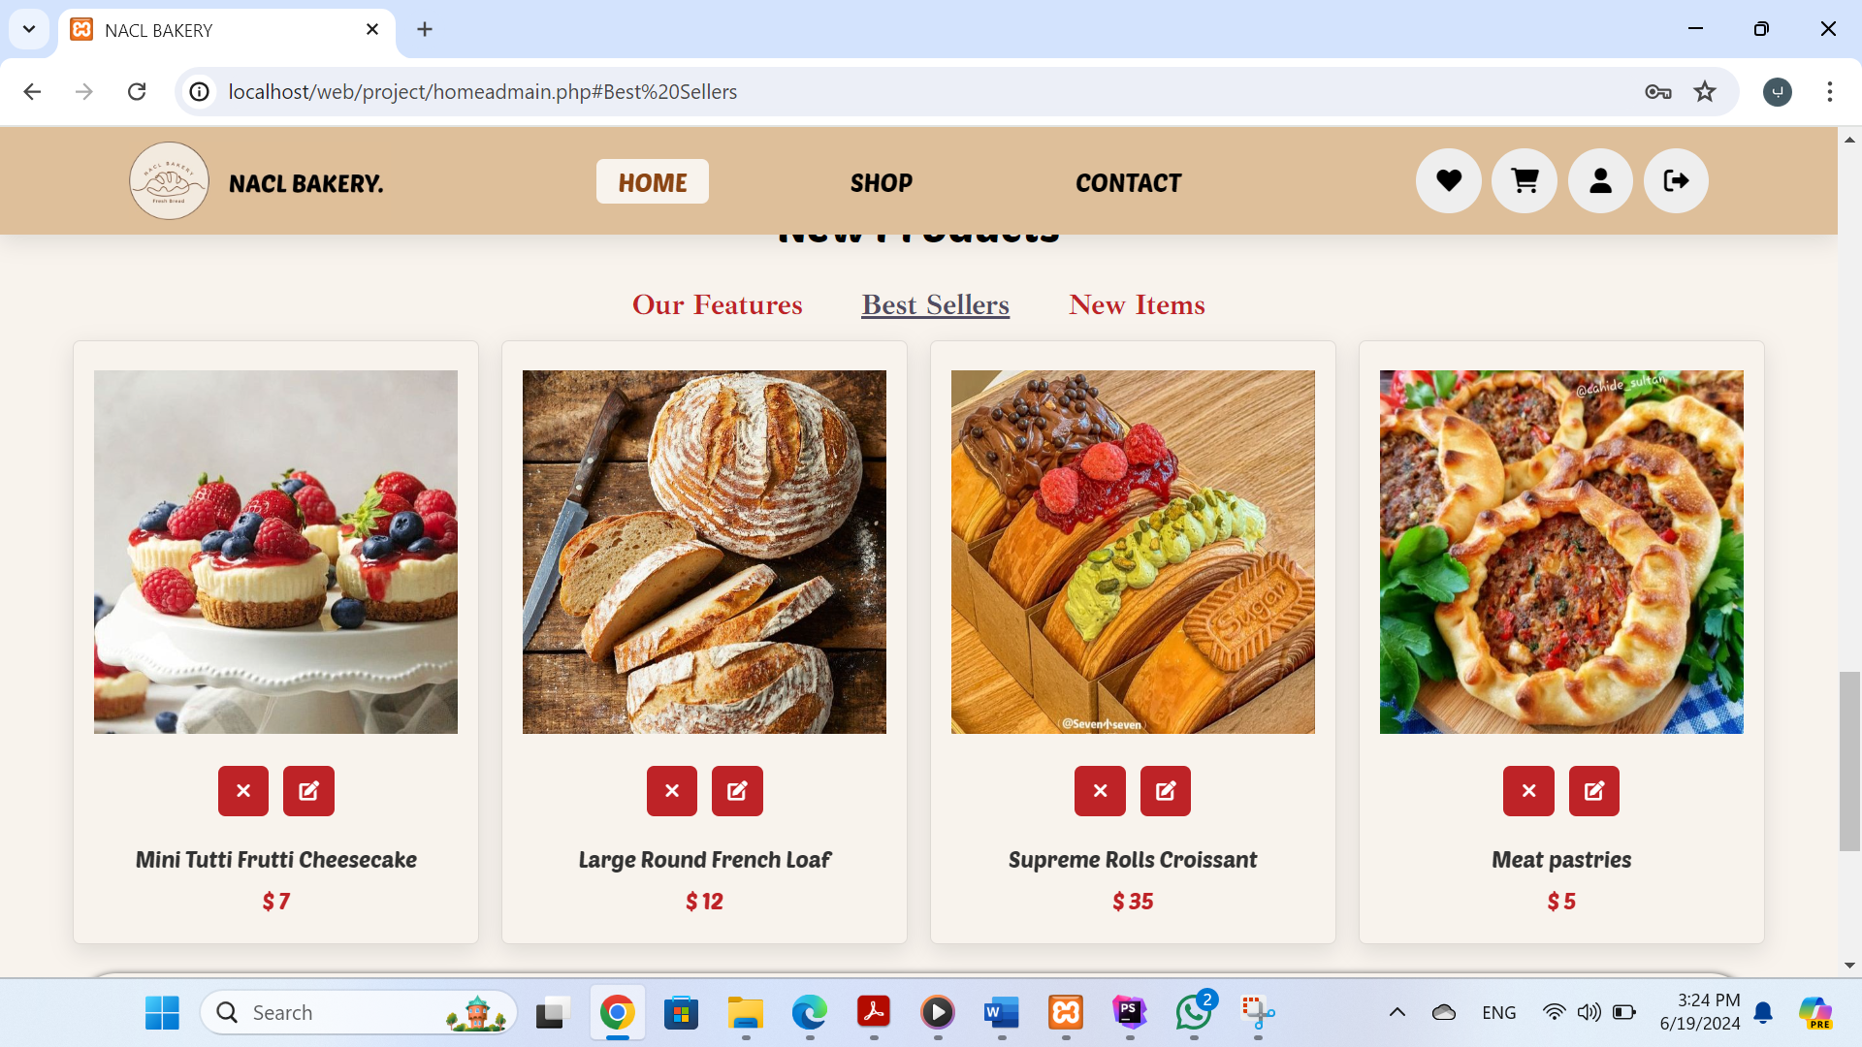

-As shown in the picture, the price of the product has been modified in the web page and database when click on edit In addition to the price, the name can be modified and it is possible to determine whether there is a discount on the product so that it appears on the discounts page that we talked about previously.

2.**Shop admin page:**

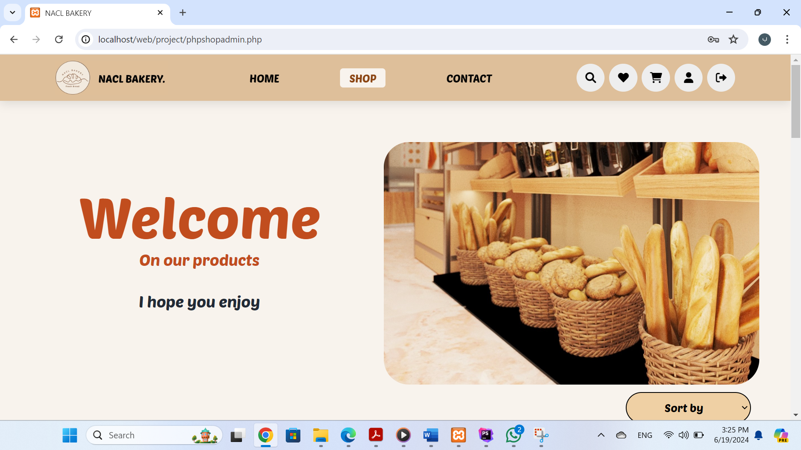

-On this page, we have changed the icons according to the Admin that the supervisor will perform. For each product there is an icon for deletion and modification ,they work as I explained previously. We will put some pictures We also note that there is a button below the filter to add a new products.

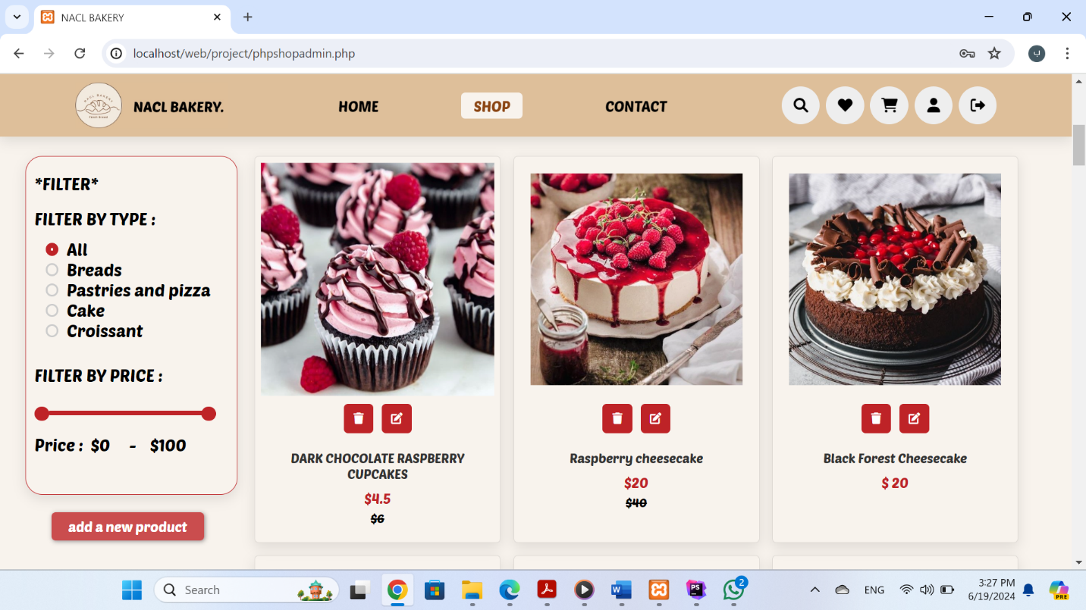

delete icon

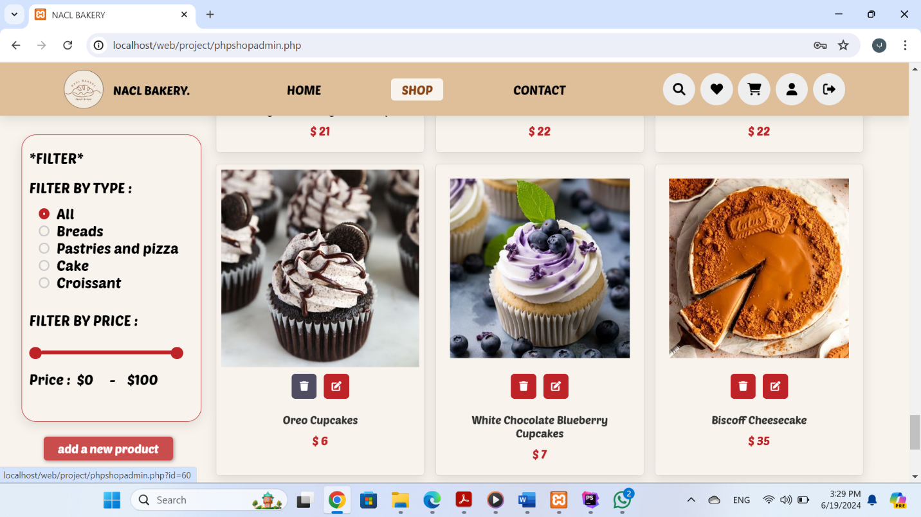

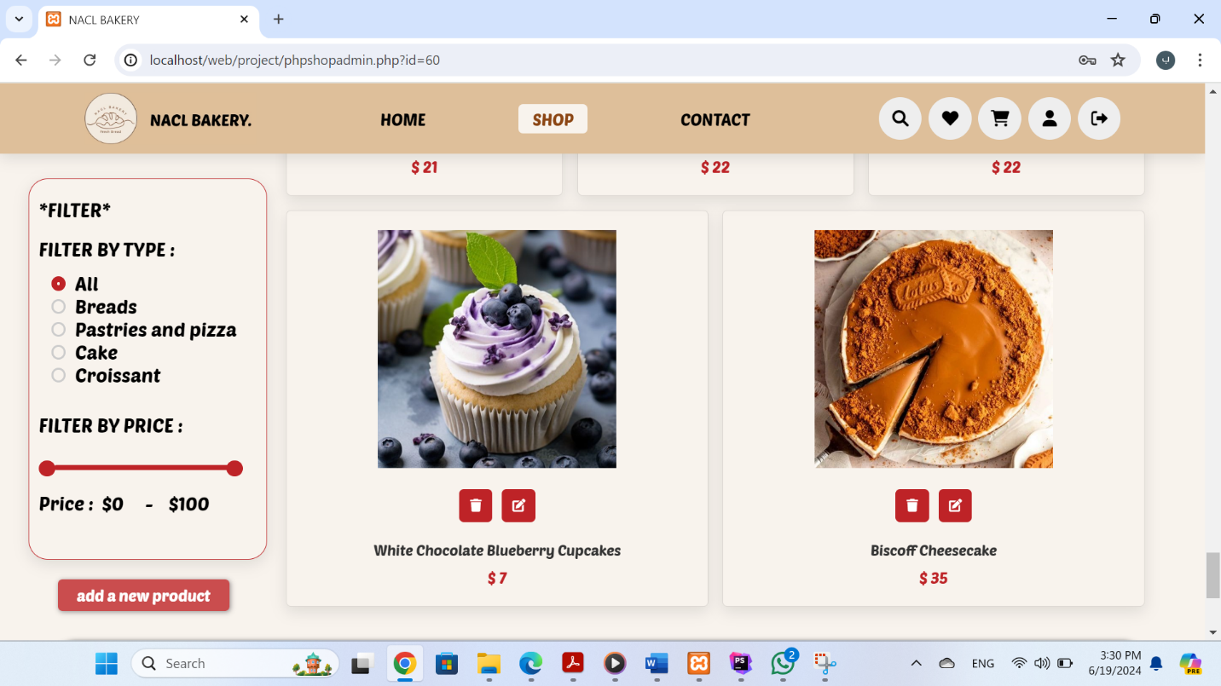

modify icon

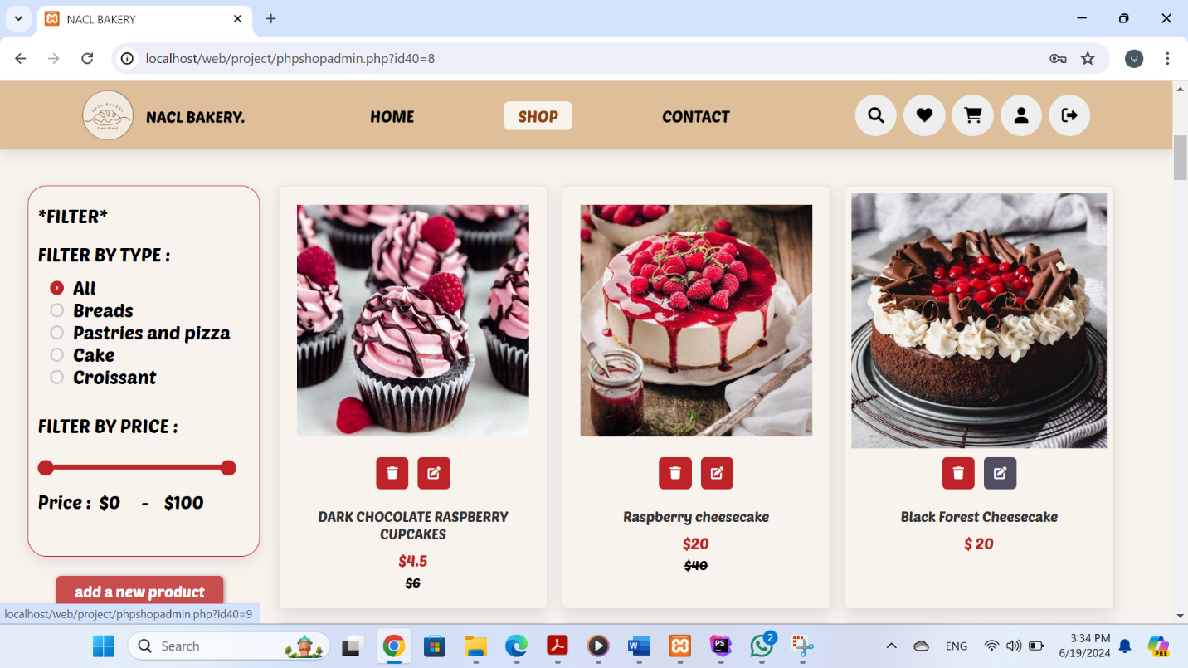

- I will change the product name and make a 50% discount

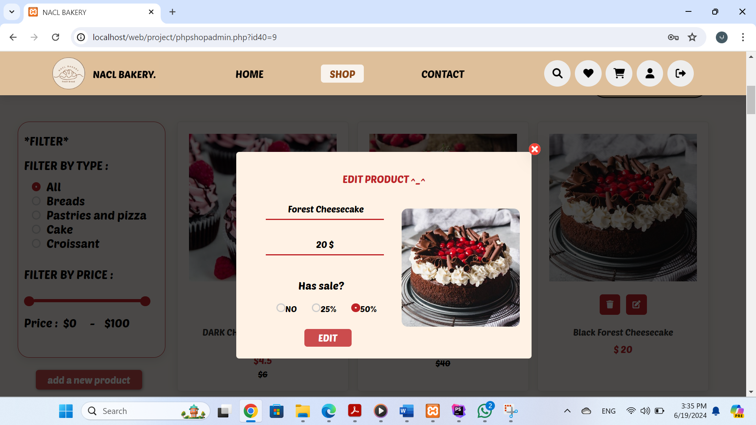

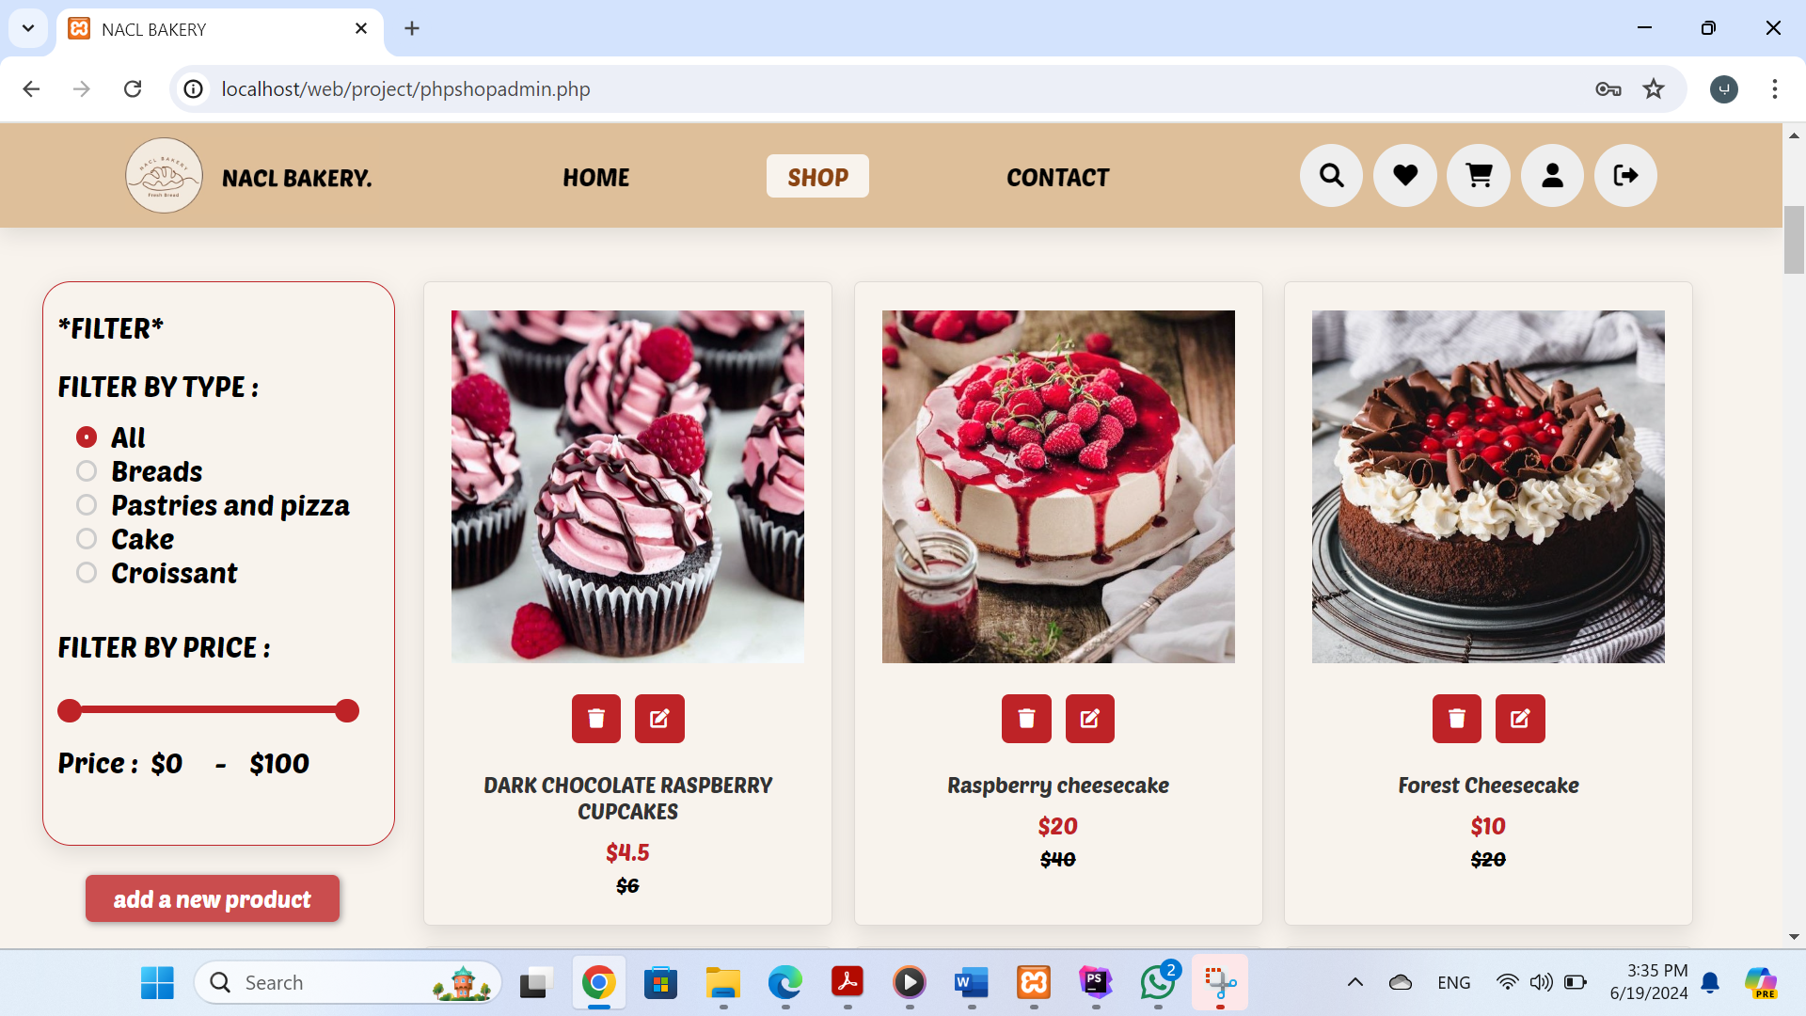

Now when click on:

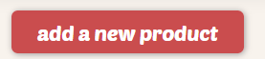

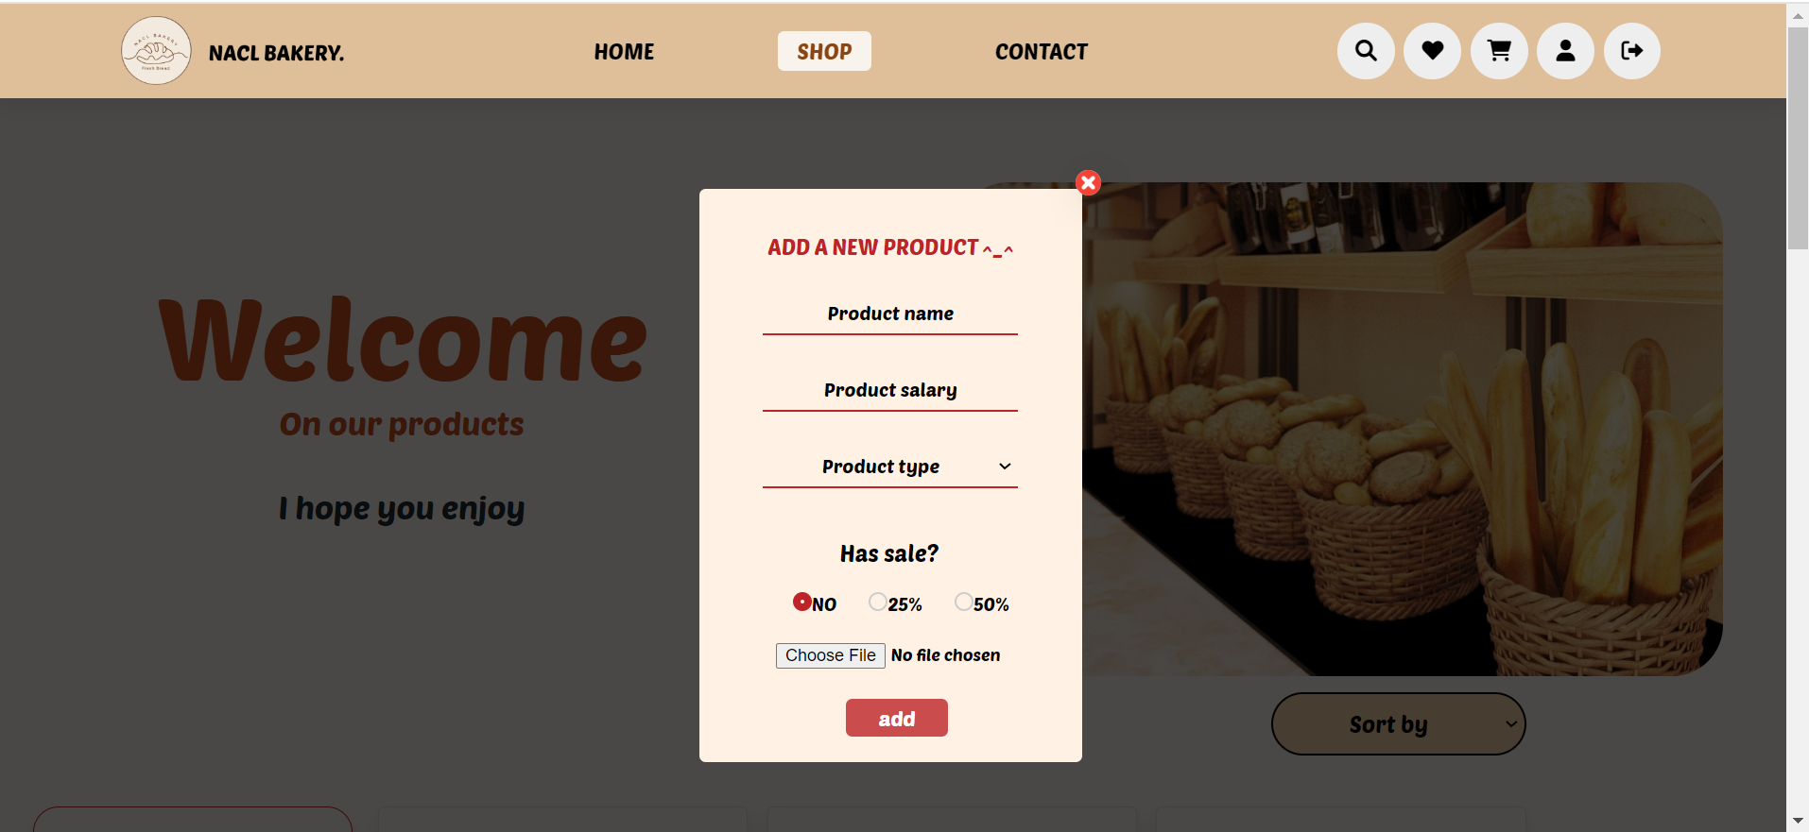

-Now let's try adding a new product:

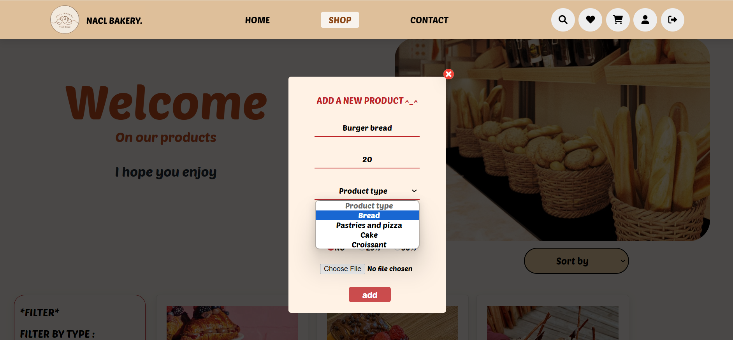

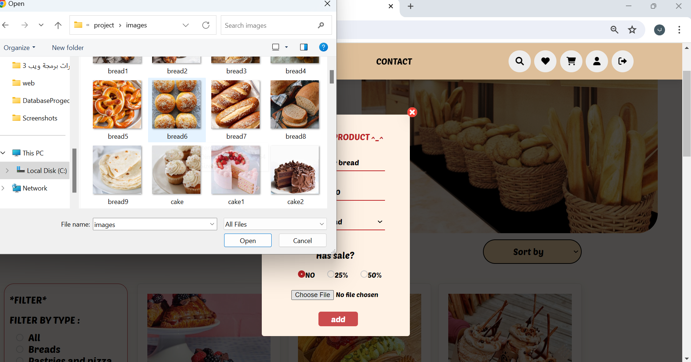

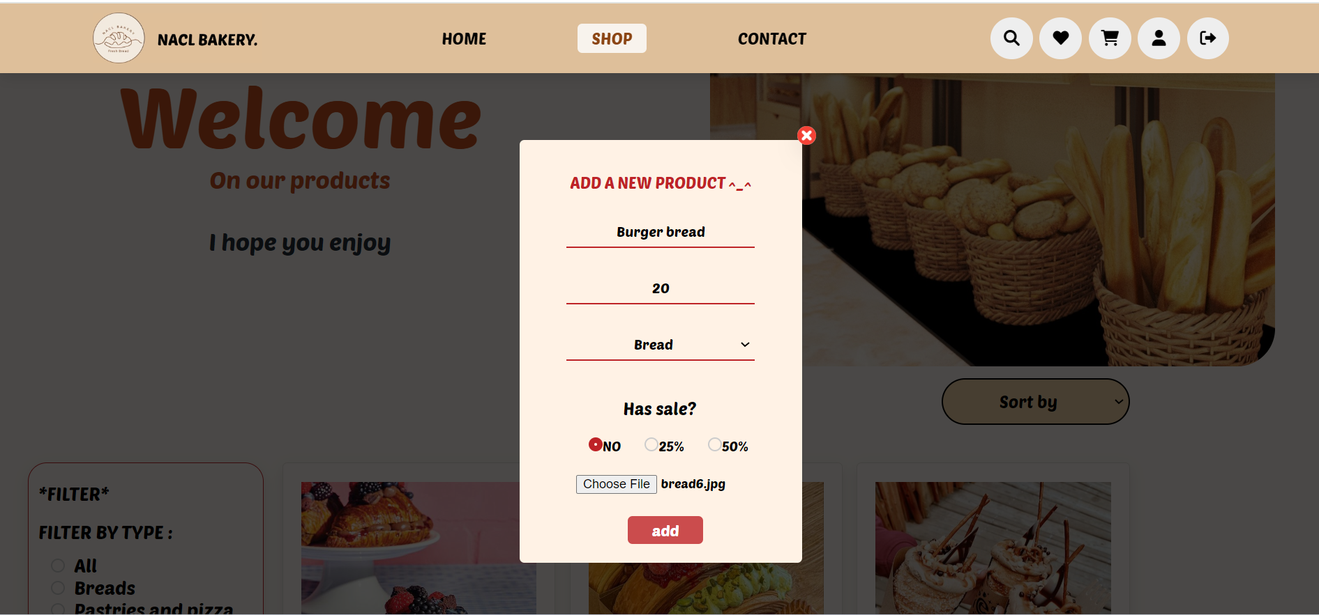

-As we can see, the product has been added successfully

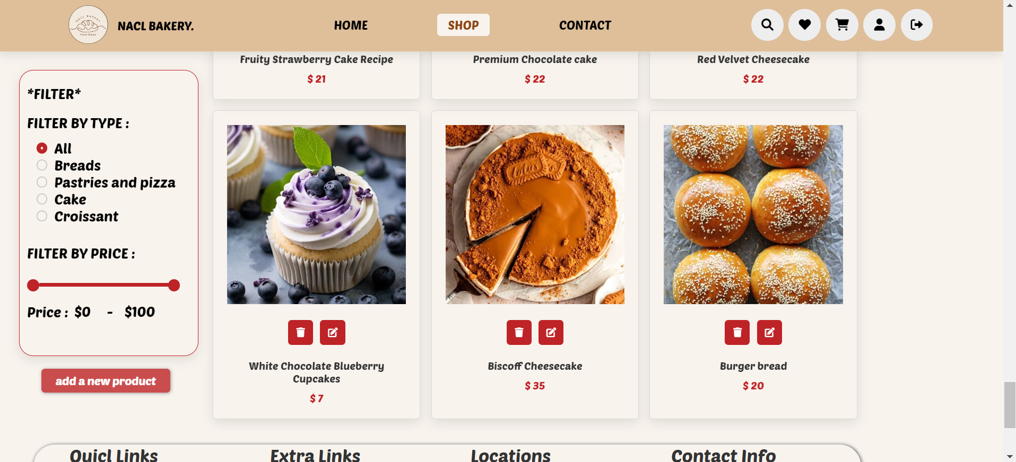

3.**contact admin page:**

-In this page, all messages from all users who sent a comment or message will appear to the administrator (we talked about this previously)

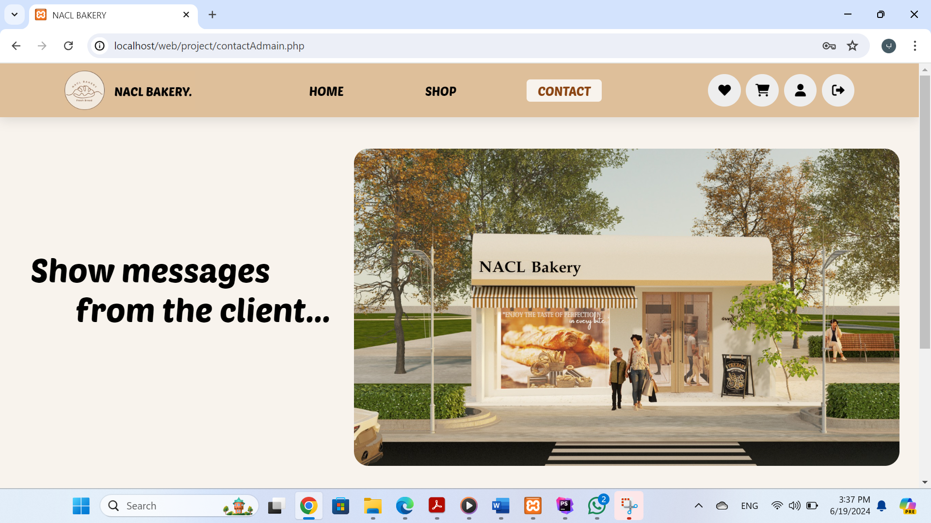

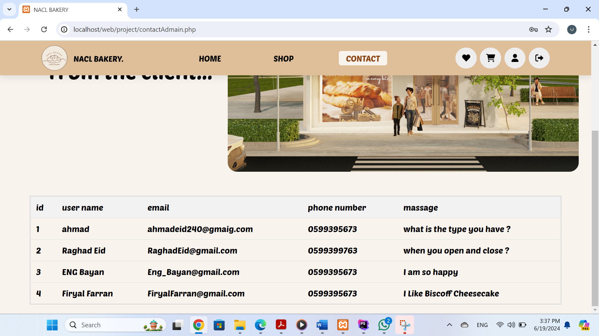

-Finally, I will explain the icons in the header, the search icon, the personal page, and the login icon, as we explained previously. The differences are in the favorite icon and the shopping cart icon, which we will explain now.

Now when I click on the favorite icon, a page will appear for the admin that shows the number of hearts for each product, The first product is the one with the most likes

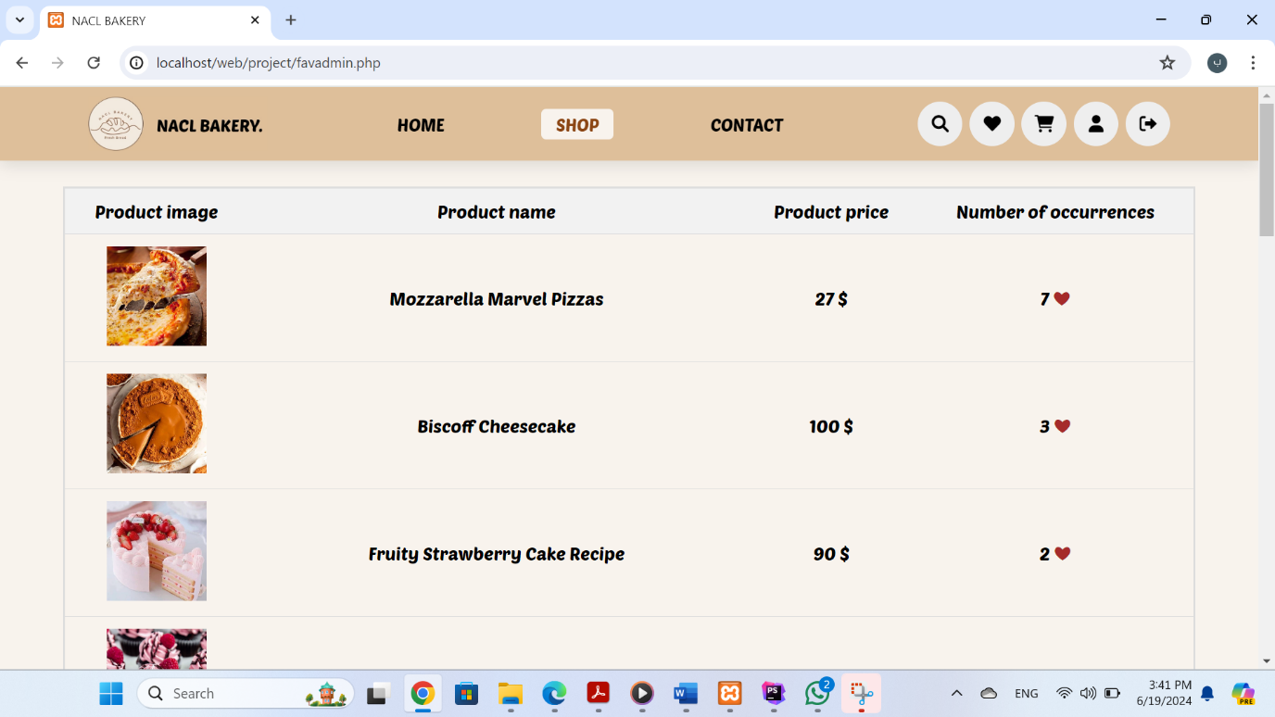

-Now when I click on the shopping cart icon, an administrative page will appear showing each person's orders

-As we can see, the tables will appear to the administrator for all users. Each table contains the user's email and the products he wants to order. You'll find a button at the bottom of each table. If the administrator clicks on it, this means that the order has been sent and the user has paid (as we explained previously, a message will appear on the user’s shopping cart page stating that the order has been completed. The total price will become 0$).

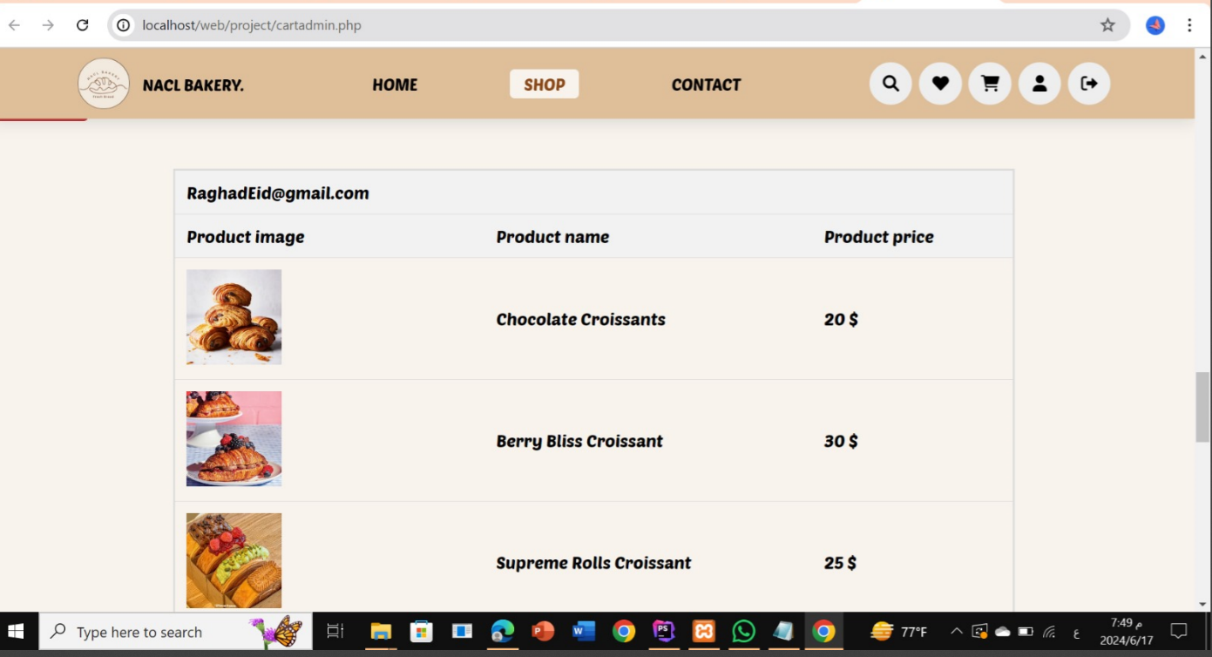

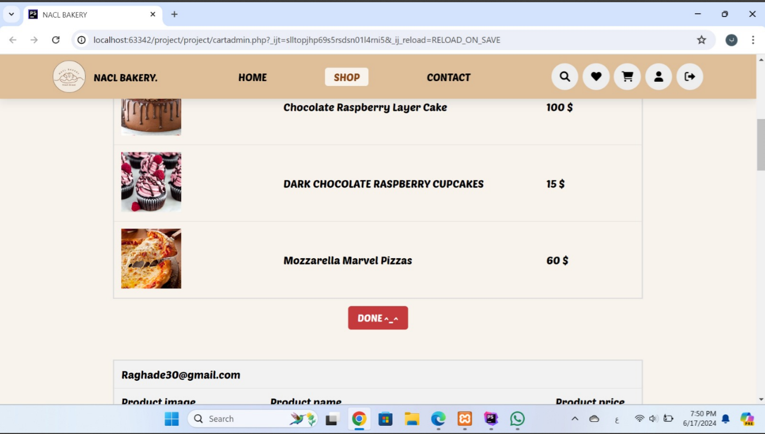

Now when click on:

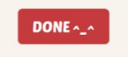

-The order will be sent and the table will be removed from this page and from this user’s shopping cart, and it will cart appear for the user like this:

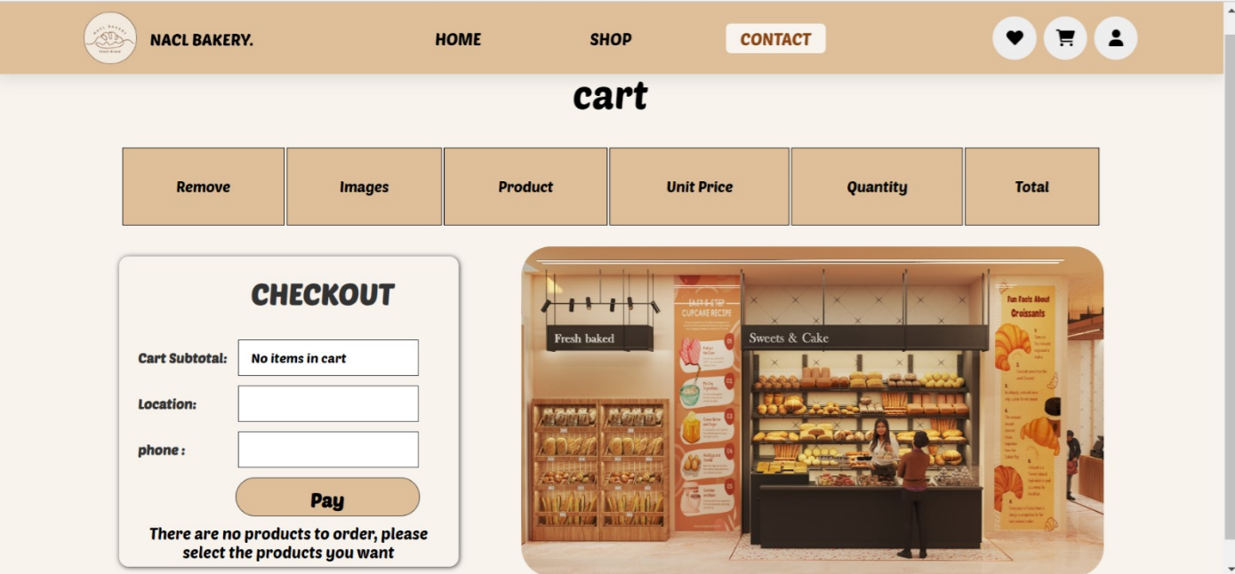

**Responsive :**

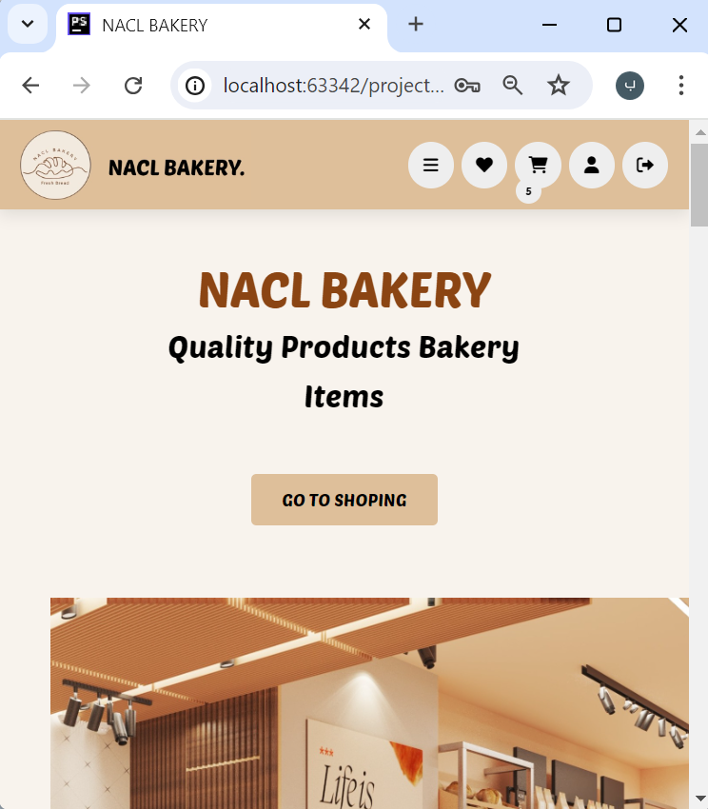 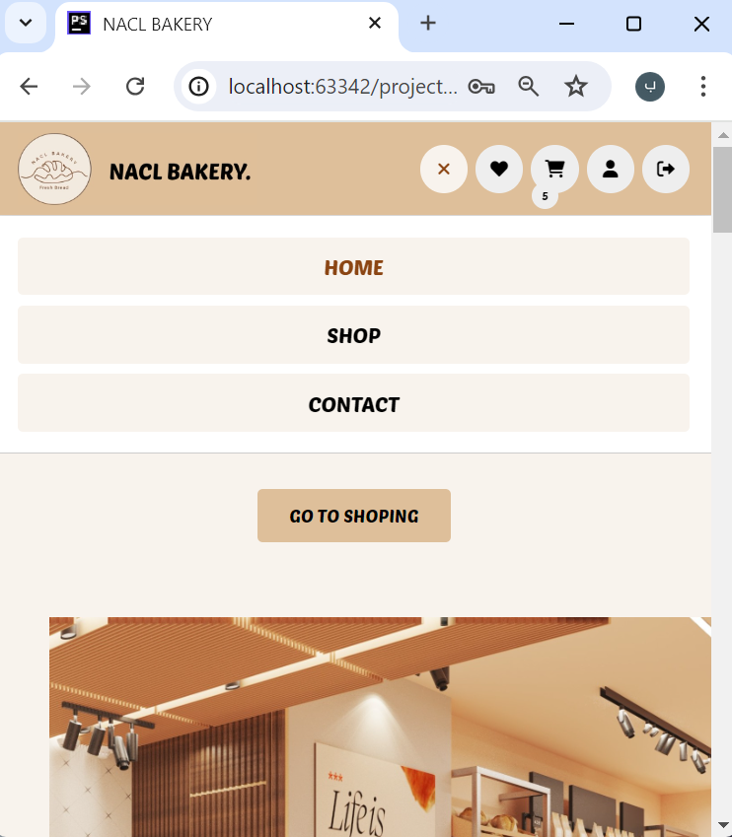 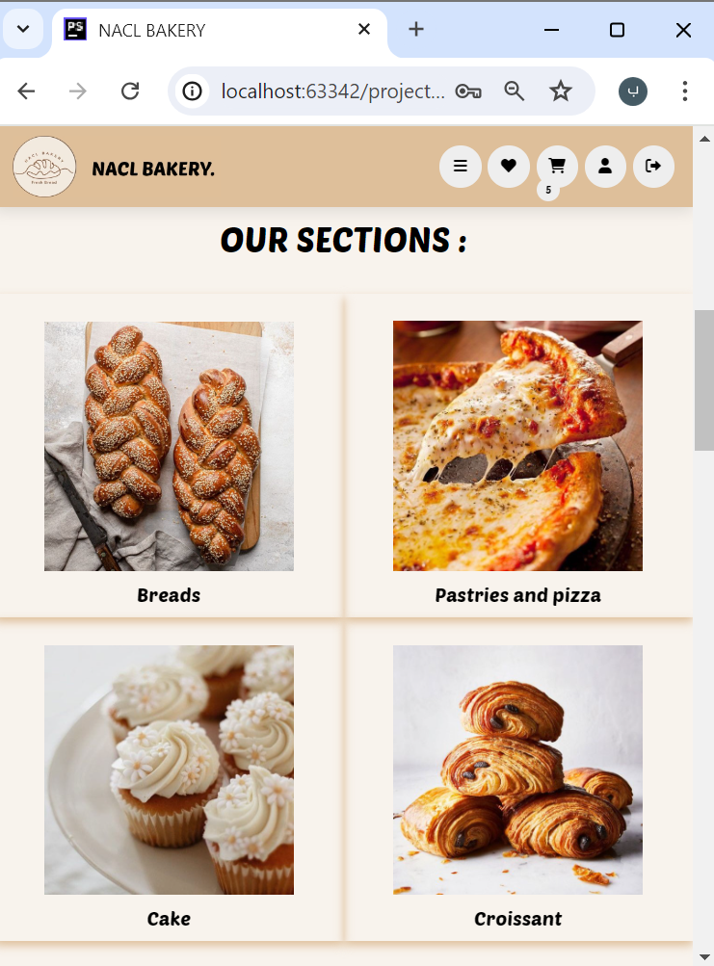

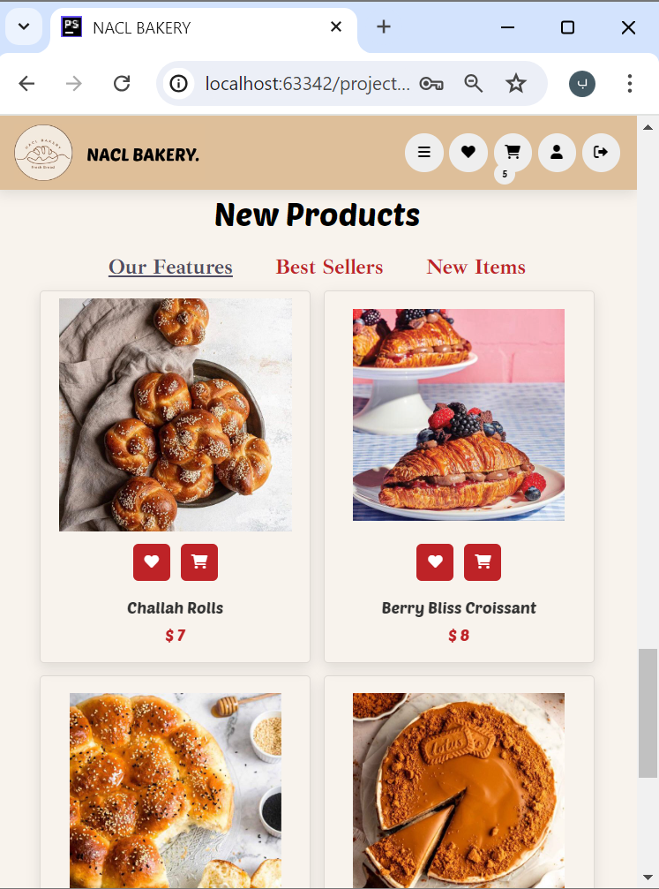 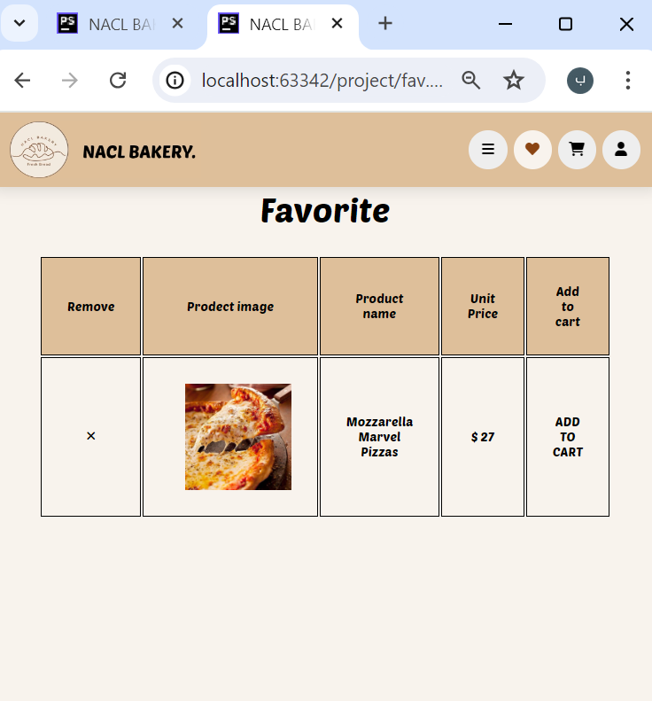 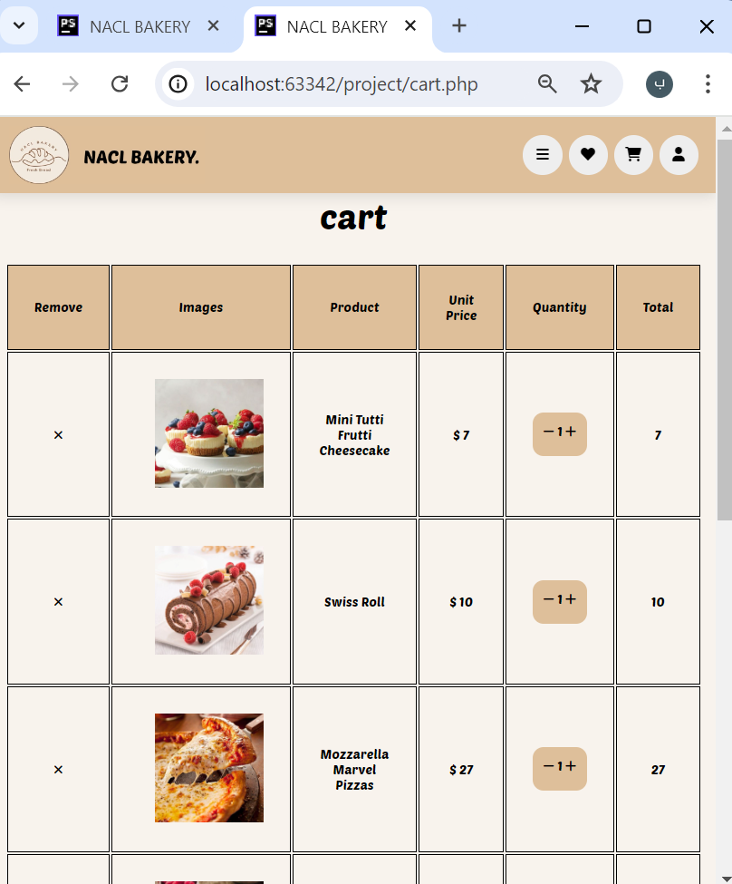

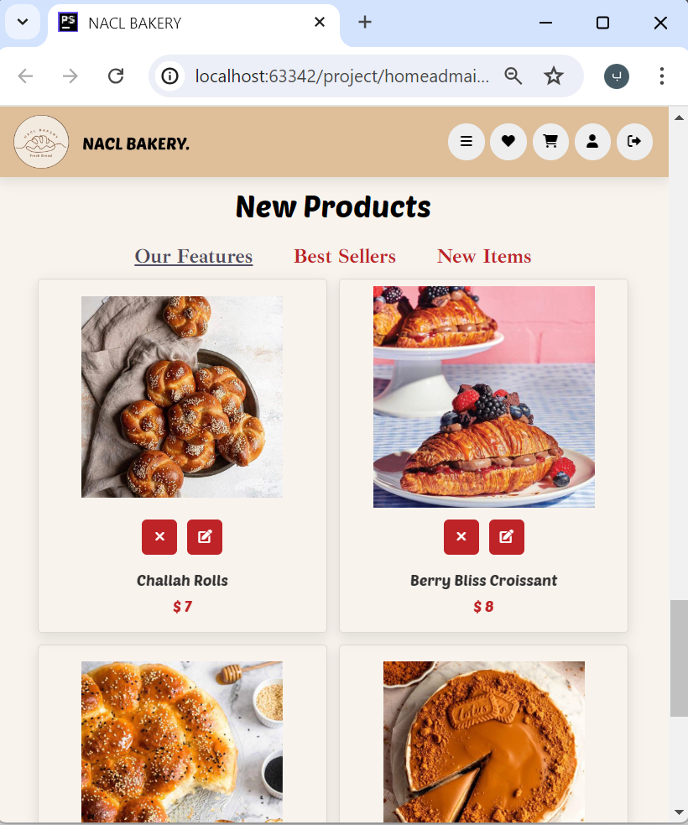 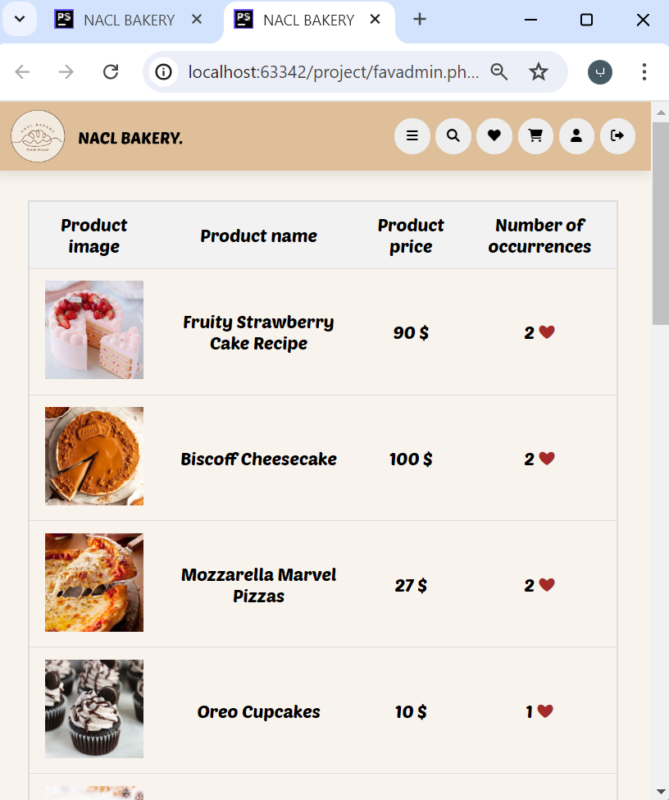 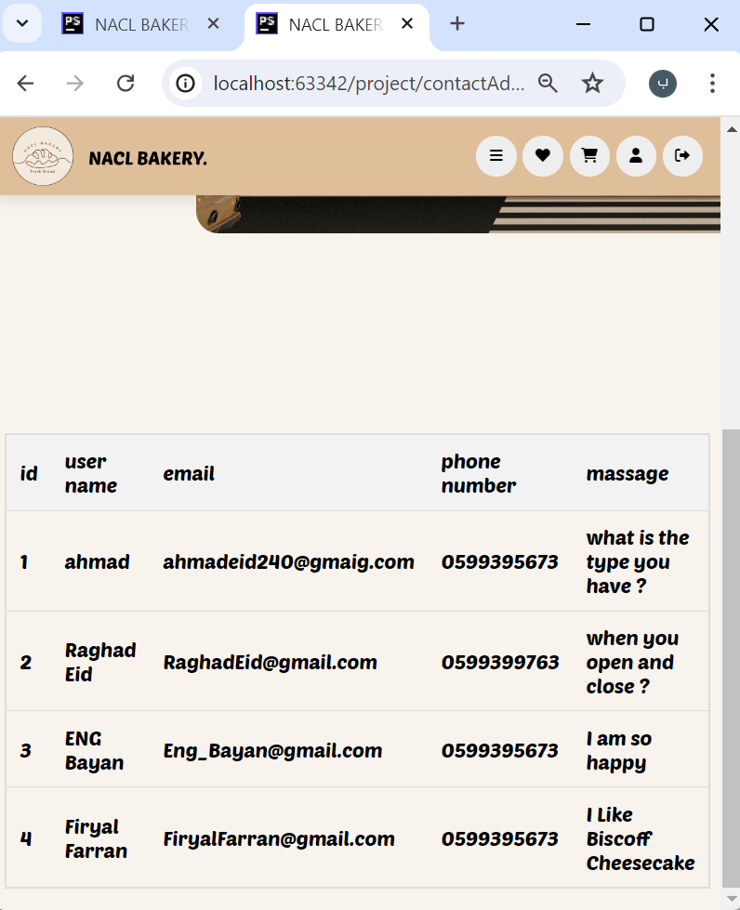

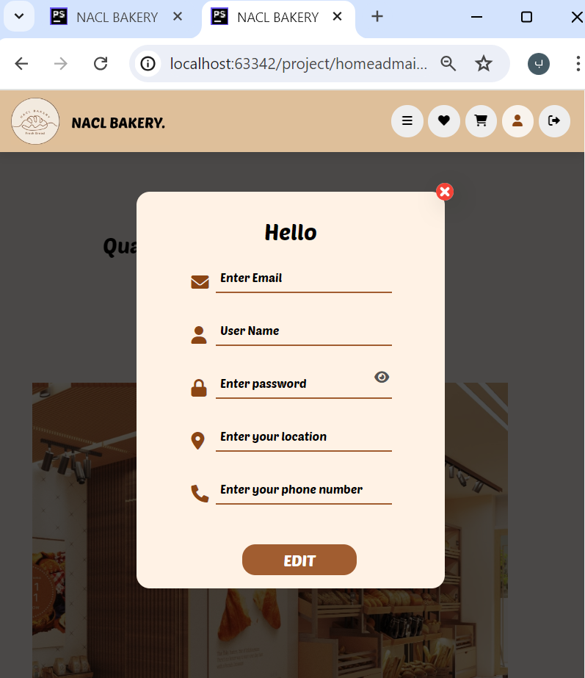 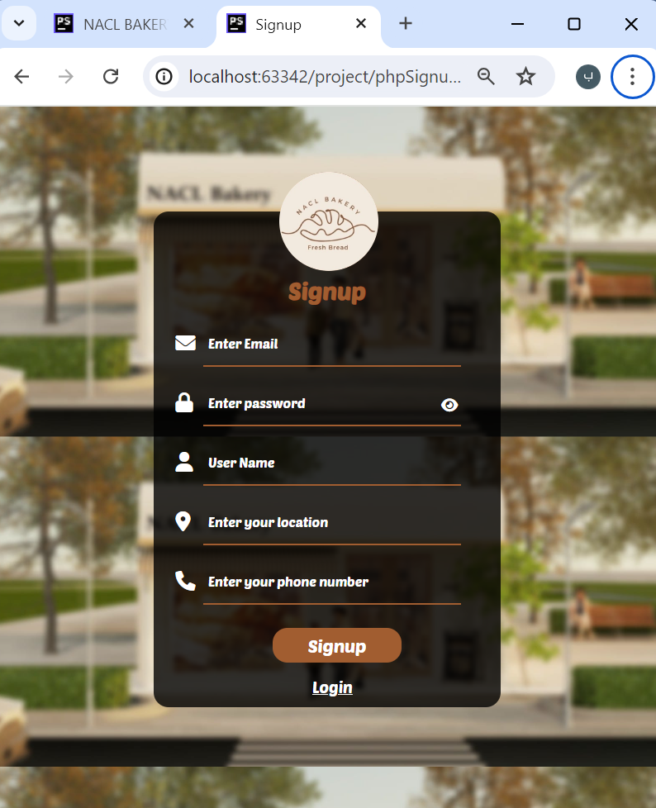 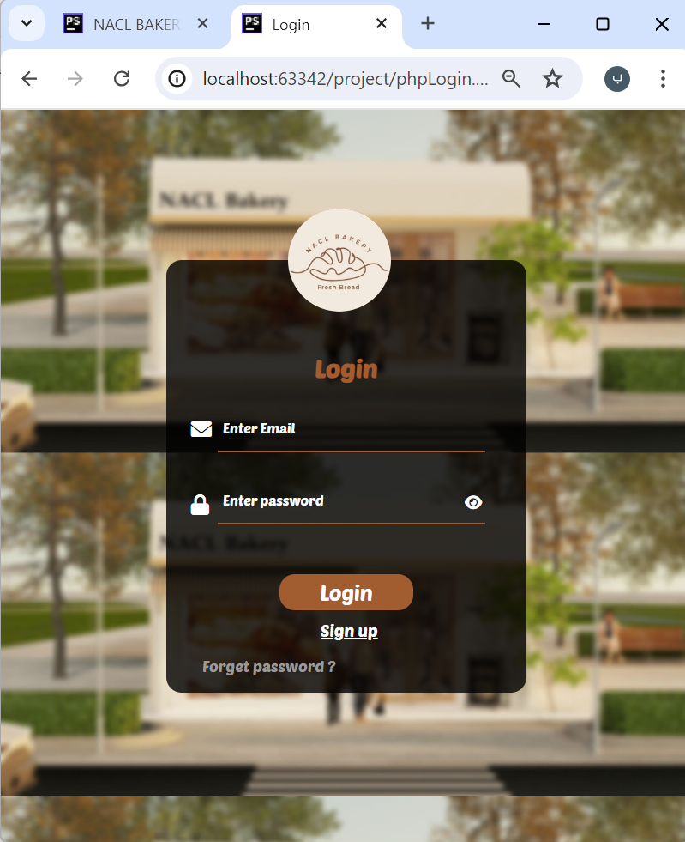

**Conclusion :**

During this web programming project, we acquired hands-on experience with HTML, CSS, JavaScript, and PHP. Our focus was on creating a user-friendly electronic shopping website to overcome navigation challenges effectively. This platform is designed to streamline processes, saving considerable time, effort, and expenses. Our analysis, conducted using UML, has significantly clarified and improved project comprehension. Moving forward, we aim to implement enhancements for both responsiveness and security on the site.

**Our future : ?**

This project is inspired by a design for a bakery shop designed by our friend from An-Najah University, designer Nada Hummaid. Thus, the design of the shop is ready and the website is ready, and we hope that it will be implemented on the ground soon **^_^** .

**Tools and references: ?**

* Web course by Dr.Syfyan Samara .
* PhpStorm .
* XAMPP control panel (Apache and MySQL services) .
* Online tutorials .
* Pinterest Image .
* W3School .
* Nunito ( google font ) .
* Web Icons & Symbols .
* **Designer Nada Hummaid .**